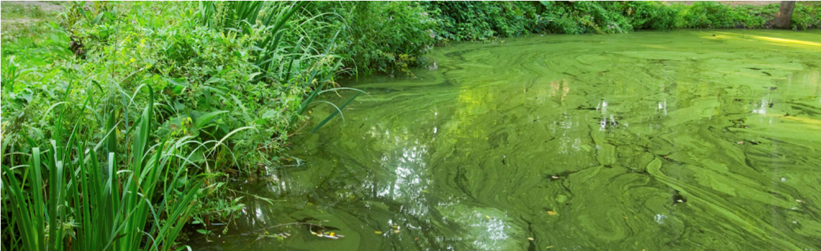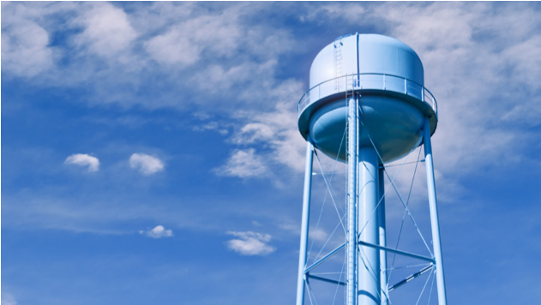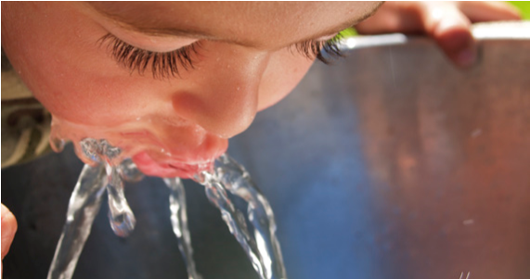
SOCIAL MEDIA
DRINKING WATER ADVISORY – INFANTS, YOUNG CHILDREN AND OTHER VULNERABLE POPULATIONS

TWITTER
■ “Drinking water advisory! Vulnerable populations including infants and young children should not drink [location]’s tap water. See: [insert website link]”
■ “Drinking water advisory! Vulnerable populations in [location] should not drink tap water. For more information visit: [insert website link]”
■ “Drinking water contains potentially harmful levels of cyanotoxins. Vulnerable populations - do not drink [location]’s tap water. See: [insert website link]”
■ “Vulnerable populations including infants and young children should not drink [location]’s tap water. For more information: [insert website link]”
■ “Vulnerable populations should temporarily avoid drinking tap water in [location] until further notice. For more information visit: [insert website link]”

FACEBOOK
■ “Drinking water advisory! Cyanotoxins were detected in [location]’s tap water exceeding the national drinking water Health Advisories for vulnerable populations (listed below). Vulnerable populations in the affected areas should not drink the water.
■ The following vulnerable populations are advised not to drink the tap water: infants, young children under the age of six, pregnant women, nursing mothers, those with pre-existing liver conditions and those receiving dialysis treatment. As a precautionary measure, the elderly and other sensitive populations should consider following these advisory instructions. You should use [alternative sources] for drinking water, making infant formula, making ice and preparing food and beverages.
■ Do Not Boil the tap water. Boiling the water will not destroy cyanotoxins and may increase the toxin levels.
■ If a person is not listed in the vulnerable category above they may drink the tap water.
■ Everyone may use tap water for showering, bathing, washing hands, washing dishes, flushing toilets, cleaning and doing laundry. However, infants and young children under the age of six should be supervised while bathing and during other tap water-related activities to prevent accidental ingestion of water.
■ Drinking water containing cyanotoxins at levels exceeding the national drinking water Health Advisories puts vulnerable populations at risk of experiencing adverse health effects associated with [cyanotoxin name]. Possible adverse health effects include upset stomach, vomiting and diarrhea as well as liver and kidney damage. Seek medical attention if you or your family members are experiencing illness.
■ Cyanotoxins can be harmful to animals. Consider alternative water sources for animals. Contact a veterinarian if animals show signs of illness.
■ [System name] will be taking the following actions to reduce the contaminant levels as soon as possible: [list actions].
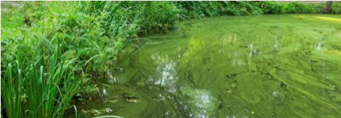
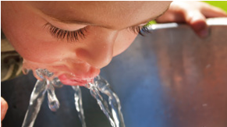
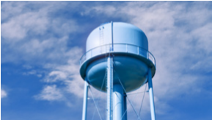
■ [System name] will post an updated advisory when: the [cyanotoxin] levels are less than or equal to the U.S. Environmental Protection Agency’s national Health Advisories, this Do Not Drink Advisory is lifted and/or if there are any changes to the conditions of this Do Not Drink Advisory.
SOCIAL MEDIA
■ For additional information: [insert website link].

AUTOMATED TEXT MESSAGES
■ “Drinking Water advisory! [Location’s] tap water contains [cyanotoxin name] at levels potentially harmful to vulnerable populations. Vulnerable populations including infants and young children under the age of six should Not Drink the tap water until further notice. DO NOT boil the tap water. Please see [insert website link] or call [insert phone number] for more information and a full list of those considered to be within the vulnerable population.”
■ Wireless Emergency Alert message: “Young children and vulnerable populations should Not Drink or boil the tap water.”

