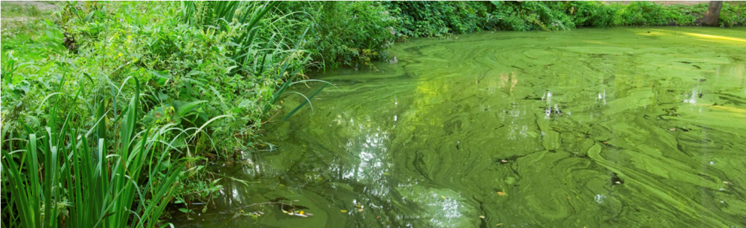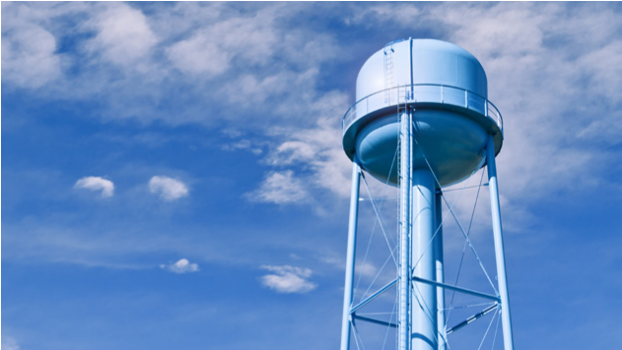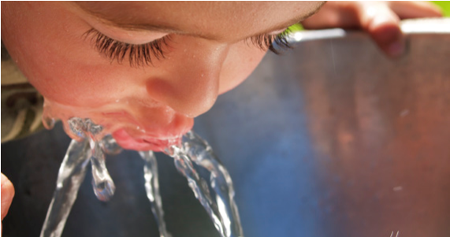
PRESS RELEASE
DRINKING WATER ADVISORY – INFANTS, YOUNG CHILDREN AND OTHER VULNERABLE POPULATIONS
FOR IMMEDIATE RELEASE
Media Contact: [insert name, title, telephone and fax number of spokesperson]
[WATER SYSTEM] ISSUES DO NOT DRINK ADVISORY FOR [CYANOTOXIN NAME] FOR
INFANTS, YOUNG CHILDREN AND OTHER VULNERABLE POPULATIONS
LOCATION [Month Date, Year] – Officials from [local/state agency] have issued a Do Not Drink and Do Not Boil drinking water advisory for infants, young children under the age of six and other vulnerable populations (listed below) in [area affected] until further notice. [Cyanotoxin name], a toxin produced by cyanobacteria (formerly known as blue-green algae), was recently detected in the tap water at [levels and/or ranges] on [dates]. This exceeds the U.S. Environmental Protection Agency’s national Health Advisory levels for vulnerable populations that is set at [level]. Therefore, vulnerable populations (listed below) in the affected areas should not drink the water.
Officials are working closely with local and state public health and/or emergency response agencies to address and resolve the situation. [System name] is working quickly to reduce [cyanotoxin name] levels in tap water by taking the following actions: [list actions such as adjusting treatment, changing source…].
[Insert quote here from local official]
This advisory applies to infants, children under the age of six, pregnant women, nursing mothers, those with preexisting liver conditions and those receiving dialysis treatment. As a precautionary measure, the elderly and other sensitive populations should use an alternate water source. Vulnerable populations, as listed above, who drink water containing [cyanotoxin name] at levels exceeding the national drinking water Health Advisories are at risk of various adverse health effects of [cyanotoxin name]. Possible adverse health effects include upset stomach, vomiting and diarrhea as well as liver and kidney damage. Seek medical attention if you or your family members are experiencing illness. If you, your family members, or your animals have experienced adverse cyanotoxin-related health effects, please contact [State or local Health Department] to report the illness.
[System name] is recommending that vulnerable consumers, as described above, use [alternative sources of water] for drinking, making infant formula, making ice and preparing food and beverages and use precautions against accidental ingestion of tap water until further notice. Do not to boil the water, as boiling water does not remove cyanotoxins and may increase toxin levels.
All those individuals not listed in the vulnerable category may drink the tap water. Everyone may use tap water for showering, bathing, washing hands, washing dishes, flushing toilets, cleaning and doing laundry. However, infants and young children under the age of six should be supervised while bathing and during other tap water-related activities to prevent accidental ingestion of water.
Telephone Number [000-000-0000]
[123 Address Street]
[City, State 00000]
[www.URL.com]

