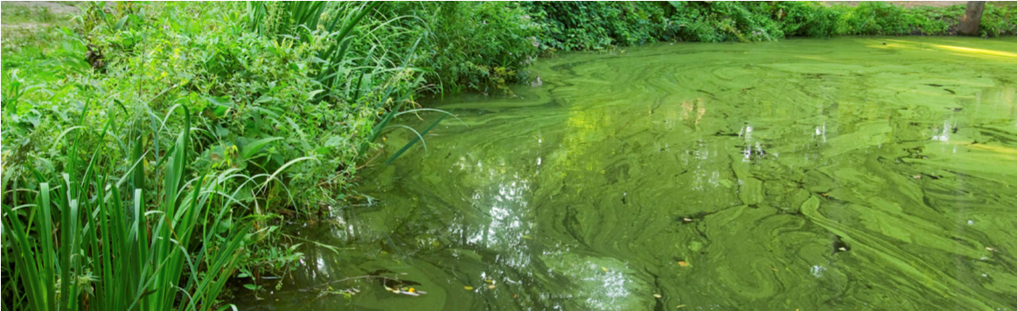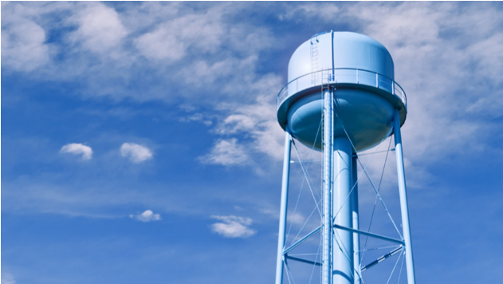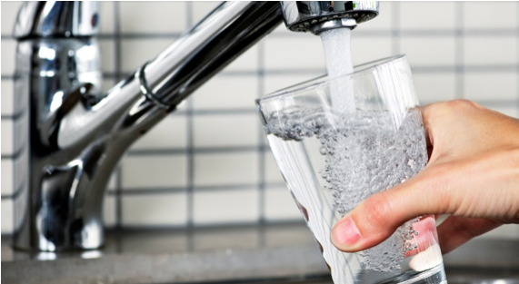
PRESS RELEASE
DRINKING WATER ADVISORY LIFTED
FOR IMMEDIATE RELEASE
Media Contact: [insert name, title, telephone and fax number of spokesperson]
[WATER SYSTEM] LIFTS THE DO NOT DRINK ADVISORY FOR [CYANOTOXIN NAME]
LOCATION [Month Date, Year] – Officials from [local/state agency] lifted the Do Not Drink and Do Not Boil drinking water advisory for [residents; or infants, young children under the age of six and other vulnerable populations] in [area affected] issued on [date]. Water quality samples collected on [dates] showed [cyanotoxin name], a toxin produced by cyanobacteria (formerly known as blue-green algae), detected in the tap water at [levels and/or ranges] on [dates]. This level is [less than or equal to] the U.S. Environmental Protection Agency’s national Health Advisory levels for [all residents; or vulnerable populations] that is set at [level]. Residents may resume using the tap water for all purposes.
[Cyanotoxin name], a toxin produced by cyanobacteria (formerly known as blue-green algae), was detected in the tap water at [levels and/or ranges] on [dates], exceeding the U.S. Environmental Protection Agency’s national Health Advisory levels for [residents; or vulnerable populations] that is set at [level]. A drinking water advisory was in place for [number of days]. The [Water system] quickly responded to reduce levels of [cyanotoxin name] in the following ways: [actions taken]. Samples collected on [dates] show [cyanotoxin name] levels are now [less than or equal to] the U.S. Environmental Protection Agency’s national Health Advisory levels for [residents; or vulnerable populations] and residents may resume using their tap water for all purposes. [Insert any suggested activities for customers to follow when resuming the consumption of their tap water]. [Insert any actions taken by public water supply to reduce risks of cyanotoxins in drinking water in the future].
[Insert quote here from local official]
Anyone wanting additional information about this event is encouraged to contact [name of person] at [contact information] and/or consult the following website for relevant information: [link to lifted advisory notification].
Telephone Number 000-000-0000
123 Address Street
City, State 00000 www.URL.com

