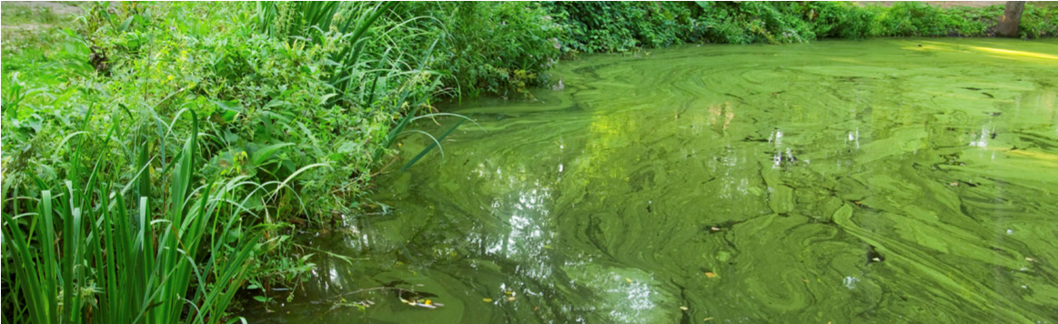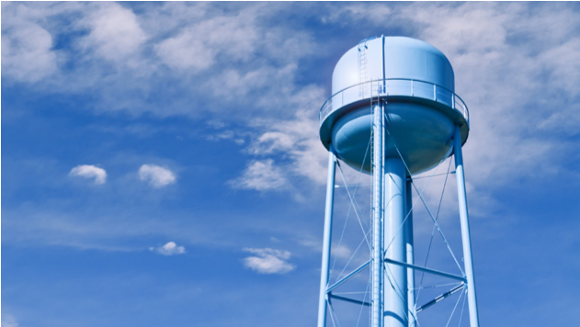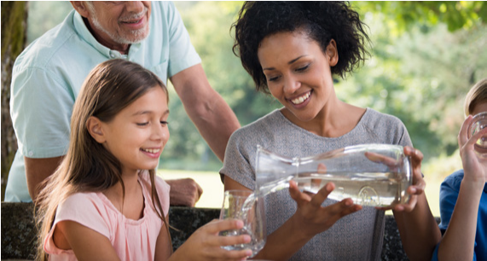
PRESS RELEASE
DRINKING WATER ADVISORY – EVERYONE
FOR IMMEDIATE RELEASE
Media Contact: [insert name, title, telephone and fax number of spokesperson]

[WATER SYSTEM] ISSUES A [CYANOTOXIN NAME] DO NOT DRINK ADVISORY
LOCATION [Month Date, Year] – Officials from [local/state agency] have issued a Do Not Drink and Do Not Boil drinking water advisory for [area affected] until further notice. [Cyanotoxin name], a toxin produced by cyanobacteria (formerly known as blue-green algae), was recently detected in the tap water at [levels and/or ranges] on [dates]. This exceeds the U.S. Environmental Protection Agency’s national Health Advisory levels of [level]. Therefore, residents in the affected areas should not drink the water.
Officials are working closely with local and state public health and/or emergency response agencies to address and resolve the situation. [System name] is working quickly to reduce [cyanotoxin name] levels in tap water by taking the following actions: [list actions such as adjusting treatment, changing source…].
[insert quote here from a local official]
Individuals who drink water containing [cyanotoxin name] at levels exceeding the national drinking water Health Advisories are at risk of various adverse health effects of [cyanotoxin name]. Possible adverse health effects include upset stomach, vomiting and diarrhea as well as liver and kidney damage. Seek medical attention if you or family members are experiencing illness. If you, your family members or your animals have experienced adverse cyanotoxin-related health effects, please contact [State or local Health Department] to report the illness.
[System name] recommends consumers use [alternative sources of water] for drinking, making infant formula, making ice and preparing food and beverages and to use precautions against accidental ingestion of tap water until further notice. Do not boil the tap water, as boiling water does not remove cyanotoxins and may increase toxin levels.
Everyone may use tap water for showering, bathing, washing hands, washing dishes, flushing toilets, cleaning and doing laundry. However, infants and young children under the age of six should be supervised while bathing and during other tap water-related activities to prevent accidental ingestion of tap water.
[insert quote here from a local official]
[System name] will post an updated advisory when: the [cyanotoxin] levels are less than or equal to the U.S.
Environmental Protection Agency’s national Health Advisories, the Do Not Drink Advisory is lifted and/or if there are any changes to the conditions of the Do Not Drink Advisory.
Anyone with concerns about this event is encouraged to contact [name of person] at [contact information] and/or consult the following website for relevant information: [link to warning]

Telephone Number [000-000-0000]
[123 Address Street]
[City, State 00000]
[www.URL.com]

