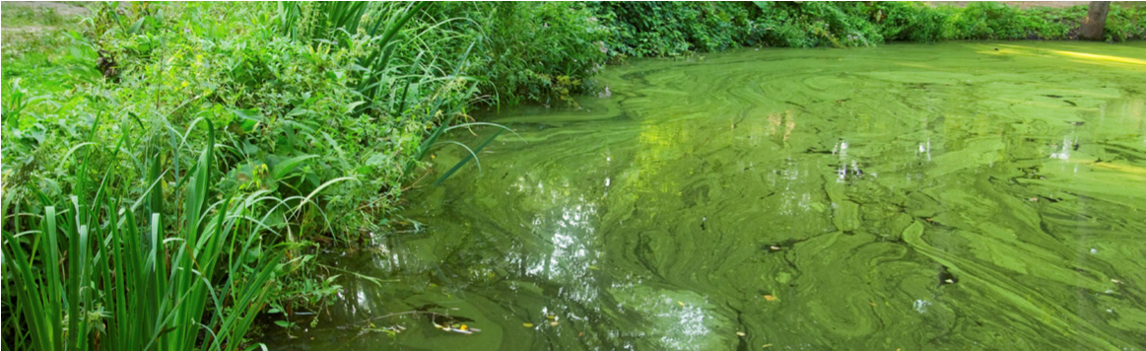
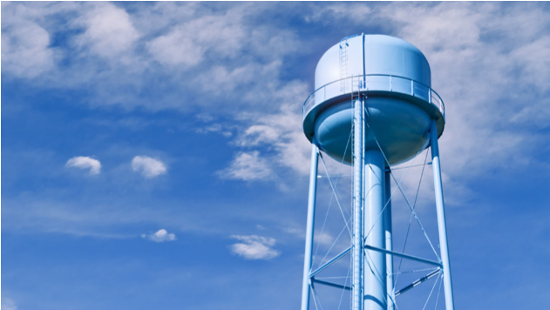
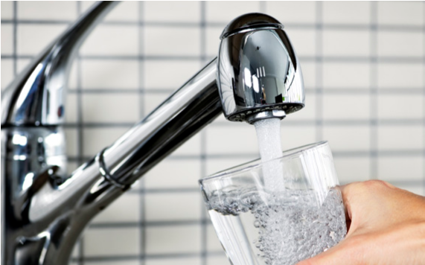
DRINKING WATER ADVISORY LIFTED
FOR [WATER SYSTEM NAME]
EVERYONE MAY DRINK THE TAP WATER – [DATE ISSUED]
WHY IS THE ADVISORY LIFTED?
■ Drinking water advisory issued on [date] for [System name] that supplies water to [geographic area: cities, counties, distribution system segments, etc.] has been lifted.
■ Samples collected on [dates] show [cyanotoxin name] in the drinking water at [levels and/or ranges], which are [less than or equal to] the U.S. Environmental Protection Agency’s [cyanotoxin name] national drinking water Health Advisory of [level].
■ [System name] took the following actions to reduce [cyanotoxin name] levels: [list actions such as adjusting treatment, changing source, etc.].
WHAT SHOULD I DO?
■ Everyone may resume using the tap water for all uses.
■ [Insert any suggested activities for customers when resuming consumption of their tap water].
■ [Insert any actions taken by public water supply to reduce risks of cyanotoxins in drinking water in the future].

Please share this information with all the other people who drink this water, especially those who may not have received this notice directly (for example, people in apartments, nursing homes, schools and businesses). You can do this by posting this notice in a public place or distributing copies by hand.
This notice is being sent to you by [system].
State Water System ID#: _______________ Date distributed: _________
Telephone Number [000-000-0000]
[123 Address Street, City, State 00000]
[www.URL.com]

