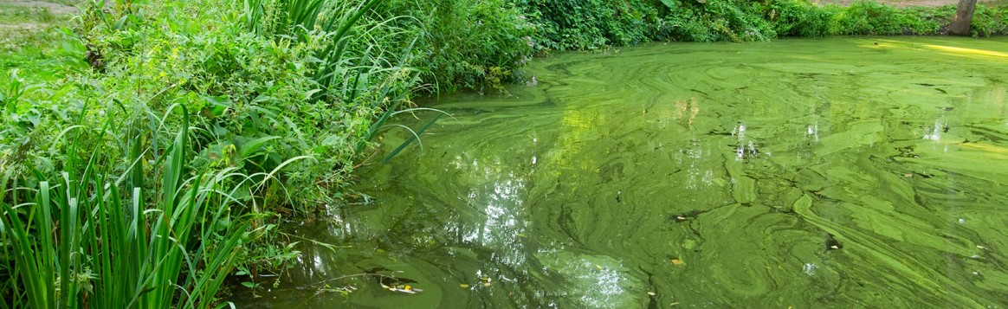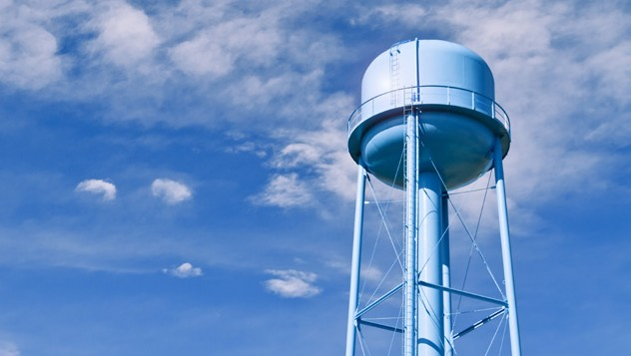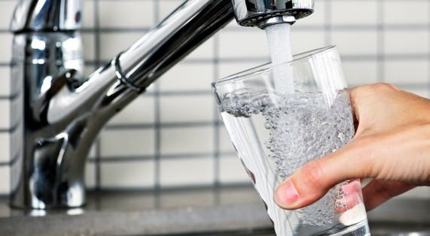
SOCIAL MEDIA
DRINKING WATER ADVISORY LIFTED

TWITTER
- “Drinking water update! The Drinking Water Advisory has been lifted, you may drink the tap water. For more information see: [insert website link]”
- “[Water system name] confirms acceptable levels of cyanotoxins in drinking water. You may drink the tap water in [location]. For more information see: [insert website link]”
- “The Drinking Water Advisory has been lifted for [location]. You may drink the tap water in [location]. For more information see: [insert website link]”
- “[Location]’s Drinking Water Advisory is lifted. All residents may drink the tap water in [location]. For more information see: [insert website link]”

FACEBOOK

“Drinking water update! Drinking Water Advisory has been lifted.

- The Drinking Water Advisory has been lifted for [location].

- [System name] has addressed the contamination issue. Tap water samples tested on [dates] for [cyanotoxin name] and show levels [less than or equal to] the U.S. Environmental Protection Agency’s national drinking water Health Advisory levels.

You may use the tap water for drinking and all other uses.

- For additional information: [insert website link]”

AUTOMATED TEXT MESSAGES
- “Drinking Water update! The Drinking Water Advisory has been lifted for [location]. You may use the tap water for drinking and all other uses. For additional information please see [website link].”
- Wireless Emergency Alert message: “Update! The Drinking Water Advisory has been lifted, you may use the tap water.”

