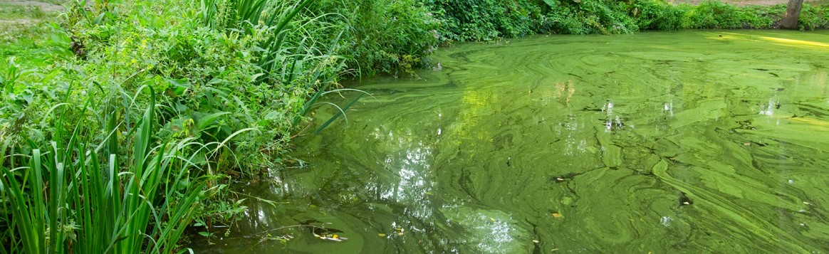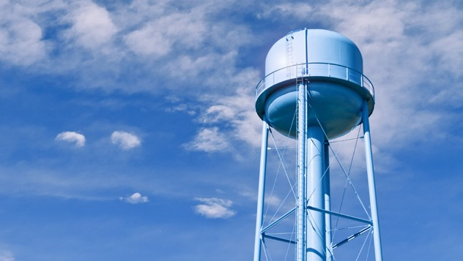
DRINKING WATER ADVISORY
[CYANOTOXIN NAME] IS PRESENT IN [WATER SYSTEM NAME] DO NOT DRINK THE TAP WATER – [DATE ISSUED]

WHY IS THERE AN ADVISORY?
- [Cyanotoxin name], a toxin produced by cyanobacteria (formerly known as blue-green algae) was detected in the drinking water from [System name] on [date].
- Elevated levels of toxins have been detected in [source name] that supplies water to [geographic area, cities, counties, distribution system segments, etc.].
- [System name] is taking the following actions to reduce [cyanotoxin name] levels: [list actions such as: adjusting treatment, changing source, etc.].
- Samples collected on [dates] show [cyanotoxin name] in the drinking water at [levels and/or ranges], which are above the
U.S. Environmental Protection Agency’s [cyanotoxin name] national drinking water Health Advisory of [level].

WHAT SHOULD I DO?

Do Not Drink the tap water.
- [Alternative sources of water] should be used for drinking, making infant formula, making ice and preparing food and beverages.
- Do Not Boil the tap water. Boiling the water will not destroy cyanotoxins and may increase the toxin levels.
- Everyone may use tap water for showering, bathing, washing hands, washing dishes, flushing toilets, cleaning and doing laundry. However, infants and young children under the age of six should be supervised while bathing and during other tap water-related activities to prevent accidental ingestion of water.
- Drinking water containing [cyanotoxin name] at levels exceeding the national drinking water Health Advisories can put you at risk of various adverse health effects including upset stomach, vomiting and diarrhea as well as liver and kidney damage. Seek medical attention if you or family members are experiencing illness.
- Animals may be vulnerable to adverse health effects of [cyanotoxin name] at the detected levels indicated above; consider providing animals alternative sources of water. Contact a veterinarian if animals show signs of illness.
- If you, your family members or your animals have experienced adverse cyanotoxin-related health effects, please contact [State or local Health Department] to report the illness.

WHAT IS BEING DONE?
- [System name] is working closely with local and state public health and emergency response agencies to address the situation and to quickly to reduce [cyanotoxin name] levels in tap water.
- [System name] will post an updated advisory when: the [cyanotoxin] levels are less than or equal to the national drinking water Health Advisories, this Do Not Drink Advisory is lifted and/or if there are any changes to the conditions of this Do Not Drink Advisory.
- For more information please contact [contact information] or visit [website].
Please share this information with all the other people who drink this water, especially those who may not have received this notice directly (for example, people in apartments, nursing homes, schools and businesses). You can do this by posting this notice in a public place or distributing copies by hand.

This notice is being sent to you by [system].
State Water System ID#: Date distributed:
Telephone Number [000-000-0000]
[123 Address Street, City, State 00000]
[www.URL.com]

