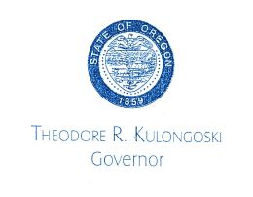

June 21, 2010

Mr. Dennis J. McLerran, Regional Administrator EPA Region 10
Regional Administrator's Office, RA-140 1200 Sixth Avenue, Suite 900
Seattle, WA 98101
Dear Mr. McLerran:
In accordance with Section 9004 of Subtitle I of the Solid Waste Disposal Act, as amended by the Resource Conservation and Recovery Act, I am forwarding an application for approval of the Underground Storage Tank Program for the State of Oregon. I believe you will find it contains the provisions necessary to implement an effective Underground Storage Tank Program.

Should you require further information, please contact Dick Pedersen, Director of the Department of Environmental Quality, at (503) 229-5300.

Thank you for your assistance.

Sincerely,
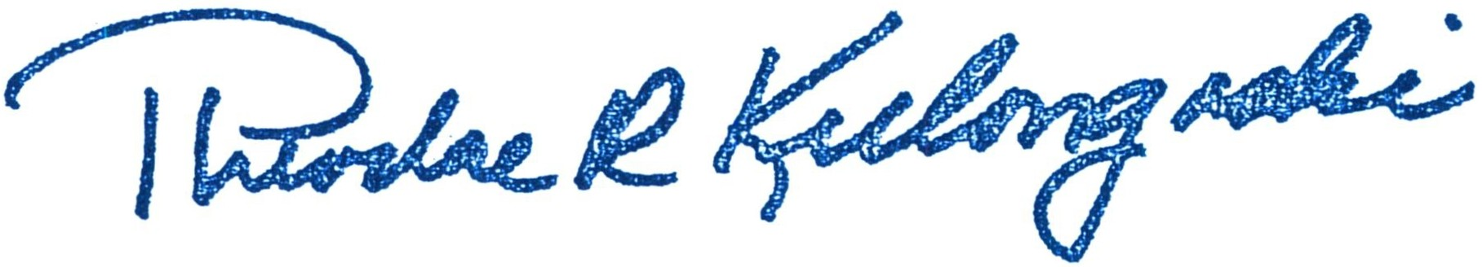
THEODORE R. KULONGOSKI
Governor

TRK:mc:jb

STATE CAPITOL, 900 COURT STREET NE, SALEM OR 97301-4047 (503) 378-3111 FAX (503) 378-6827 WWW.GOVERNOR.OREGON.GOV

