**Appendix A**

**Example Standard Operating Procedures**

Appendix A Table of Contents

STANDARD OPERATING PROCEDURE 1M: Assemble the MetalMapper System and Verify Correct Operation 70

SOP 1M: Attachment 1 Preparatory MetalMapper Assembly QC Checklist 76

STANDARD OPERATING PROCEDURE 1T: Assemble the TEMTADS 2x2 System and Verify Correct Operation 77

SOP 1T: Attachment 1 Preparatory TEMTADS Assembly QC Checklist 84

STANDARD OPERATING PROCEDURE 2: Test Sensor and System at the Instrument Verification Strip (IVS)……..…….84

SOP 2 Attachment 1 Preparatory IVS Construction QC Checklist 93

SOP 2: Attachment 2 Initial IVS QC Checklist 94

SOP 2: Attachment 3 Follow-on IVS QC Checklist 95

STANDARD OPERATING PROCEDURE 3: Production Area Seeding 96

SOP 3: Attachment 1 Preparatory Production Area Seeding QC Checklist 100

STANDARD OPERATING PROCEDURE 4M: Perform Dynamic Surveys with MetalMapper 101

SOP 4M: Attachment 1 Dynamic MetalMapper Data Collection QC Checklist 105

STANDARD OPERATING PROCEDURE 4T: Perform Dynamic Surveys with TEMTADS 2x2 106

SOP 4T: Attachment 1 Dynamic TEMTADS Data Collection QC Checklist 110

STANDARD OPERATING PROCEDURE 5M: Process Dynamic Survey Data - MetalMapper 111

SOP 5M: Attachment 1 Dynamic MetalMapper Data Processing QC Checklist 117

STANDARD OPERATING PROCEDURE 5T: Process Dynamic Survey Data - TEMTADS 2x2 118

SOP 5T: Attachment 1 Dynamic TEMTADS Data Processing QC Checklist 124

STANDARD OPERATING PROCEDURE 6: Collect Static Background Measurements 125

SOP 6: Attachment 1 Preparatory Background Collection QC Checklist 130

SOP 6: Attachment 2 Initial Background Data Collection QC Checklist 131

SOP 6: Attachment 3 Follow-on Background Data Collection QC Checklist 132

STANDARD OPERATING PROCEDURE 7: Collect Cued Target Measurements 133

SOP 7: [Attachment 1 Cued Geophysical Data Collection Follow-on QC Checklist 137](#_Toc442877318)

STANDARD OPERATING PROCEDURE 8: Process Cued MetalMapper or TEMTADS Data 138

Attachment 1 Cued Geophysical Data Processing QC Checklist 144

STANDARD OPERATING PROCEDURE 9: Verify Recovered Objects Are Compatible With Predictions 145

SOP 9: Attachment 1 Follow-on QC Checklist for Recovered Item Verification 148

STANDARD OPERATING PROCEDURE 10: [Validate Classification Process 149](#_Toc442877340)

SOP 10: Attachment 1 Follow-on QC Checklist for Validation 151

# STANDARD OPERATING PROCEDURE 1M

# Assemble the MetalMapper System and Verify Correct Operation

### Purpose and Scope

The purpose of this Standard Operating procedure (SOP) is to identify the methods to be employed when assembling the MetalMapper sensor system and verifying that all components are correctly assembled, operating normally, and capable of acquiring data of sufficient quality.

### Personnel, Equipment and Materials

This section describes the personnel, equipment and materials required to implement this SOP.

The following individuals will be involved in the assembly and verification of the MetalMapper:

* Project Geophysicist
* QC Geophysicist
* Field Team Leader
* Data Processor

The qualifications of the personnel implementing this SOP are documented in the QAPP Worksheet #4, 7 & 8.

The following is a list of required equipment and materials:

* Geometrics MetalMapper sensor coupled with a real-time kinematic Global Positioning System (RTK GPS) and Inertial Measurement Unit (IMU) for orientation measurements
* transport vehicle (skid steer, tractor, extended reach forklift) used to move the MetalMapper during data collection
* a schedule 80 small Industry Standard Object (small ISO80) for operational testing
* digital camera or cell phone. (Note, personnel should not have cell phones when operating the MetalMapper)

### Procedures and Guidelines

The Geometrics MetalMapper is an advanced electromagnetic induction sensor designed for the detection and classification of buried metal objects. The sensor consists of three orthogonal 1-m x 1-m transmit coils for target illumination and seven, three-axis receive cubes. It measures the decay curve up to 8-ms after the transmitters are turned off for each of the 21 receive channels. The orientation of the three transmit coils is shown in Figure 1.

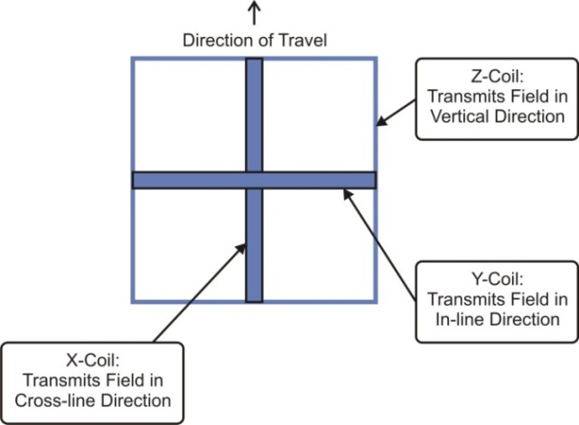

**Figure 1**. Orientation of the three MetalMapper transmit coils

Positioning of the MetalMapper is accomplished using an RTK GPS. The MetalMapper orientation is measured using a six-degree-of-freedom inertial measurement unit (IMU). For proper functioning it is important to verify that the IMU has been mounted to the MetalMapper in the correct orientation.

#### Assemble the MetalMapper

All assembly operations are described in the MetalMapper manual as published by Geometrics (see <http://www.geometrics.com/files/metalmapper_manual_beta1.pdf>) and the detailed instructions contained there should be followed precisely. Figure 2 shows a schematic overview of the assembly steps which are briefly described below:



* + - 1. Using the bolts and brackets provided, attach the X transmitter coil then the Y transmitter coil to the Z-transmitter box.
      2. Attach the GPS platform legs to the Z-transmitter box and then the GPS platform to the legs.
      3. Securely attach the GPS antenna to the platform.
      4. Loosely attach the IMU to the platform. The attachment will be secured after correct IMU orientation is verified.
      5. Mount the MetalMapper on the survey sled that will be used.
      6. Mount one end of the attachment bar to the survey sled and the other end to the vehicle using the hitch mount provided.
      7. Mount the data acquisition computer in the vehicle so that it can be easily accessed by the operator. Mount the display screen where it can be easily seen by the operator during normal vehicle operations. Do not obscure the operator’s view of the sensor sled with the computer or screen.

**Figure 2** Overview of the MetalMapper system assembly

* + - 1. Route all cables (three transmit cables, the receive cable bundle, and the cables for the GPS and IMU) along the attachment bar to the acquisition computer. Secure the cables to the bar in several places.
      2. Attach all cables to the marked connectors in the acquisition computer.

#### Verify Assembly

In order for the standard data analysis routines to successfully handle MetalMapper data, you must verify that the transmit coils have been assembled in the correct orientation and the IMU has been installed correctly.

##### Orientation of the Transmit Coils

The correct orientation of the transmit coils and their polarities are shown in Figure 3. Visually verify that the assembled sensor matches this diagram.



**Figure 3**. Correct orientations and polarities of the three MetalMapper transmit coils

##### Orientation of the IMU

The procedure to verify the correct orientation of the IMU is shown in Figure 4 and instructions for this test follow:



**Figure 4.** Procedure for verifying IMU Orientation

1. Facing the direction of travel, rotate the IMU around the along-track axis to produce a positive ROLL as shown in Figure 5. Verify that the data acquisition system records a positive ROLL. If it does not, reorient the IMU on its mount and test again.

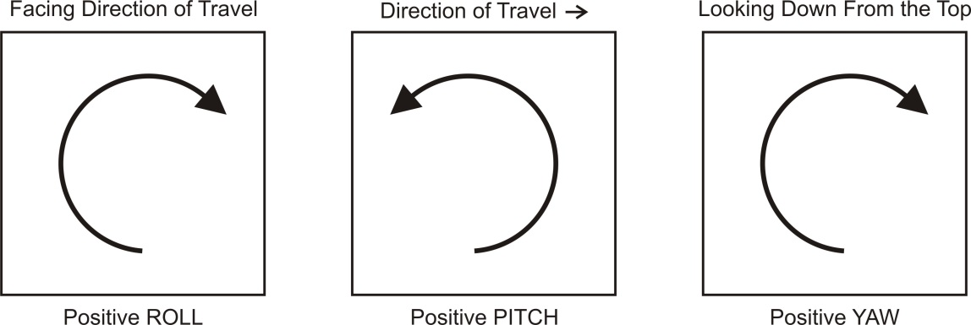

**Figure 5**. Positive ROLL, PITCH, and YAW rotations of the IMU

1. Standing on the side of the sensor with the direction of travel to your right, rotate the IMU around the cross-track axis to produce a positive PITCH as shown in Figure 5. Verify that the data acquisition system records a positive PITCH. If it does not, reorient the IMU on its mount and return to step 1.
2. Looking down on the sensor from above, rotate the IMU around the vertical axis to produce a positive YAW as shown in Figure 5. Verify that the data acquisition system records a positive YAW. If it does not, reorient the IMU on its mount and return to step 1.

##### Operation of the GPS

Turn on the GPS receiver, allow it time to lock onto a position, and verify that GPS readings are being received at the data acquisition computer.

##### MetalMapper Function Test

Dig, or find, a small depression in the ground in a clear area as shown on the left side of Figure 6. Place a small ISO80 in the depression oriented horizontally. Center the MetalMapper over the depression so that the ISO is under measurement position 1.

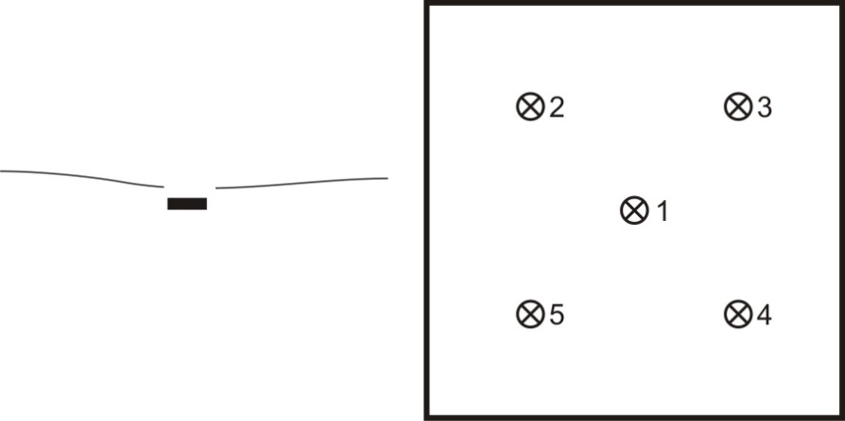

**Figure 6**. Small ISO80 placed horizontally in a shallow depression (left) and the five measurement locations under the MetalMapper (right)

Collect a cued measurement with the MetalMapper. Verify that the transmit current is within the expected range. Position the MetalMapper so the ISO is under measurement positions 2 through 5 collecting cued data in each position. Invert each of the five data sets and verify that the resulting polarizability decays match the library values for a small ISO80 with a match metric of 0.95 or greater.

##### Photograph the Sensor

Using a cell phone or other pocket camera, photograph the installed sensor. Verify that the photograph(s) depict the orientation of the MetalMapper relative to the vehicle and shows the locations of the GPS and IMU sensors.

### Data Management

The following sections describe the data that is needed to perform this SOP and the resulting data.

#### Input Data Required

Input data consists of the MetalMapper manual as published by Geometrics.

#### Output Data

The five test measurements over the ISO80 described in Section 3.2.4 will be saved in the project database along with the inversion results and library match metric for each of the measurements. Also, the QC checklist in Attachment 1 of this SOP will be completed, signed, and filed with the assembly photograph as proof of correct assembly.

### Quality Control

As this definable feature of work is accomplished only during the preparatory phase, only preparatory QC checks will be performed. QC consists of performing the inspections on the Preparatory Phase Quality Control Checklist that is included as Attachment 1 to this SOP. This checklist will be completed by the Field or Project Geophysicist and will be observed by the QC geophysicist who will document the implementation of this SOP in the Geophysics Daily QC Report.

The measurement quality objectives (MQOs) for this task are presented in Worksheet #22 of the project-specific QAPP. The MetalMapper will not be tested on the Instrument Verification Strip (IVS) (SOP 2) until the MQOs are documented as being met as described below.

### Reporting

Achievement of the Sensor Assembly MQOs (see the MQOs in Worksheet #22) will be documented by the Field or Project Geophysicist by completion of the Preparatory QC Checklist in Attachment 1 to this SOP and will be verified by the QC Geophysicist in the Geophysics Daily QC Report.

The delivered data package for the assembled and tested MetalMapper will include:

* a brief description of the assembly and test process along with the photograph(s) taken in Section 3.3 will be included in the IVS letter report.
* the completed Preparatory QC Checklist signed by the Project, Field Geophysicists verifying the assembly and orientation tests described above.
* the inversion results from the five measurements over the ISO80 overlain over the library polarizabilities for the small ISO80.
* the verification in the Geophysics Daily QC Report.

## SOP 1M

## Attachment 1 Preparatory MetalMapper Assembly QC Checklist

This checklist is to be completed by the Project or Field Geophysicist and checked by the QC Geophysicist during assembly and initial testing of the MetalMapper.

|  |  |  |  |
| --- | --- | --- | --- |
| **QC Step** | **QC Process and Guidance Reference** | **Yes/No** | **Initial of Field or Project Geophysicist** |
| 1. Qualifications | Have the qualifications of the Project and Field Geophysicists and the Data Processor listed in QAPP Worksheet #4, 7 & 8 been verified? |  |  |
| 1. Assembly | Is the MetalMapper assembled in accordance with the published instructions and in the sequence i/a/w this SOP? |  |  |
| 1. Assembly: Transmit coil verification | Is the orientation of the transmit coils verified to be in the correct orientation i/a/w this SOP? |  |  |
| 1. Testing: IMU orientation verification | Has the procedure and tests for verification of the IMU orientation been completed i/a/w this SOP? |  |  |
| 1. Testing: GPS | Was the GPS warmed up and allowed time to lock onto position i/a/w this SOP? |  |  |
| 1. Photograph the installation | Was a photograph showing the orientation of the MetalMapper relative to the vehicle and the placement of the GPS and IMU taken? |  |  |
| 1. Testing: ISO80 placement | Was an ISO80 used for testing and was it placed i/a/w this SOP? |  |  |
| 1. Testing: MetalMapper functioning | Was the MetalMapper tested over the ISO80 in all five locations i/a/w this SOP? Record the library match metric for the five inversions below:   1. ________________ 2. ________________ 3. ________________ 4. ________________ 5. ________________ |  |  |
| 1. MQO Documentation | Have the appropriate MQOs from Worksheet #22 been achieved? |  |  |

Project or Field Geophysicist: _____________________________Date:___________

Data Processor: ________________________________________Date:___________

QC Geophysicist: _______________________________________Date:__________

# STANDARD OPERATING PROCEDURE 1T

# Assemble the TEMTADS 2x2 System and Verify Correct Operation

### Purpose and Scope

The purpose of this Standard Operating procedure (SOP) is to identify the methods to be employed when assembling the TEMTADS 2x2 sensor system for dynamic collection and verifying that all components are correctly assembled, operating normally, and are capable of acquiring data of sufficient quality.

### Personnel, Equipment and Materials

This section describes the personnel, equipment and materials required to implement this SOP.

The following individuals will be involved in the assembly and verification of the TEMTADS:

* Project Geophysicist
* Field Team Leader
* Quality Control (QC) Geophysicist
* Data Processor

The qualifications of the personnel implementing this SOP are documented in the QAPP Worksheet #4, 7 & 8.

The following is a list of required equipment and materials:

* TEMTADS 2x2 sensor coupled with a real-time kinematic Global Positioning System (RTK GPS) and Inertial Measurement Unit (IMU) for orientation measurements
* a schedule 80 small Industry Standard Object (small ISO80) in the Delrin mounting ring for sensor function testing
* a digital camera or cell phone. (Note, personnel should not have cell phones when operating the TEMTADS)

### Procedures and Guidelines

The TEMTADS 2x2 is an advanced electromagnetic induction sensor designed for the detection and classification of buried metal objects. The sensor consists of four sensor elements arranged on 40‑centimeter (cm) centers in a 2x2 array. Each sensor element consists of a 35-cm square transmit coil for target illumination with an 8-cm three-axis receive cube centered in the transmit coil. The transmitters are energized in sequence and the decay curve is recorded up to 25 milliseconds after the transmitters are turned off for each of the 12 (4 cubes with 3 axes each) receive channels. A schematic of the sensor coil configuration is shown on Figure 1.



**Figure 1**. Orientation of the Four TEMTADS 2x2 Sensor Elements (topview)

Positioning of the TEMTADS 2x2 is accomplished using an RTK GPS. The TEMTADS 2x2 orientation is measured using a six-degree-of-freedom IMU. For proper functioning it is important to verify that the IMU has been mounted to the TEMTADS 2x2 in the correct orientation.

#### Assemble the TEMTADS 2x2

All assembly operations are described in the TEMTADS 2x2 unpacking instructions and user guide available from the Naval Research Laboratory (NRL) and the detailed instructions contained there should be followed precisely. Figure 2 shows a schematic overview of the assembly steps which are briefly described below:



1. Remove the sensor assembly from the packing crate following the instructions in the unpacking guide.
2. Attach the wheels or sled.
3. Securely attach the GPS antenna to the top of the mounting platform. If GPS is not being used, move to Step 4.
4. Set the IMU onto its position below the GPS. The attachment will be secured after correct IMU orientation is verified.
5. Connect the sensor cable bundle to the sensor. This includes the sensor Tx and Rx cables and the cables to the GPS and IMU.
6. Remove the electronic housing from its shipping container and attach it to the backpack.
7. Attach the Tx, Rx, and IMU cables to the electronics box. The GPS cable will be attached after booting the computer.

**Figure 2.** Overview of the TEMTADS Assembly Process

#### Turn On and Initialize the Data Acquisition Computers

Following the instructions in Section 5 of the TEMTADS 2x2 User Guide, start the data acquisition system. After the main computer in the electronics housing boots, plug the GPS cable into the electronics. The last step in Section 5 involves observing the IMU output. Leave the system in this state for the next operation.

#### Verify IMU Orientation

The procedure to verify the correct orientation of the IMU is shown in Figure 3 and instructions for this test follow:



**Figure 3**. Procedure for Verifying IMU Orientation

1. Facing the direction of travel, rotate the IMU around the along-track axis to produce a positive ROLL as shown in Figure 4. Verify that the data acquisition system records a positive ROLL, Figure 5. If it does not, reorient the IMU on its mount and test again.



**Figure 4**. Positive ROLL, PITCH, and YAW Rotations of the IMU

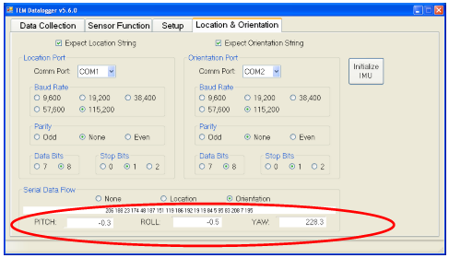

**Figure 5**. Electronics Box Screen Showing Orientation Inputs

1. Standing on the side of the sensor with the direction of travel to your right, rotate the IMU around the cross-track axis to produce a positive PITCH as shown in Figure 4. Verify that the data acquisition system records a positive PITCH. If it does not, reorient the IMU on its mount and return to step 1.
2. Looking down on the sensor from above, rotate the IMU around the vertical axis to produce a positive YAW as shown in Figure 4. Verify that the data acquisition system records a positive YAW. If it does not, reorient the IMU on its mount and return to step 1.

#### Photograph the Sensor

Using a cell phone or other camera, photograph the installed sensor. Verify that the photograph(s) shows the locations and orientations of the GPS and IMU sensors.

#### Set up the Data Acquisition Parameters

In preparation for the sensor function test, use the [Setup] tab in TEMDataLogger or TEMTablet to set the correct data acquisition parameters for the dynamic survey. The easiest way to accomplish this is to use [Standard Dynamic] or [Standard Cued] button, Figure 6. The standard parameters are listed in Table 1.

**Table 1**. Standard Data Acquisition Parameters

|  |  |  |
| --- | --- | --- |
| **Parameter** | **Cued Survey** | **Dynamic Survey** |
| Acq Mode | Decimated | Decimated |
| Gate Width | 5% | 20% |
| Stacks | 18 | 1 |
| Repeats | 9 | 3 |
| Stack Period | 0.9 | 0.033 |

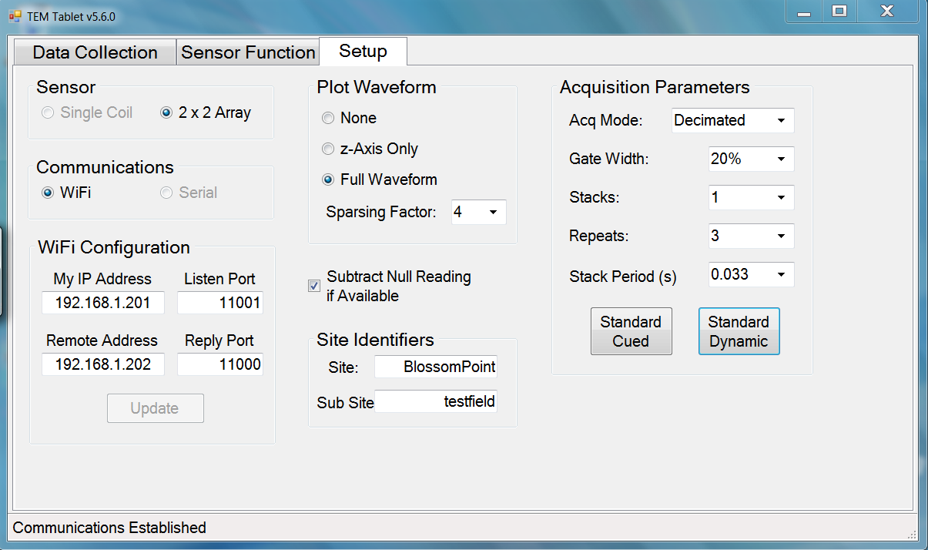

**Figure 6**. Standard Acquisition Parameters for Dynamic Surveys

#### Perform a Sensor Function Test

If there is a reference response for the combination of hardware and data acquisition parameters you are using, the [Sensor Function] tab will be available on the data acquisition computer. Access that tab to perform a sensor function test.

1. Position the sensor in a spot known to be clear of buried metal. Often the clear position in the Instrument Verification Strip (IVS) will be the best choice. Collect a background measurement from [Sensor Function] tab of the data acquisition software.
2. 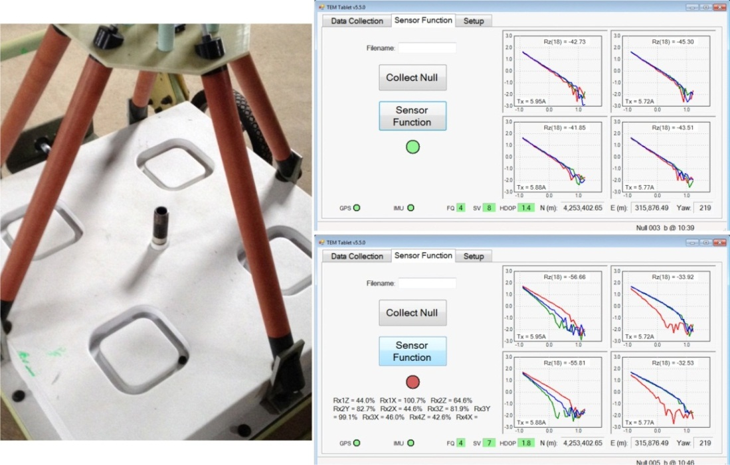Without moving the sensor, mount the ISO80 test item in the hole on the top of the sensor housing.

**Figure 7**, left panel

1. Collect sensor function data. If the results agree with the reference values, a green LED is displayed. If they do not agree, a red LED is displayed and a summary of the incorrect results is displayed.
2. Transfer the background and sensor function data files to the QC Geophysicist for archiving.

### Data Management

The following sections describe the data that is needed to perform this SOP and the resulting data.

#### Input Data Required

Input data consists of the assembly and operation instructions for the TEMTADS 2x2 contained in the unpacking instructions and user guide available from NRL.

#### Output Data

The sensor function test described in Section 3.6 will be saved in the project database. Also, the QC checklist in Attachment 1 of this SOP will be completed, signed, and filed with the assembly photograph(s) as proof of correct assembly.

### Quality Control

As this definable feature of work is accomplished only during the preparatory phase, only preparatory QC checks will be performed on this activity. QC consists of performing the inspections on the Preparatory Phase Quality Control Checklist that is included as Attachment 1 to this SOP. This checklist will be completed by the Field or Project Geophysicist and will be reviewed by the QC Geophysicist who will document the implementation of this SOP.

The measurement quality objective (MQO) (QAPP Worksheet #22) for this SOP is verification that the assembly instructions have been followed. The TEMTADS 2x2 will not be tested on the IVS (see SOP 2) until this has been documented as described below.

### Reporting

Achievement of the Sensor Assembly MQO will be documented by the Field or Project Geophysicist by completion of the Preparatory QC Checklist in Attachment 1 to this SOP and will be verified by the QC Geophysicist.

The delivered data package for the assembled and tested TEMTADS will be included in a section of the IVS Letter Report titled “TEMTADS Assembly and Operation Verification” and will include:

* a brief description of the assembly and test process along with the photograph(s) required by Section 3.4 of this SOP.
* the completed Preparatory QC Checklist signed by the Project or Field Geophysicists and checked by the QC Geophysicist verifying the assembly and orientation tests described above.
* the Sensor Function Test result.

## SOP 1T

## Attachment 1 Preparatory TEMTADS Assembly QC Checklist

This checklist is to be completed by the Project or Field Geophysicist and checked by the QC Geophysicist during assembly and initial testing of the TEMTADS.

|  |  |  |  |
| --- | --- | --- | --- |
| **QC Step** | **QC Process and Guidance Reference** | **Yes/No** | **Initial of Field or Project Geophysicist** |
| 1. Assembly | Is the TEMTADS assembled in accordance with the published instructions and in the sequence specified in this SOP? |  |  |
| 1. Testing: IMU orientation verification | Has the procedure and tests for verification of the IMU orientation been completed i/a/w this SOP? |  |  |
| 1. Photograph the installation | Was a photograph showing the placement and orientation of the GPS and IMU taken? |  |  |
| 1. TEMTADS sensor function test | Was the TEMTADS sensor function test performed i/a/w this SOP and were the results saved in the project database? |  |  |

Project or Field Geophysicist: ____________________________Date:___________

Data Processor: _______________________________________Date:___________

QC Geophysicist:______________________________________ Date:____________

# STANDARD OPERATING PROCEDURE 2

# Test Sensor and System at the Instrument Verification Strip (IVS)

### Purpose and Scope

The purpose of this Standard Operating procedure (SOP) is to identify the means and methods to be employed when verifying the operation of an advanced digital geophysical mapping system prior to and during site surveys. The Instrument Verification Strip (IVS) is constructed of a series of buried inert munitions or industry standard objects (ISO). During the IVS process the advanced electromagnetic induction sensor system measures the response of each item in the IVS and these responses are compared to a library of expected responses to ensure and document proper functioning of the system.

### Personnel, Equipment and Materials

This section describes the personnel, equipment and materials required to implement this SOP.

The following individuals will be involved in verifying correct operation of the MetalMapper system at the IVS:

* Project Geophysicist
* QC Geophysicist
* Field Team Leader
* Data Processor

UXO Personnel will be responsible for overall daily site access and safety aspects of the project, compiling subcontractor health and safety documents, conducting daily safety briefings and performing munitions and explosives of concern (MEC) avoidance, as needed, in the field. Information on the specific qualifications for various UXO personnel support roles can be found in the project Health and Safety Plan.

The qualifications of the personnel implementing this SOP are documented in the QAPP Worksheet #4, 7 & 8.

The following is a list of required equipment and materials:

* Geometrics MetalMapper or TEMTADS sensor coupled with a real-time kinematic Global Positioning System (RTK GPS) and Inertial Measurement Unit (IMU) for orientation measurements
* transport vehicle (skid steer, tractor, extended reach forklift) used to move the MetalMapper during data collection
* inert munitions and/or schedule 80 small ISOs (small ISO80) to construct the IVS
* measuring tape and non-metallic markers (pin flags, stakes, tent pegs, spray paint, etc.) to mark the positions of the test items and the beginning and end of the IVS
* hand tools including shovels, pick axes, breaker bars, etc. to construct the IVS

### Procedures and Guidelines

#### Advanced Digital Geophysical Mapping System

The advanced digital geophysical mapping (DGM) will be conducted using the Geometrics MetalMapper or TEMTADS both of which have been extensively validated in a series of demonstrations conducted by DoD’s Environmental Security Technology Certification Program (ESTCP). Both the MetalMapper and TEMTADS are advanced electromagnetic induction sensors designed for the detection and classification of buried metal objects. The MetalMapper sensor consists of three orthogonal 1-m x 1-m transmit coils for target illumination and seven three-axis receive cubes. Its sampling is electronically programmable and therefore flexible. It measures the decay curve up to 8-ms after the transmitters are turned off for each of the 21 receive channels. The TEMTADS sensor consists of four sensor elements arranged on 40‑centimeter (cm) centers in a 2x2 array. Each sensor element consists of a 35-cm square transmit coil for target illumination with an 8-cm three-axis receive cube centered in the transmit coil. The transmitters are energized in sequence and the decay curve is recorded up to 25 milliseconds after the transmitters are turned off for each of the 12 (4 cubes with 3 axes each) receive channels.

Positioning of the sensor will be accomplished using RTK GPS. With adequate satellite visibility, RTK GPS can provide antenna locations with accuracies on the order of 5 cm. The sensor orientation is measured using a six-degree-of-freedom inertial measurement unit (IMU). Combining the sensor orientation and location measurements in this manner typically results in derived target locations within 15 cm of the ground truth.

#### Instrument Verification Strip Construction

Verification of the advanced EMI system is accomplished using an IVS. Multiple IVS locations may be constructed during the project for convenience (for example, to avoid long travel times to reach the IVS on large sites). The constructions details and verification procedures described in this document apply to each IVS location.

##### Location and Configuration of the IVS

IVS locations will be determined during initial site reconnaissance by the DGM field team. The IVS should be established in an area that is easily accessible, not prone to flooding and other weather-related phenomena, and is determined to be relatively free of subsurface metal objects. The IVS is constructed as one or more survey transects.

##### IVS Objects

Seed objects for the IVS can be either actual inert munitions or ISOs. Using inert munitions that match those expected to be found on the site may be preferable as this demonstrates to stakeholders that the system is able to accurately classify the exact MEC of concern. However, using ISOs is the technical equivalent and extraordinary measures to obtain inert munitions are not warranted.

ISOs, if used, should approximate the size of the MEC expected to be found on the site and more than one type of ISO should be used if MEC of various sizes are expected. Small, medium, or large ISOs, singly or in combination, can be selected. Table 1 shows the specifications for the three possible ISO and Figure 1 is a photograph of the three ISO.

**Table 1**. Industry standard objects characterized for use as munitions surrogates

|  |  |  |  |  |  |
| --- | --- | --- | --- | --- | --- |
| **Item** | **Nominal**  **Pipe Size** | **Outside**  **Diameter** | **Length** | **Part**  **Number1** | **Schedule** |
| Small ISO80 | 1" | 1.315"  (33 mm) | 4"  (102 mm) | 4550K226 | 80 |
| Medium ISO40 | 2" | 2.375"  (60 mm) | 8"  (204 mm) | 44615K529 | 40 |
| Large ISO40 | 4" | 4.500"  (115 mm) | 12"  (306 mm) | 44615K137 | 40 |

1 Part number from the McMaster-Carr catalog (<http://www.mcmaster.com/>).



**Figure 1**. Small, medium and large ISO

##### IVS Procedures

Figure 2 illustrates the overall IVS process and the procedures to be followed during the siting, emplacement, and use of the IVS.

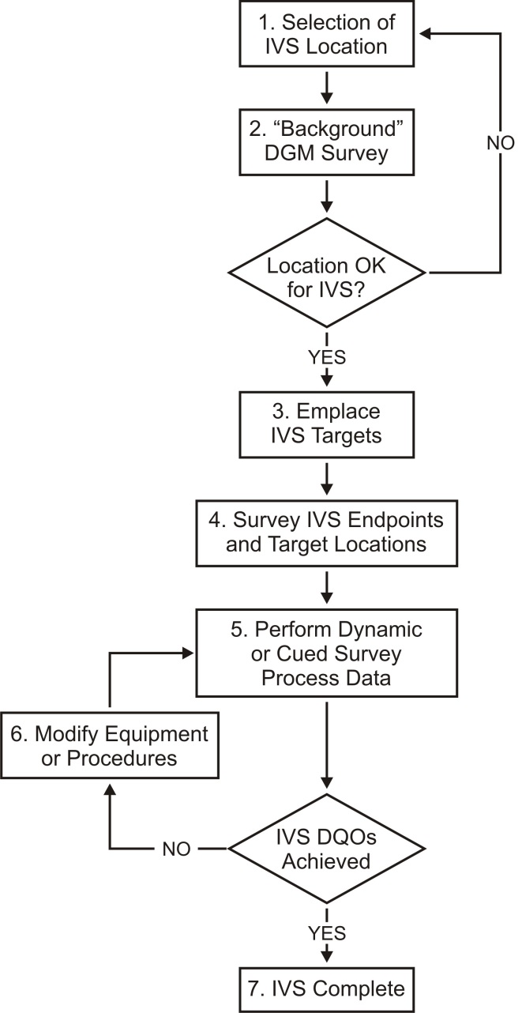

**Figure 2**: IVS siting, emplacement, and use

1. An IVS location will be selected with preference for the following (although none of the conditions are vital for IVS success):

* terrain, geology, and vegetation similar to that of a majority of the DGM survey area
* geophysical noise conditions similar to those expected across the survey area
* large enough site to accommodate all necessary IVS tests and equipment and for adequate spacing (at least 3-m separation and preferably greater) of the ISO items to avoid ambiguities in data evaluation
* readily accessible to project personnel
* close proximity to the actual survey site (if not within the site)

1. A background DGM survey will be performed with the MetalMapper or TEMTADS using RTK GPS. The purpose of this step is to document the appropriateness of the location (e.g. few existing anomalies), and will verify that IVS targets are not seeded near existing anomalies. The data from this IVS pre-survey will be processed and provided to the Project, Field and QC Geophysicists for evaluation.
2. Once the IVS area is deemed suitable for use, (i.e. free of significant subsurface anomalies or containing anomalies that are clearly identified so that they can be avoided during seeding), targets will be buried horizontally at depths below ground surface of approximately 3 and 7 times their diameter. These depths are intended to provide adequate signal to noise ratio for detecting the targets. The generalized diagram of the seeded IVS transect is presented as Figure 3. In this example, only one target is shown. This is the minimum requirement for an IVS. Local custom, stakeholder comfort, or other similar reasons may lead to larger number of items in the IVS. Rarely will more than three or four items be required.

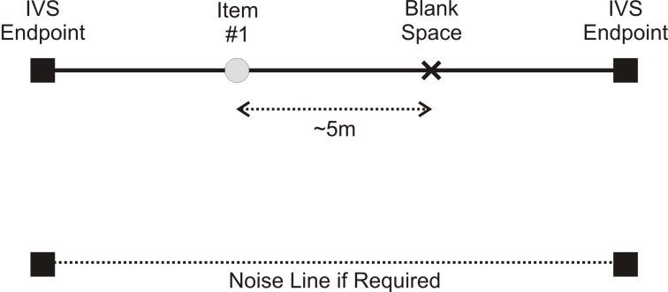

**Figure 3**. Example layout of the IVS

Measurements of the item depths will be to the center of mass of each item. On‐site personnel will bury the IVS targets using shovels to dig the holes to the appropriate depths for burial of the seed items in coordination with the QC Geophysicist. UXO personnel will implement MEC avoidance procedures using analog instruments during installation. The background survey data and anomaly avoidance techniques will be reviewed so that transect start and end stakes and the seed items are not placed on top of or near existing anomalies. IVS construction personnel will bury the ISOs and record the following information:

* transect endpoints
* target type
* target emplacement location
* target emplacement depth
* target emplacement orientation (azimuth and inclination)

1. The holes will then be filled with soil and a wooden survey stake or other suitable non‐metallic marker will be placed at each buried item location as well as the start and end location of the IVS. The marker will not extend more than 3 inches above the ground surface to prevent interference with the MetalMapper or TEMTADS when passing over them.
2. Prior to collecting production data and each morning before beginning field operations, the MetalMapper or TEMTADS will be used to collect IVS data as follows:

**Cued:**

Cued data will be collected over each of the positions in the IVS including the background location (blank space). The raw .tem files and converted .csv files for each measurement will be passed to the data processor who will perform the following steps:

* 1. Examine the cued data from each IVS location and verify that all measured decays are valid.
  2. Verify the data collected over the blank space is suitable for use as a background reading.
     1. If this is the first measurement on this IVS, verify that all decay amplitudes are below the threshold set in UX-Analyze.
     2. Otherwise, verify that all decay amplitudes are within 10% of the mean of those previously measured at this location.
  3. Use the measurement over the blank space to background correct the other data sets and invert the corrected data.
  4. Verify that the resulting polarizabilities match the expected library values with a match statistic of 0.9 or greater.

**Dynamic:**

Dynamic data will be collected along the IVS and noise lines. The raw .tem files and converted .csv files for both measurements will be passed to the data processor who will perform the following steps:

* 1. Calculate the RMS variation along the noise line.
     1. If this is the first noise measurement on this IVS, verify that the site noise is compatible with project planning assumptions and will allow project detection goals to be met.
     2. Otherwise, verify that the RMS noise is within 10% of the mean of those previously measured at this location.
  2. Background correct the survey data over the IVS using the patch over the blank spot.
  3. Run the target location algorithm and verify that the resulting positions match the emplaced positions of each IVS item to 25 cm.

1. If the initial measurement quality objectives (MQOs) have not been met, the QC Geophysicist will initiate a root cause analysis to determine the source of the discrepancies. If modifications to the instrument or procedures can be made so that the MQOs can be met, these modifications will be made. If the MQOs cannot be met, for example if the initial background decay amplitudes are too large, the Project and QC Geophysicist will meet with the project team to discuss potential resolutions.
2. Once the initial (or modified) MQOs have been met, the IVS survey will be complete and the system and operators verified for field data collection.

### Data Management

#### Input Data Required

Input data required for this SOP are the locations and identities of the IVS items and the library polarizabilities for each.

#### Output Data

The test measurements over the IVS items described in Section 3.2.3, Step 5 will be saved in the project database along with the inversion results and library match metric for each of the measurements. Also, the QC checklists in Attachments 1 through 3 of this SOP will be completed, signed, and filed as proof of performance.

### Quality Control

#### IVS Quality Control

This procedure is performed throughout the project and, therefore, has Preparatory, Initial and Follow-on QC checks. Performance of the required QC checks will be documented by the Field or Project Geophysicist on the Preparatory, Initial and Follow-on QC checklists in Attachments 1 through 3 to this SOP. The QC Geophysicist will verify and document successful completion of the following procedures in the Geophysics Daily QC Report:

* The Preparatory QC Checklist covers the construction of the IVS and preparation of the MetalMapper or TEMMTADS prior to the first IVS tests. This checklist is completed once per project.
* The Initial QC Checklist covers the initial IVS tests to demonstrate proper functioning of the MetalMapper or TEMTADS system prior to performing production data acquisition.
* The Follow-on QC Checklist documents the IVS tests that are performed at least twice per day throughout the project, each morning prior to starting production data collection and at the conclusion of data collection.
* The QC tests in the following attachments will be performed as part of IVS procedure. In addition, instrument‐specific start-up and function checks for the MetalMapper or TEMTADS will also be performed at start-up prior to all data collections including IVS data collection.
* Achievement of the IVS MQOs will be verified by the Field and QC Geophysicist on their QC checklists.
* During review of the Initial and Follow-on data packages, the Data Processor will overlay the polarizabilities of each IVS target from all measurements to observe the time variation of the inverted results. Should an issue be detected (such as a data trend indicating a MQO limit is being approached) or a MQO is not met, a comprehensive root‐cause analysis will be performed and a corrective action determined.

#### Measurement Quality Objective (MQOs)

The MQOs for the IVS are presented in Worksheet #22 of the QAPP. The MetalMapper will not be used for field data collection until it is able to meet these MQOs or until the project team agrees on modifications to these MQOs.

### Reporting

This procedure will be documented through the completion of the Preparatory, Initial and Follow-on QC Checklists in Attachments 1 through 3. The IVS construction and implementation will be documented in an IVS Letter Report and a copy of the completed Preparatory Checklist from SOP 1 and the Preparatory and Initial Checklists from this SOP (including the MetalMapper or TEMTADS Start-up Checklist from Attachment 1 of SOP 1) will be included as attachments to that report. A Follow-on QC Checklist will be completed by the Field or Project Geophysicist each time IVS data is collected during the production survey and a copy of these completed checklists will be included with the Classification Project Report at the end of the project.

## SOP 2

## Attachment 1 Preparatory IVS Construction QC Checklist

This checklist is to be completed by the Field or Project Geophysicist during construction of the IVS. Construction of the IVS and completion of this checklist will be observed by the QC Geophysicist and verified in the Daily Geophysics QC Report.

|  |  |  |  |
| --- | --- | --- | --- |
| **QC Step** | **QC Process** | **Yes/No** | **Initial of Field or Project Geophysicist** |
| 1. Qualifications | Have the qualifications of the Project and Field Geophysicists and the Data Processor been verified? |  |  |
| 1. IVS Construction | Has an appropriate location for the IVS been selected i/a/w this SOP?? |  |  |
| 1. IVS Construction | Have appropriate IVS seed targets been selected and procured i/a/w this SOP? |  |  |
| 1. IVS Construction | Has the background geophysical survey been performed i/a/w this SOP? |  |  |
| 1. IVS Construction | Were the target seeds buried appropriately, backfilled and marked i/a/w this SOP? |  |  |
| 1. IVS Construction | Is the required data on the IVS construction recorded for inclusion in the IVS Letter Report i/a/w this SOP? |  |  |

Field Geophysicist: _____________________________Date:___________

Project Geophysicist: ___________________________Date:___________

Data Processor: _______________________________Date:___________

## SOP 2

## Attachment 2 Initial IVS QC Checklist

This checklist is to be completed by the Field or Project Geophysicist during the initial demonstration of the MetalMapper or TEMTADS performance on the IVS and observed and verified by the QC Geophysicist in the Geophysics Daily QC Report.

|  |  |  |  |
| --- | --- | --- | --- |
| **QC Step** | **QC Process and Guidance Reference** | **Yes/No** | **Initial of Field or Project Geophysicist** |
| 1. Preparation | Has the SOP 1 Preparatory Checklist been successfully completed? |  |  |
| 1. Preparation | Have the start-up procedures and pre-operation checklist from SOP 1 (Attachment 1) been successfully completed? |  |  |
| 1. Data collection | Is the IVS data collected i/a/w this SOP? |  |  |
| 1. Data processing | Did the Data Processor process the IVS i/a/w this SOP? |  |  |
| 1. Data analysis | Is the data collected on the blank space suitable for use as background i/a/w this SOP? |  |  |
| 1. Data analysis | Are all decay amplitudes below the threshold set in UX-Analyze i/a/w this SOP? |  |  |
| 1. Data analysis | Was the background data from the blank space used to correct the target data sets and to invert the data i/a/w this SOP? |  |  |
| 1. Data analysis | Do the resulting polarizibilities match the expected library values with a match statistic of 0.9 or greater i/a/w this SOP? |  |  |
| 1. MQO Documentation | Have the appropriate MQOs from Worksheet #22 been achieved? |  |  |

Field Geophysicist: _____________________________Date:___________

Project Geophysicist: ___________________________Date:___________

Data Processor: _______________________________Date:___________

## SOP 2

## Attachment 3 Follow-on IVS QC Checklist

This checklist is to be completed by the Field or Project Geophysicist every time IVS data is collected (at least twice per day at the beginning and end of each day’s data collection). Performance of the IVS and completion of this checklist will also be observed by the QC Geophysicist and documented in the Geophysics Daily QC Report.

|  |  |  |  |
| --- | --- | --- | --- |
| **QC Step** | **QC Process** | **Yes/No** | **Initial of Field or Project Geophysicist** |
| 1. Qualifications | Are the same geophysical personnel being used as in SOP 1? If not, have the qualifications of the new personnel been verified? |  |  |
| 1. Preparation | Have the start-up procedures and pre-operation checklist from SOP 1 (Attachment 1) been successfully completed? |  |  |
| 1. Data collection | Is the IVS data collected i/a/w this SOP? |  |  |
| 1. Data processing | Did the Data Processor process the IVS data i/a/w this SOP? |  |  |
| 1. Data analysis | Is the data collected on the blank space suitable for use as background i/a/w this SOP? |  |  |
| 1. Data analysis | Are all decay amplitudes within 10% of the mean of those previously measured at each location i/a/w this SOP? |  |  |
| 1. Data analysis | Was the background data from the blank space used to correct the target data sets and to invert the data i/a/w this SOP? |  |  |
| 1. Data analysis | Do the resulting polarizibilities match the expected library values with a match statistic of 0.9 or greater i/a/w this SOP? |  |  |
| 1. MQO Documentation | Have the appropriate MQOs from Worksheet #22 been achieved? |  |  |

Field Geophysicist: ________________________________________

Project Geophysicist: ______________________________________

Data Processor: __________________________________________

# STANDARD OPERATING PROCEDURE 3

# Production Area Seeding

### Purpose and Scope

The purpose of this Standard Operating procedure (SOP) is to identify the methods to be employed when emplacing QC or validation seeds in the production area.

### Personnel, Equipment and Materials

This section describes the personnel, equipment and materials required to implement this SOP.

The following individuals will be involved in production area seeding:

* Project Geophysicist
* QC Geophysicist

UXO Personnel will be responsible for overall daily site access and safety aspects of the project, compiling subcontractor health and safety documents, conducting daily safety briefings and performing munitions and explosives of concern (MEC) avoidance, as needed, in the field. Information on the specific qualifications for various UXO personnel support roles can be found in the project Health and Safety Plan.

The qualifications of the personnel implementing this SOP are documented in the QAPP Worksheet #4, 7 & 8.

The following is a list of required equipment and materials:

* inert munitions and schedule 80 small ISOs (small ISO80) to emplace the seeds
* hand-held geophysical sensor (typically a Schonstedt magnetic locator or White’s metal detector)
* hand tools including shovels, pick axes, breaker bars, etc. to emplace the seeds
* excavators if required by the production seed plan
* RTK GPS unit to record the location of seed items
* meter stick and straight edge to measure the depth of the seeded items
* level or inclinometer and compass to measure the inclination and orientation of the seeded items

### Procedures and Guidelines

The production area seed plan provides a list of seed identities, locations, depths, and orientations. When emplacing the seeds, the emplacement team should employ anomaly avoidance techniques as described in Section 3.1 and use the emplacement procedure described in Section 3.2.

#### Anomaly Avoidance

It is likely that the demonstration area will contain some metallic items or electromagnetically active geology. These will produce anomalies in data collected with a magnetometer or electromagnetic induction instrument. The emplacement team should avoid emplacing seeds in the immediate vicinity of any strong anomalies. Figure 1 describes the process that should be used to avoid strong anomalies when emplacing a seed. First, the emplacement team should acquire the seed’s intended location. Then, the team should use a hand-held instrument to survey within the immediate vicinity (30 to 40 cm radius) of the intended location. If there are no strong anomalies in the immediate vicinity, then the team should emplace the seed at the intended location. If, however, the intended location is in the immediate vicinity of any strong anomaly, then the team should select a new location for the seed, as close as safety allows. The new location should ***not*** be within the immediate vicinity of any strong anomaly and should ***not*** be within 60 cm of another seed.

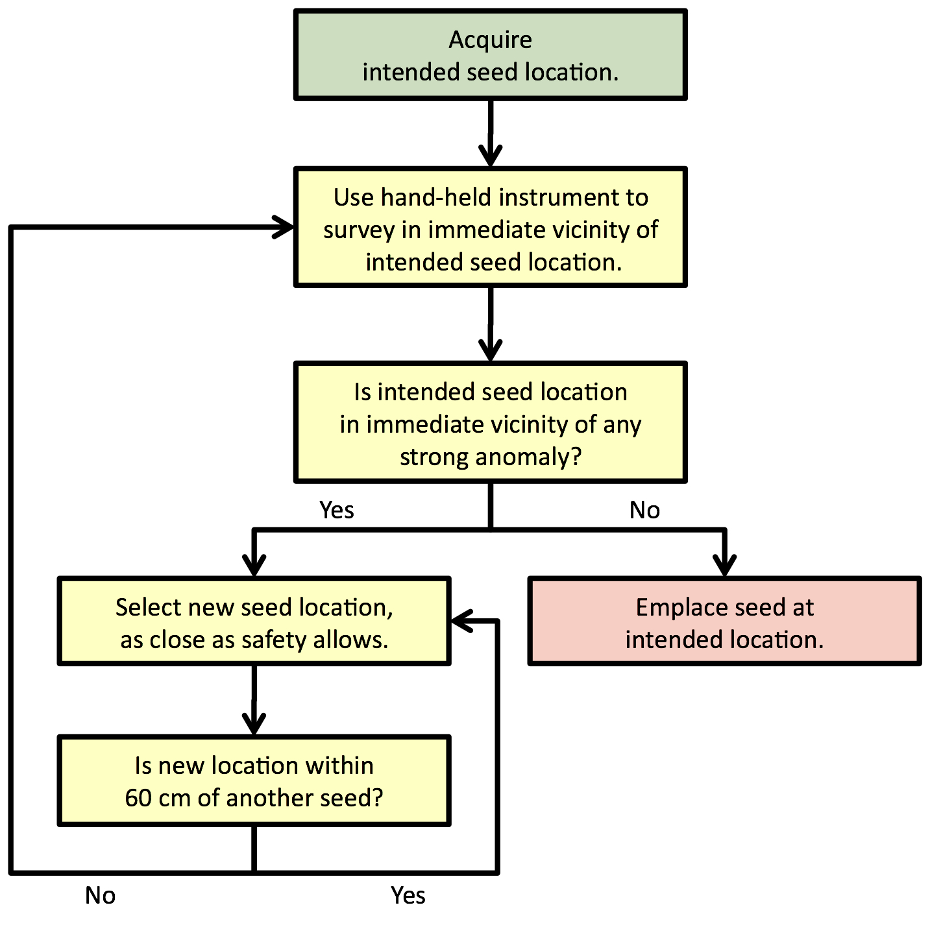

**Figure 1**: Anomaly avoidance during seed emplacement.

#### Seed Emplacement

The study will attempt to reconstruct the physical parameters of the buried targets, such as location, depth, inclination, azimuth, and size. Therefore it is critical for the success of the study that the ***actual locations*** of the buried seeds are surveyed as accurately and precisely as possible. To that end, the emplacement team should dig in a fashion to minimize seed migration (e.g., settling) after burial.

The production area seed plan specifies the seeds’ intended burial parameters. The intended locations are given to 1 cm precision, with the intended depths to 2 cm precision and the intended inclinations and azimuths to 15 degree precision. All locations should be acquired as accurately and precisely as possible before digging begins, as this ensures anomaly avoidance. Locations should be surveyed relative to a cm-level control point.

This plan is merely a ***guide*** for seed emplacement. The emplacement team may allow small deviations from the intended burial parameters listed in the attached spreadsheet. This variation is desired and the exact parameters should be recorded by survey. For example, the inclinations are specified to within 45 degrees of horizontal or vertical down. Therefore, the emplacement team should avoid burying the seeds exactly horizontal or exactly vertical down. In addition, the emplacement team should adjust the inclination angles of the seeds to ensure 5 cm of overburden.

After emplacing a seed in the ground, but before covering it with dirt, the following information should be carefully recorded:

* the x, y, and z coordinates for the center of the seed, with coordinates reported in UTM (NAD 83) meters
* the depth of the seed, measured as the vertical distance from the bottom of a straight edge placed across the opening of the hole down to the center of the seed
* a photograph of the seed, showing its serial number. A ruler or similar scale should also be included in the photograph.

For each seed, the emplacement team should also:

* ensure the seed is marked with blue paint (inert).
* replace any metallic items that were found in the hole (i.e., emplace the metallic items in the hole along with the seed).
* replace dirt in the hole as completely as possible.
* level the burial location.
* replace the grass plug over the burial location (if possible).

### Data Management

The following sections describe the data that is needed to perform this SOP and the resulting data.

#### Input Data Required

The production area seed plan which contains a table of seed items, initial locations, and depths and orientations is required for this SOP.

#### Output Data

The output data from this SOP is the final production area seed report. This report consists of a brief narrative describing the seed emplacement and a discussion of significant deviations from the seed plan. The bulk of the report consists of a seed location table that includes the “as emplaced” identity, location, depth, and orientation of each of the emplaced seeds accompanied by a photograph of the item in the ground before being covered.

### Quality Control

The measurement quality objective (MQO) (QAPP Worksheet #22) for this SOP is verification that all seeds have been emplaced with the specified precision. No field work will be performed until this has been documented as described below.

### Reporting

This procedure will be documented through the completion of the Preparatory QC Checklist in Attachment 1. Production area seeding will be documented in Production Area Seed Report as described in Section 4.2.

## SOP 3

## Attachment 1 Preparatory Production Area Seeding QC Checklist

This checklist is to be completed by the QC or Project Geophysicist following completion of production area seeding. Emplacement of the production area QC seeds will be observed by the QC Geophysicist and verified in the Daily Geophysics QC Report.

|  |  |  |  |
| --- | --- | --- | --- |
| **QC Step** | **QC Process and Guidance Reference** | **Yes/No** | **Initial of Field or Project Geophysicist** |
| 1. Qualifications | Have the qualifications of the Project and QC Geophysicists listed in QAPP Worksheet #4, 7 & 8 been verified? |  |  |
| 1. Preparation | Have appropriate production area seed targets been selected and procured? |  |  |
| 1. Seed Emplacement | Were the target seeds buried appropriately, measured, photographed, and backfilled? |  |  |
| 1. Completion of Task | Has the production area seed report been prepared i/a/w this SOP? |  |  |

QC Geophysicist: _____________________________Date:___________

Project Geophysicist: ___________________________Date:___________

# STANDARD OPERATING PROCEDURE 4M

# Perform Dynamic Surveys with MetalMapper

### Purpose and Scope

The purpose of this Standard Operating procedure (SOP) is to identify the means and methods to be employed when performing dynamic surveys using a MetalMapper advanced electromagnetic induction (EMI) sensor for target detection.

Dynamic MetalMapper data collection involves navigating the sensor along transects at a transect spacing designed to meet the project objectives with respect to detection performance of suspected targets of interest (TOI) in the subsurface. The detection objectives and resultant transect spacing are identified in the project-specific QAPP.

The observed signal measured by the MetalMapper is composed of 1) the EMI response of potential buried targets, 2) the self-signature of the sensor system, and 3) any response from the ambient environment in which the target is buried. To isolate responses associated with buried discrete metal objects, a background model comprised of the latter two contributing signals must be derived and removed from the raw data. The resulting ‘leveled’ signal data, (raw data – background model) are used as inputs into a detection algorithm where anomalous responses due to potential targets of interest are mapped and selected for further investigation. Details of the data processing and analysis of dynamic data are covered in SOP 5.

### Personnel, Equipment and Materials

This section describes the personnel, equipment, and materials required to implement this SOP.

The following individuals will be involved in the collection of dynamic survey data:

* Project Geophysicist
* QC Geophysicist
* Field Team Leader
* Data Processor

The qualifications of the personnel implementing this SOP are documented in the QAPP Worksheet #4, 7 & 8.

The following is a list of required equipment and materials:

* MetalMapper sensor coupled with a real-time kinematic Global Positioning System (RTK GPS) and Inertial Measurement Unit (IMU) for orientation measurements
* transport vehicle (skid steer, tractor, extended reach forklift) used to move the MetalMapper during data collection
* field survey grade tape measure

### Procedures and Guidelines

#### Survey Grid Preparation

Grid preparation involves demarking the site boundaries and survey transects required to achieve the coverage specified in the project-specific QAPP. The site will be subdivided into grids with sizes depending upon the site conditions such that the sensor can be precisely navigated along the desired transect. Survey transect locations will be generated using the “survey layout” function in UX-Detect. The generated lines will be exported in a .XYZ file that can be imported into EM3D, the MetalMapper’s data collection software. Data collection transect locations will also be developed for the IVS.

#### Function Test Measurements

Function test measurements (described in SOP 1) will be performed prior to each sortie to confirm that all transmit and receive components of the MetalMapper sensor are operational.

#### Daily IVS Survey

Prior to the start and at the end of each day of data collection, measurements of the set of IVS targets will be performed (described in SOP 2).

#### Dynamic Data Collection

Dynamic survey for DGM involves collecting data along transects across the survey area. In combination with SOPs for sensor assembly (SOP 1) and testing at the IVS (SOP 2), in-motion data is collected along each transect at a spacing appropriate to the site and project needs, as defined in the project-specific QAPP. Data collection is controlled by the user with the EM-3D software, which allows the user to assign a numerical ID to each transect line and start/stop data collection at the beginning/end of each transect. When an obstacle is encountered along a transect, the obstacle can be avoided by either altering the path of the transect or stopping data collection when the obstacle is encountered and resuming a new ID transect on the other side of the obstacle. Data gaps that are the result of obstacles should be recorded by the field geophysicist and submitted to the data processor. Data gaps that are the result of line spacing over the defined acceptable spacing will be determined by the data processor and provided to the field geophysicist for recollection. Data acquisition will be performed using the following steps:

1. **Start-up and test the MetalMapper**. The geophysical and navigation systems are started and a function test is performed prior to every data collection sortie. In addition the data acquisition software is monitored to ensure that all data streams (EMI, global positioning system, [GPS], and inertial measurement unit [IMU]) are valid and being recorded.
2. **Navigate and collect data along transects**. Navigation along transects is by following the survey lines plotted on the MetalMapper screen. Positioning in the data is captured through the use of the RTK GPS system and the IMU.
3. **Verify the integrity and quality of the collected data**. During data acquisition, the integrity and quality of the data will be verified by the operator by inspection of the MetalMapper data collection screen to ensure that:

* the data collection starts and stops in coordination with the beginning and end of each transect.
* each transect is assigned a unique numerical identifier (ID), in sequential order.
* the amplitude responses measured by each receiver coil appear reasonable (i.e., not ‘flat-lined’).

1. **Verify complete coverage of survey area**. 100% coverage surveys will require appropriate line spacing (presented in QAPP Worksheet #12). Data gaps resulting from obstacles or inaccessible terrain will be marked and verified by the field geophysicist. Data gaps exceeding the MQOs identified in QAPP Worksheet #22 will be reacquired using RTK GPS and recollected.

### Data Management

#### Data inputs

The data inputs required are:

* A list of coordinates identifying the site boundaries
* A list of instrument verification strip (IVS) transect start and end points

#### Data Outputs

The data outputs are:

* dynamic MetalMapper transect data over the IVS line and survey area
* function test measurement data
* raw field notes (pdf images of hand written notes)
* digital field notes (an Excel, MS Access, or other digitally recorded table presenting data filenames as delivered and rectified field notes [i.e. differences between delivered digital filenames and field notes are resolved])

### Quality Control

Practical considerations limit the real-time quality control (QC) of the dynamic data acquisition activities to qualitative assessments. Quantitative QC and assessment of the collected data will be performed as part of SOP 5M dealing with the processing of dynamic MetalMapper detection data. The Quality Control checklist presented as Attachment 1 to this SOP will be filled out and delivered as part of the reporting requirement for this SOP.

The measurement quality objectives (MQOs) for dynamic data acquisition are presented in Worksheet #22 of the project-specific QAPP. Performance relative to the MQOs will be assessed during the processing of the collected data (SOP 5M). Dynamic MetalMapper data will not be used to detect targets until these MQOs are met or until the project team agrees on modifications to these MQOs.

### Reporting

Reporting of the activities associated with this SOP will consist of the digital copies of the field notes and completion of the checklist provided in Attachment 1.

## SOP 4M

## Attachment 1 Dynamic MetalMapper Data Collection QC Checklist

This checklist is to be completed by the Field or Project Geophysicist each day dynamic TEMTADS data are collected.

|  |  |  |  |
| --- | --- | --- | --- |
| **QC Step** | **QC Process** | **Yes/No** | **Initial of Field or Project Geophysicist** |
| 1. Preparation | Has the SOP 1 checklist detailing the proper assembly and operation of the TEMTADS sensor for Dynamic detection surveys been completed (or recompleted as required due to equipment modifications)? |  |  |
| 1. Function Tests | Were function tests performed a minimum of twice per day and did all function tests pass using the real-time assessment? |  |  |
| 1. IVS Tests | Were transect surveys conducted over the IVS items at the start and end of the day with exceptions noted in the field notes? |  |  |
| 1. Sensor Navigation | For the dynamic data collected, were valid data collected along the intended transects with any exceptions or gaps in coverage noted in the field notes? |  |  |
| 1. Data Measurements | For the dynamic data collection (including IVS measurements), was the system monitored with regard to transmit current, receiver decay curves and any exceptions noted in the field notes? |  |  |
| 1. Reporting | Were the field notes converted to digital format and filenames resolved with regard to the field notes? |  |  |

Field Geophysicist: _____________________________Date:___________

Project Geophysicist: ___________________________Date:___________

Data Processor: _______________________________Date:____________

# STANDARD OPERATING PROCEDURE 4T

# Perform Dynamic Surveys with TEMTADS 2x2

### Purpose and Scope

The purpose of this Standard Operating procedure (SOP) is to identify the means and methods to be employed when performing dynamic surveys using a TEMTADS 2x2 (TEMTADS) advanced electromagnetic induction (EMI) sensor for target detection.

Dynamic TEMTADS data collection involves navigating the sensor along transects at a transect spacing designed to meet the project objectives with respect to detection performance of suspected targets of interest (TOI) in the subsurface. The detection objectives and resultant transect spacing are identified in the project-specific QAPP.

The observed signal measured by the TEMTADS is composed of 1) the EMI response of potential buried targets, 2) the self-signature of the sensor system, and 3) any response from the ambient environment in which the target is buried. To isolate responses associated with buried discrete metal objects, a background model comprised of the latter two contributing signals must be derived and removed from the raw data. The resulting ‘leveled’ signal data, (raw data – background model) are used as inputs into a detection algorithm where anomalous responses due to potential targets of interest are mapped and selected for further investigation. Details of the data processing and analysis of dynamic data are covered in SOP 5T.

### Personnel, Equipment and Materials

This section describes the personnel, equipment, and materials required to implement this SOP.

The following individuals will be involved in the collection of dynamic survey data:

* Project Geophysicist
* QC Geophysicist
* Field Team Leader
* Data Processor

The qualifications of the personnel implementing this SOP are documented in the QAPP Worksheet #4, 7 & 8.

Required equipment includes:

* TEMTADS sensor coupled with a real-time kinematic Global Positioning System (RTK GPS) and orientation sensor
* Archos Tablet
* field survey grade tape measure

Required material includes

* traffic cones or equivalent for lane marking, or
* marking paint

### Procedures and Guidelines

#### Survey Grid Preparation

Grid preparation involves demarking the site boundaries and survey transects required to achieve the coverage specified in the project-specific QAPP. The site will be subdivided into grids with sizes depending upon the site conditions such that the sensor can be precisely navigated along the desired transect. The transect ends will be measured and pre-marked. Traffic cones will be used to identify the start and end of each transect as it is transgressed.

#### Function Test Measurements

Function test measurements (described in SOP 1) will be performed prior to each sortie to confirm that all transmit and receive components of the TEMTADS sensor are operational.

#### Daily IVS Survey

Prior to the start and at the end of each day of data collection, measurements of the set of IVS targets will be performed (described in SOP 2).

#### Dynamic Data Collection

Dynamic survey for DGM involves collecting data along transects across the survey area. In combination with SOPs for sensor assembly (SOP 1) and testing at the IVS (SOP 2), in-motion data is collected along each transect at a spacing appropriate to the site and project needs, as defined in the project-specific QAPP. Data collection is controlled by the user with the EM-3D software, which allows the user to assign a numerical ID to each transect line and start/stop data collection at the beginning/end of each transect. When an obstacle is encountered along a transect, the obstacle can be avoided by either altering the path of the transect or stopping data collection when the obstacle is encountered and resuming a new ID transect on the other side of the obstacle. Data gaps that are the result of obstacles should be recorded by the field geophysicist and submitted to the data processor. Data gaps that are the result of line spacing over the defined acceptable spacing will be determined by the data processor and provided to the field geophysicist for recollection. Data acquisition will be performed using the following steps:

1. **Start-up and test the TEMTADS**. The geophysical and navigation systems are started and a function test is performed prior to every data collection sortie. In addition the data acquisition software is monitored to ensure that all data streams (EMI, global positioning system, [GPS], and inertial measurement unit [IMU]) are valid and being recorded.
2. **Navigate and collect data along transects**. Navigation along transects is performed visually with the assistance of markers, which are determined at the discretion of the field geophysicist. They may include, but are not limited to, ropes, tapes, spray paint, or flags. This can be accomplished by marking the track of the inside wheels as the sensor moves along a transect. Positioning in the data is captured through the use of the RTK GPS system and the IMU.
3. **Verify the integrity and quality of the collected data**. During data acquisition, the integrity and quality of the data will be verified by the operator by inspection of the TEMTADS data collection screen to ensure that:

* the data collection starts and stops in coordination with the beginning and end of each transect.
* each transect is assigned a unique numerical identifier (ID), in sequential order.
* the amplitude responses measured by each receiver coil appear reasonable (i.e., not ‘flat-lined’).

1. **Verify complete coverage of survey area**. 100% coverage surveys will require appropriate line spacing (presented in QAPP Worksheet #12). Data gaps resulting from obstacles or inaccessible terrain will be marked and verified by the field geophysicist. Data gaps exceeding the MQOs identified QAPP Worksheet #22 will be reacquired using RTK GPS and recollected.

### Data Management

#### Data Inputs

The data inputs required are:

* a list of coordinates identifying the site boundaries.
* a list of instrument verification strip (IVS) transect start and end points.

#### Data Outputs

The data outputs are:

* dynamic TEMTADS transect data over the IVS line and survey area.
* function test measurement data.
* raw field notes (pdf images of hand written notes).
* digital field notes (an excel or other digitally recorded table presenting data filenames as delivered and rectified field notes [i.e. differences between delivered digital filenames and field notes are resolved]).

### Quality Control

Practical considerations limit the real-time quality control (QC) of the dynamic data acquisition activities to qualitative assessments. Quantitative QC and assessment of the collected data will be performed as part of SOP 5T dealing with the processing of dynamic TEMTADS detection data. The Quality Control checklist presented as Attachment 1 to this SOP will be filled out and delivered as part of the reporting requirement for this SOP.

The measurement quality objectives (MQOs) for dynamic data acquisition are presented in Worksheet #22 of the project-specific QAPP. Performance relative to the MQOs will be assessed during the processing of the collected data (SOP 5T). Dynamic TEMTADS data will not be used to detect targets until these MQOs are met or until the project team agrees on modifications to these MQOs.

### Reporting

Reporting of the activities associated with this SOP will consist of the digital copies of the field notes and completion of the checklist provided in Attachment 1.

## SOP 4T

## Attachment 1 Dynamic TEMTADS Data Collection QC Checklist

This checklist is to be completed by the Field or Project Geophysicist each day dynamic TEMTADS data are collected.

|  |  |  |  |
| --- | --- | --- | --- |
| **QC Step** | **QC Process** | **Yes/No** | **Initial of Field or Project Geophysicist** |
| 1. Preparation | Has the SOP 1 checklist detailing the proper assembly and operation of the TEMTADS sensor for Dynamic detection surveys been completed (or recompleted as required due to equipment modifications)? |  |  |
| 1. Function Tests | Were function tests performed a minimum of twice per day and did all function tests pass using the real-time assessment? |  |  |
| 1. IVS Tests | Were transect surveys conducted over the IVS items at the start and end of the day with exceptions noted in the field notes? |  |  |
| 1. Sensor Navigation | For the dynamic data collected, were valid data collected along the intended transects with any exceptions or gaps in coverage noted in the field notes? |  |  |
| 1. Data Measurements | For the dynamic data collection (including IVS measurements), was the system monitored with regard to transmit current, receiver decay curves and any exceptions noted in the field notes? |  |  |
| 1. Reporting | Were the field notes converted to digital format and filenames resolved with regard to the field notes? |  |  |

Field Geophysicist: _____________________________Date:___________

Project Geophysicist: ___________________________Date:___________

Data Processor: _______________________________Date:__________

# STANDARD OPERATING PROCEDURE 5M

# Process Dynamic Survey Data - MetalMapper

### Purpose and Scope

The purpose of this Standard Operating procedure (SOP) is to identify the means and methods to be employed when processing dynamic survey data collected using a MetalMapper advanced electromagnetic induction (EMI) sensor for target detection.

Dynamic MetalMapper data collection involves navigating the sensor along transects at a transect spacing designed to meet the project objectives with respect to detection performance of suspected targets of interest (TOI) in the subsurface. The detection objectives and resultant transect spacing are identified in the Geophysical Classification for Munitions Response (GCMR) Quality Assurance Project Plan (QAPP). Processing the dynamic data involves processing and assessing all QC tests (including daily function tests and IVS surveys), leveling the raw data to remove EMI signal due to the self-signature of the sensor systems and the ambient EMI soil response, and target selection.

A set of QC measurements are conducted upon initial commissioning of the system and on a daily basis to validate the operation of the various components of the MetalMapper dynamic survey system.

In the dynamic survey data, the observed signal measured by the MetalMapper is composed of 1) the EMI response of potential buried metallic objects, 2) the self-signature of the sensor system, and 3) any response from the ambient environment in which the target is buried. To isolate responses associated with buried discrete metal objects, a background model comprised of the latter two contributing signals must be derived and removed from the raw data. The resulting ‘leveled’ signal data (raw data – background model) are used as inputs into a detection algorithm where anomalous responses due to potential TOI are mapped and selected for further investigation.

### Personnel and Equipment

This section describes the personnel and equipment required to implement this SOP.

The following individuals will be involved in the analysis of dynamic data:

* Project Geophysicist
* QC Geophysicist
* Data Processor

The qualifications of the personnel implementing this SOP are documented in the QAPP Worksheet #4, 7 & 8.

The only required equipment is a data processing computer suitable for and equipped to run the processes provided in the UXA-advanced module of Geosoft’s Oasis montaj geophysical processing environment.

### Procedures and Guidelines

This section describes the procedures used to process the dynamic production data including positioning and leveling of the data, process/assess the QC activities related to dynamic data collection, and select target anomalies from the final processed data.

#### Processing of Dynamic MetalMapper data

The processing of dynamic MetalMapper data is achieved in the following steps:

* data import and QC
* data positioning and background removal
* target selection

##### Data Import/Initial QC

The raw *.TEM data files are converted to ASCII *.csv files using EM3D Plot export utility and imported into a Geosoft Database (*.gdb) using a purpose built utility in UXA-Advanced. Once imported the data are inspected and assessed against the measurement quality objectives (MQOs) provided in Worksheet #22 for:

* transmit (Tx) current within limits
* global positioning system (GPS) fit quality
* valid inertial measurement unit (IMU) data
* EMI response signal not saturated

Data measurements that do not pass the MQOs are automatically identified by a series of scripts that are used to default the position data where the MQOs are not met. This maintains the chronologic integrity of the EMI data but prevents the out-of-specification data from being mapped and used for detection.

##### Data Positioning and Leveling

A second purpose-built software routine automatically assigns the monostatic, Z-component EMI measurements positions based upon the GPS antenna location, platform geometry and platform attitude (IMU) data. A site-specific de-median filter is applied to the raw monostatic, Z-component data to derive an estimate of the background model. This model is subtracted from the raw data to provide a background removed or ‘leveled’ data set. Figure 1 shows an example of raw data (top panel, red trace), the background model derived from these data (top panel, green trace) and the resulting background removed data.

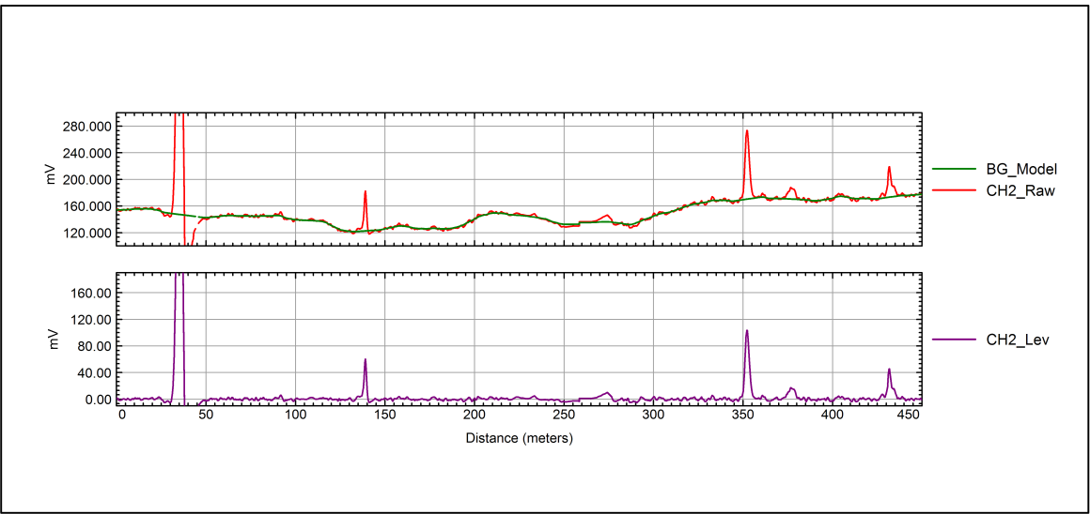

**Figure 1**. Example of Raw and Leveled Data

The leveled monostatic data are gridded and mapped using conventional Geosoft tools. The mapped monostatic Z-component data are then used for amplitude response based target selection whereby the position of peak responses in the data that exceed the project threshold are selected and identified as target anomalies for further analysis.

The gridded and mapped monostatic Z-component data are also suitable for use to select background locations, which in turn can be used to level all of the 21 Receive (Rx) coil channels in a manner similar to that used for background removal of cued target measurements.

##### Target Selection

Target selection using the MetalMapper dynamic data is performed using the traditional amplitude response metric using the mapped Z-component data described above. Alternately a dipole response filter approach or other advanced anomaly selection technique that uses a larger subset of the available data can be used.

###### Response Amplitude Detection:

Traditional anomaly selection is based almost entirely on signal response amplitude. Using the MetalMapper dynamic survey monostatic Z-component response amplitude as a detection metric is essentially the same as using a Geonics EM61 response amplitude detection. After the data have been gridded, the Geosoft automatic grid peak detection algorithm is used to extract locations of all grid peaks that are above the project detection threshold. These target anomaly locations are reviewed by the project geophysicist and manual additions and deletions are made to this list. The final list is reviewed by the quality control (QC) geophysicist prior to finalization of the target list.

###### Dipole Response Filter Detection:

The ‘dipole response filter’ approach to anomaly detection makes use of the rich data set output of the advanced sensors. This target selection routine takes advantage of all the measured data – not just the monostatic Z component – by employing an automated dipole inversion routine to estimate the source locations. The process involves:

* assuming a target’s location (at every 10 centimeter [cm] spaced grid node across the site).
* extracting data within a specified sensor footprint.
* inverting for dipole polarizations.
* extracting the ‘goodness-of-fit parameter’ as the detection metric.

The ‘goodness-of-fit’ filter output is the squared correlation between the full multi-axis, multi-static MetalMapper data set and a dipole model fit to those data. This filter output is mapped in the same manner as the amplitude response and peaks in the detection metric indicate target locations as illustrated by Figure 2.

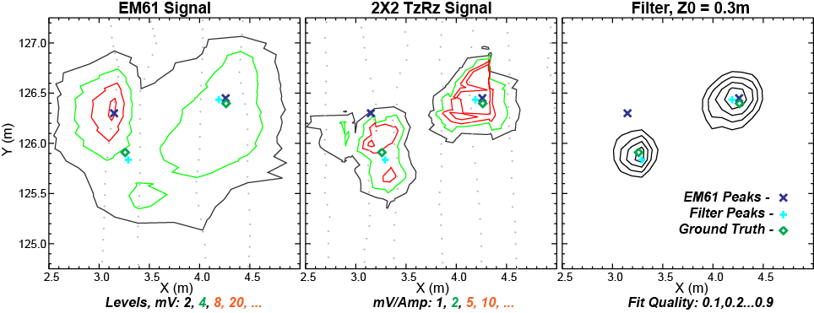

**Figure 2**. Data subset showing mapped response amplitude (left) and mapped filter response output (right) with ground truth information superimposed. Contour line values are provided in the legend.

Accordingly, target selection using the dipole filter fit coherence metric is accomplished in the same manner as for the amplitude response approach. After running the automatic peak detection routine, the target list will be reviewed and manual additions/deletions will be made.

#### Assessment of Quality Control of Dynamic Survey Data

During the course of a dynamic survey, QC measurements are performed on a daily basis to verify the operation of the sensor and associated components. These tests are comprised of function tests (described in SOP 1) and transects along the instrument verification strip (IVS). The successful completion of these tests on a daily basis is required to validate the survey data collected on that day.

##### Function Test Measurement Processing

Function test measurements (described in SOP 1) are performed prior to each sortie to confirm that all transmit and receive components of the MetalMapper sensor are operational. The data from each function test are assessed relative to the MQOs presented in Worksheet #22, compiled and presented in graphical form for review. Results that do not pass the MQOs are identified and the appropriate action specified in Worksheet #22 is taken.

##### Daily IVS Survey Processing

Prior to the start and at the end of each day of data collection, measurements of the set of IVS targets are performed (described in SOP 2). These data are processed in the same manner as the production survey data with regard to positioning and background removal. The data from each IVS test are assessed relative to the MQOs presented in Worksheet #22, compiled and presented in graphical form for review. Results that do not pass the MQOs are identified and the appropriate action specified in Worksheet #22 (root cause analysis [RCA]/corrective action [CA]) are taken. Depending upon the findings of the RCA, the survey data associated with the IVS MQO failure may need to be re-collected.

### Data Management

#### Data inputs

The data inputs required for processing dynamic MetalMapper data are:

* a list of coordinates identifying the site boundaries
* raw dynamic MetalMapper data files
* amplitude response minimum detection threshold (derived from the project-specific QAPP)

#### Data Outputs

The data outputs of the processing of dynamic MetalMapper data are:

* QC reports summarizing daily QC measurement results
* mapped detection metric data (Z-component amplitude and dipole response coherence) in ASCII (x,y,z) format
* target anomaly list (identifier [ID], X, Y)
* letter report detailing processing approach including leveling and target selection procedures

### Quality Control

The Quality Control checklist presented as Attachment 1 to this SOP will be filled out and delivered as part of the reporting requirement for this SOP.

The MQOs for processing dynamic MetalMapper data are presented in Worksheet #22 of the project-specific QAPP. Performance relative to the MQOs will be assessed during the processing of the data. Dynamic MetalMapper data will not be used to select targets until these MQOs are met or until the project team agrees on modifications to these MQOs.

### Reporting

Reporting of the activities associated with this SOP will consist of the following:

* digital Field notes
* data processing log detailing the following for each sortie (chronologically contiguous data collection set):
* survey date
* % invalid data with regard to transmit (Tx) current, GPS fix quality, IMU data quality, EMI response within range
* standard quality control checks performance
* correct coordinates for grids
* coverage
* line gaps
* background response
* dropouts
* downline density
* appropriate leveling
* appropriate anomaly selection
* associated Function Test filename
* associated IVS Test filename(s)
* area subset (grid ID)
* QC report summarizing daily QC results (Function tests and IVS tests)
* target list – final list of identified anomalies for delivered area subset
* final data archive (gdb or xyz format) for delivered area subset
* final grids of Z-component amplitude response for delivered area subset
* final grids of detection metric (if not amplitude response) for delivered area subset
* processing/data selection letter report

## SOP 5M

## Attachment 1 Dynamic MetalMapper Data Processing QC Checklist

This checklist is to be completed by the data processor or Project Geophysicist for every delivered data set (usually a contiguous subset of the project survey area).

|  |  |  |  |
| --- | --- | --- | --- |
| **QC Step** | **QC Process** | **Yes/No** | **Initial of Field or Project Geophysicist** |
| 1. Function Tests | Was the functionality of the MetalMapper EMI components verified for each sortie using function tests and did all function tests pass the MQO for this test? |  |  |
| 1. IVS Tests | Was the functionality of the MetalMapper system verified for each sortie using IVS tests and did all IVS tests pass the associated MQOs? |  |  |
| 1. Data Validity | Were invalid data for each sortie (with regard to Tx current, GPS fit quality, IMU data quality, and EMI response within range) identified and rejected? |  |  |
| 1. Coverage | Were gaps in data coverage due to down-line and across line sampling identified and accounted for (obstructions)? |  |  |
| 1. Background removal | Was the background model inspected prior to subtraction from the raw data and was the leveling reviewed by the QC Geophysicist? |  |  |
| 1. Target selection | Was the final target list reviewed by the data processor and the QC geophysicist? |  |  |
| 1. Reporting/deliverables | Were the following documents completed and delivered:   * Digital Field notes * Data processing log * Target List * Final data archive (gdb or xyz format) * Final grids |  |  |

Data Processor: _______________________________Date:___________

Project Geophysicist: ___________________________Date:___________

# STANDARD OPERATING PROCEDURE 5T

# Process Dynamic Survey Data - TEMTADS 2x2

### Purpose and Scope

The purpose of this Standard Operating procedure (SOP) is to identify the means and methods to be employed when processing dynamic survey data collected using a TEMTADS 2x2 (TEMTADS) advanced electromagnetic induction (EMI) sensor for target detection.

Dynamic TEMTADS data collection involves navigating the sensor along transects at a transect spacing designed to meet the project objectives with respect to detection performance of suspected targets of interest (TOI) in the subsurface. The detection objectives and resultant transect spacing are identified in the Geophysical Classification for Munitions Response (GCMR) Quality Assurance Project Plan (QAPP). Processing the dynamic data involves processing and assessing all QC tests (including daily function tests and IVS surveys), leveling the raw data to remove EMI signal due to the self-signature of the sensor systems and the ambient EMI soil response, and target selection.

A set of QC measurements are conducted upon initial commissioning of the system and on a daily basis to validate the operation of the various components of the TEMTADS dynamic survey system.

In the dynamic survey data, the observed signal measured by the TEMTADS is composed of 1) the EMI response of potential buried metallic objects, 2) the self-signature of the sensor system, and 3) any response from the ambient environment in which the target is buried. To isolate responses associated with buried discrete metal objects, a background model comprised of the latter two contributing signals must be derived and removed from the raw data. The resulting ‘leveled’ signal data, (raw data – background model) are used as inputs into a detection algorithm where anomalous responses due to potential TOI are mapped and selected for further investigation.

### Personnel and Equipment

This section describes the personnel and equipment required to implement this SOP.

The following individuals will be involved in the analysis of dynamic data:

* Project Geophysicist
* QC Geophysicist
* Data Processor

The qualifications of the personnel implementing this SOP are documented in the QAPP Worksheet #4, 7 & 8.

The only required equipment is a data processing computer suitable for and equipped to run the processes provided in the UXA-advanced module of Geosoft’s Oasis Montaj geophysical processing environment.

### Procedures and Guidelines

This section describes the procedures used to process the dynamic production data including positioning and leveling of the data, process/assess the QC activities related to dynamic data collection, and select target anomalies from the final processed data.

#### Processing of Dynamic TEMTADS data

The processing of dynamic TEMTADS data is achieved in the following steps:

1. Data import and QC
2. Data positioning and background removal
3. Target selection

##### Data Import/initial QC

The raw *.TEM data files are converted to ASCII *.csv files using Convert_TEMTADS and imported into a Geosoft Database (*.gdb) using a purpose built utility in UXA-Advanced. Once imported the data are inspected and assessed against the measurement quality objectives (MQOs) provided in Worksheet #22 for:

* transmit (Tx) current within limits
* Global positioning system (GPS) fit quality
* valid inertial measurement unit (IMU) data
* EMI response signal not saturated

Data measurements that do not pass the MQOs are automatically identified by a series of scripts that are used to default the position data where the MQOs are not met. This maintains the chronologic integrity of the EMI data but prevents the out-of-specification data from being mapped and used for detection.

##### Data Positioning and Leveling

A second purpose-built software routine automatically assigns the monostatic, Z-component EMI measurements positions based upon the GPS antenna location, platform geometry and platform attitude (IMU) data. A site-specific de-median filter is applied to the raw monostatic, Z-component data to derive an estimate of the background model. This model is subtracted from the raw data to provide a background removed or ‘leveled’ data set. Figure 1 shows an example of raw data (top panel, red trace), the background model derived from these data (top panel, green trace) and the resulting background removed data.



**Figure 1**. Example of Raw and Leveled Data

The leveled monostatic data are gridded and mapped using conventional Geosoft tools. The mapped monostatic Z-component data are then used for amplitude response based target selection whereby the position of peak responses in the data that exceed the project threshold are selected and identified as target anomalies for further analysis.

The gridded and mapped monostatic Z-component data are also suitable for use to select background locations, which in turn can be used to level all of the 48 Tx/Receive (Rx) coil combination data in a manner similar to that used for background removal of cued target measurements.

##### Target Selection

Target selection using the TEMTADS dynamic data is performed using the traditional amplitude response metric using the mapped Z-component data described above. Alternately a dipole response filter approach or other advanced anomaly selection technique that uses a larger subset of the available data can be used.

###### Response Amplitude Detection:

Traditional anomaly selection is based almost entirely on signal response amplitude. Using the TEMTADS dynamic survey monostatic Z-component response amplitude as a detection metric is essentially the same as using a Geonics EM61 response amplitude detection. After the data have been gridded, the Geosoft automatic grid peak detection algorithm is used to extract locations of all grid peaks that are above the project detection threshold. These target anomaly locations are reviewed by the project geophysicist and manual additions and deletions are made to this list. The final list is reviewed by the quality control (QC) geophysicist prior to finalization of the target list.

###### Dipole Response Filter Detection:

The ‘dipole response filter’ approach to anomaly detection makes use of the rich data set output of the advanced sensors. This target selection routine takes advantage of all the measured data – not just the monostatic Z component – by employing an automated dipole inversion routine to estimate the source locations. The process involves:

1. assuming a target’s location (at every 10 centimeter [cm] spaced grid node across the site)
2. extracting data within a specified sensor footprint
3. inverting for dipole polarizations
4. extracting the ‘goodness-of-fit parameter’ as the detection metric

The ‘goodness-of-fit’ filter output is the squared correlation between the full multi-axis, multi-static TEMTADS data set and a dipole model fit to those data. This filter output is mapped in the same manner as the amplitude response and peaks in the detection metric indicate target locations as illustrated by Figure 2.



**Figure 2**. Data subset showing mapped response amplitude (left) and mapped filter response output (right) with ground truth information superimposed. Contour line values are provided in the legend.

Accordingly, target selection using the dipole filter fit coherence metric is accomplished in the same manner as for the amplitude response approach. After running the automatic peak detection routine, the target list will be reviewed and manual additions/deletions will be made.

#### Assessment of Quality Control of Dynamic Survey Data

During the course of a dynamic survey, QC measurements are performed on a daily basis to verify the operation of the sensor and associated components. These tests are comprised of function tests (described in SOP 1) and transects along the instrument verification strip (IVS). The successful completion of these tests on a daily basis is required to validate the survey data collected on that day.

##### Function Test Measurement Processing

Function test measurements (described in SOP 1) are performed prior to each sortie to confirm that all transmit and receive components of the TEMTADS sensor are operational. The data from each function test are assessed relative to the MQOs presented in Worksheet #22, compiled and presented in graphical form for review. Results that do not pass the MQOs are identified and the appropriate action specified in Worksheet #22 is taken.

##### Daily IVS Survey Processing

Prior to the start and at the end of each day of data collection, measurements of the set of IVS targets are performed (described in SOP 2). These data are processed in the same manner as the production survey data with regard to positioning and background removal. The data from each IVS test are assessed relative to the MQOs presented in Worksheet #22, compiled and presented in graphical form for review. Results that do not pass the MQOs are identified and the appropriate action specified in Worksheet #22 (root cause analysis (RCA)/corrective action (CA) are taken. Depending upon the findings of the RCA, the survey data associated with the IVS MQO failure may need to be re-collected.

### Data Management

#### Data inputs

The data inputs required for processing dynamic TEMTADS data are:

* a list of coordinates identifying the site boundaries.
* raw Dynamic TEMTADS data files.
* amplitude response minimum detection threshold (derived from the project-specific QAPP).

#### Data Outputs

The data outputs of the processing of dynamic TEMTADS data are:

* QC reports summarizing daily QC measurement results
* mapped detection metric data (Z-component amplitude and dipole response coherence) in ASCII (x,y,z) format
* target anomaly list (identifier (ID), X, Y)
* letter report detailing processing approach including leveling and target selection procedures

### Quality Control

The Quality Control checklist presented as Attachment 1 to this SOP will be filled out and delivered as part of the reporting requirement for this SOP.

The MQOs for processing dynamic TEMTADS data are presented in Worksheet #22 of the project-specific QAPP. Performance relative to the MQOs will be assessed during the processing of the data. Dynamic TEMTADS data will not be used to select targets until these MQOs are met or until the project team agrees on modifications to these MQOs.

### Reporting

Reporting of the activities associated with this SOP will consist of the following:

* digital Field notes
* data processing log detailing the following for each sortie (chronologically contiguous data collection set):
* survey date
* % invalid data with regard to transmit (Tx) current, GPS fix quality, IMU data quality, EMI response within range
* standard quality control checks performance
* correct coordinates for grids
* coverage
* line gaps
* background response
* dropouts
* downline density
* appropriate leveling
* appropriate anomaly selection
* associated Function Test filename
* associate IVS Test filename(s)
* area subset (grid ID)
* QC report summarizing daily QC results (Function tests and IVS tests)
* target List – final list of identified anomalies for delivered area subset
* final data archive (gdb or xyz format) for delivered area subset
* final grids of Z-component amplitude response for delivered area subset
* final grids of detection metric (if not amplitude response) for delivered area subset
* processing/data selection letter report

## SOP 5T

## Attachment 1 Dynamic TEMTADS Data Processing QC Checklist

This checklist is to be completed by the data processor or Project Geophysicist for every delivered data set (usually a contiguous subset of the project survey area).

|  |  |  |  |
| --- | --- | --- | --- |
| **QC Step** | **QC Process** | **Yes/No** | **Initial of Field or Project Geophysicist** |
| 1. Function Tests | Was the functionality of the TEMTADS EMI components verified for each sortie using function tests and did all function tests pass the MQO for this test? |  |  |
| 1. IVS Tests | Was the functionality of the TEMTADS system verified for each sortie using IVS tests and did all IVS tests pass the associated MQOs? |  |  |
| 1. Data Validity | Were invalid data for each sortie (with regard to Tx current, GPS fit quality, IMU data quality, and EMI response within range) identified and rejected? |  |  |
| 1. Coverage | Were gaps in data coverage due to down-line and across line sampling identified and accounted for (obstructions)? |  |  |
| 1. Background removal | Was the background model inspected prior to subtraction from the raw data and was the leveling reviewed by the QC Geophysicist? |  |  |
| 1. Target selection | Was the final target list reviewed by the data processor and the QC geophysicist? |  |  |
| 1. Reporting/deliverables | Were the following documents completed and delivered:   * Digital Field notes * Data processing log * Target List * Final data archive (gdb or xyz format) * Final grids |  |  |

Data Processor: _______________________________Date:___________

Project Geophysicist: ___________________________Date:___________

# STANDARD OPERATING PROCEDURE 6

# Collect Static Background Measurements

### Purpose and Scope

The purpose of this Standard Operating procedure (SOP) is to identify the means and methods to be employed when selecting the positions for background measurements using an advanced digital geophysical mapping system and verifying the usability of the resulting background data. The observed signal in a cued measurement using advanced sensors is composed of 1) the EMI response of the buried target, 2) the self-signature of the sensor system, and 3) any response from the ambient environment in which the target is buried. The objective of taking background measurements is to independently measure the last two contributors to the overall EMI response. These “non-target” values can then be subtracted from the overall signal response to determine the signal response from only the unknown buried object being evaluated. For this to be successful the background measurements must be collected in an area without any buried targets and with a geology representative of that where the unknown items are located. They must also be taken throughout the survey day because environmental changes such as large changes in ambient temperature, significant changes in background moisture (morning dew evaporating, rain showers passing through, etc.), or significant changes to the sensor itself (cable replacement, new GPS antenna, etc.) will cause the sensor or environmental contribution to the background reading to change.

### Personnel, Equipment and Materials

This section describes the personnel, equipment and materials required to implement this SOP.

The following individuals will be involved in the collection of background data:

* Project Geophysicist
* QC Geophysicist
* Field Team Leader
* Data Processor

The qualifications of the personnel implementing this SOP are documented in the QAPP Worksheet #4, 7 & 8.

The following is a list of required equipment and materials:

* Geometrics MetalMapper or TEMTADS sensor coupled with a real-time kinematic Global Positioning System (RTK GPS) and orientation sensor

### Procedures and Guidelines

Background measurements will be recorded no less than every two hours throughout the survey day and at one or more geographic locations as required to document the EMI signatures of near-surface soils present at the site. Background measurements involve positioning the sensor and collecting static measurements over a pre-identified set of background locations. In combination with SOPs for sensor assembly (SOP 1) and testing at the IVS (SOP 2), background data are collected that are used to correct the static data described in SOP 6.

Prior to cued data collection, the correct operation of the geophysical sensor and navigation and orientation systems must be verified at the Instrument Verification Strip (IVS) as described in SOP 2. This will be verified by completion of the QC checklist attached to SOP 2.

#### Choose Locations for the Background Measurements and Verify Their Suitability

One or more locations for background measurements will be planned at each site. The number and location of the background measurements will be influenced by the following considerations:

* The background measurements should be collected at locations that are similar to that of the production survey area with regard to geophysical noise, terrain, geology, and vegetation. If these factors change appreciably, additional background measurements, taken at a more representative location, will be required.
* The background measurements should be collected at locations devoid of buried metal objects. If a suitable object free area cannot be identified, attempts should be made to create a “clear” 2-m square area by surveying and removing all metal objects. Once cleaned, the background measurements should be re-collected in the “clear” area.
* For efficiency, background measurements should be collected in areas that are close to the survey area(s) to minimize travel time.

Once an adequate number of background locations have been identified, an initial measurement should be collected over each of the background locations in turn as illustrated in Figure 1 on the next page.



NO

**Figure 1**. Choosing and verifying locations for background measurements

1. Initial locations for the background measurement are chosen most easily by referring to the dynamic survey data. These data can be used to guide the geophysicist to suitable locations that satisfy the considerations noted above.
2. Once an adequate number of initial locations have been identified an initial measurement should be collected over each of the background locations as follows:
   1. Center the MetalMapper or TEMTADS over the location chosen as a background point. Mark the corners of the sensor with non-metallic pin flags to allow this same location to be found again for future background readings.
   2. Record the stationary geophysical data at this location and verify that the signal amplitudes for all decays measured are below the threshold chosen for this project. If higher amplitude decays are observed, the location should be inspected and any metal contamination found should be removed. Alternatively, another nearby location can be chosen.
3. Each background location is verified by comparing a set of 5 measurements taken at the intended location: one measurement at the location and one more with the sensor offset by ½ sensor spacing in each cardinal direction. Next, the forward model of the most challenging target of interest / depth scenario (e.g. 37mm at 30cm depth) is added to the center background measurement and the background is verified by separately subtracting each of the 4 offset backgrounds and performing a library match to the target of interest. The background location is considered valid if the library match from all 4 offsets exceeds 0.9. These images will be saved and presented in a background summary report.
4. Continue this process at each of the chosen locations until their suitability for background measurements has been verified.
5. Once this process is complete, these measurements will serve as baseline values for succeeding background measurements at each point.

#### Collect Background Measurements throughout the Survey Day

Background measurements should be collected with a minimum spacing of two hours throughout the survey day. Additional background measurements can be taken if the Project Geophysicist or Field Team Leader determines that changes made to the sensor or natural environmental changes may have caused the sensor or environmental contribution to the background reading to change. Careful field notes should be made to document the reasons for extra background readings to guide the Data Processor in choosing the correct background for each cued data set.

The procedure for taking background measurements is as follows:

1. Return the sensor to one of the previously verified background measurement locations taking care to position the sensor as closely as possible to the initial location and orientation.
2. Collect a background measurement.
3. Compare the Background Amplitude Metric to the original value at this location. If the two values differ by more than a factor of five, repeat the measurement.
4. If the deviations persist, document the environmental changes that may have led to this deviation in the field notes and record approval by the Project Geophysicist before proceeding.

### Data Management

The following sections describe the data that is needed to perform this SOP and the resulting data.

#### Input Data Required

In initial list of suitable background locations, identified from the survey data, is required to begin this SOP. After the locations have been verified, they become the final background location list.

#### Output Data

The background data collected at each background location will be saved in the project database. Also, the QC checklist in Attachments 1 through 3 of this SOP will be completed, signed, and filed.

### Quality Control

This procedure is performed throughout the project and, therefore, has Preparatory, Initial and Follow-on QC checks. Performance of the required QC checks will be documented on the Preparatory, Initial and Follow-on QC checklists in Attachments 1 -3 to this SOP as follows:

* The Preparatory Checklist (Attachment 1) will be completed to document the identification of the background locations.
* The Initial Checklist (Attachment 2) will be completed to document the initial background readings at each selected background location.

This procedure ensures that the MetalMapper is working properly and that the field geophysical team is collecting data of adequate quality. Therefore, for routine background measurements, this procedure requires only Follow-on QC inspections which are documented through the following steps:

1. The operating software automatically logs the responsible geophysicist’s identification in each data file. By logging the background data, and thereby taking responsibility for it, the geophysicist logging the data is certifying that they have complied with the requirements of this SOP.
2. The QC Geophysicist will observe background data collection each morning and afternoon of data collection activities and document this in the Daily Geophysics QC Report.
3. Achievement of the background collection MQOs will be documented by the Field or Project Geophysicist and verified by the QC Geophysicist in the Geophysics Daily QC Report.
4. During review of each background measurement, the Data Processor will overlay the measured decays from all measurements at that location to observe any variation. Should variations be observed that are not the result of changing environmental conditions documented by the field crew, a comprehensive root‐cause analysis will be performed and a corrective action determined.

The measurement quality objectives (MQOs) for background measurements are presented in Worksheet #22 of the QAPP. Measured backgrounds will not be used to correct field data until these MQOs are met or until the project team agrees on modifications to these MQOs.

### Reporting

This procedure will be documented through the completion of the Preparatory, Initial and Follow-on QC Checklists in Attachments 1 through 3 by the Field or Project Geophysicists. The completed checklists will be used to document the selection and preparation of the background areas (Preparatory Inspection Checklist in Attachment 1), the initial background readings taken at each selected area (Initial Inspection Checklist in Attachment 2), and the routine four-times-daily (at a minimum) background readings taken during the production survey (Follow-on Checklist in Attachment 3). The QC Geophysicist will observe the background readings being collected and will document completion of all checklists in the Geophysics Daily QC Report and copies of the completed checklists will be attached to the report.

## SOP 6

## Attachment 1 Preparatory Background Collection QC Checklist

This checklist is to be completed by the Field or Project Geophysicist during selection and preparation of the background areas. Successful completion of this process will be verified by the QC Geophysicist in the Daily Geophysics QC Report.

|  |  |  |  |
| --- | --- | --- | --- |
| **QC Step** | **QC Process** | **Yes/No** | **Initial of Field or Project Geophysicist** |
| 1. Qualifications | Are the same geophysical personnel being used as in SOP 1? If not, have the qualifications of the new personnel been verified? |  |  |
| 1. Background area selection | Do the selected background areas have similar geophysical noise, terrain, geology and vegetation as the production survey area they represent i/a/w this SOP? |  |  |
| 1. Background area selection and preparation | Are the selected background areas devoid of buried metal objects or has a 2-m square area been “cleaned” i/a/w this SOP? |  |  |
| 1. Background area selection | Are the selected background areas sufficiently close to the production area to minimize travel i/a/w this SOP? |  |  |

Field Geophysicist: _____________________________Date:___________

Project Geophysicist: ___________________________Date:___________

Data Processor: _______________________________Date:___________

## SOP 6

## Attachment 2 Initial Background Data Collection QC Checklist

This checklist is to be completed by the Field or Project Geophysicist during the initial data collection at each background area. Successful completion of this process will be observed and verified by the QC Geophysicist in the Daily Geophysics QC Report.

|  |  |  |  |
| --- | --- | --- | --- |
| **QC Step** | **QC Process and Guidance Reference** | **Yes/No** | **Initial of Field or Project Geophysicist** |
| 1. Qualifications | Are the same geophysical personnel being used as in SOP 1? If not, have the qualifications of the new been verified? |  |  |
| 1. Preparation | Has the SOP 1 Preparatory Checklist been successfully completed? |  |  |
| 1. Preparation | Have the instrument start-up procedures and pre-operation checklist from SOP 1 (Attachment 1) been successfully completed? |  |  |
| 1. Data collection | Is the instrument properly centered on the background location and are the corners of the sensor marked with non-metallic pin flags i/a/w this SOP? |  |  |
| 1. Data collection | Was the background data recorded and the signal amplitude verified to be below the selected threshold i/a/w this SOP? |  |  |
| 1. Data collection | Is background data recorded for each background location i/a/w this SOP? |  |  |
| 1. Data analysis | Are the background readings for each area recorded i/a/w this SOP?  Background ID _____________ Reading _____________  Background ID _____________ Reading _____________  Background ID ______________ Reading ____________  Background ID ______________ Reading ____________  Background ID _____________ Reading _____________ |  |  |
| 1. MQO Documentation | Have the appropriate MQOs from Worksheet #22 been achieved? |  |  |

Field Geophysicist: _____________________________Date:___________

Project Geophysicist: ___________________________Date:___________

Data Processor: _______________________________Date:___________

## SOP 6

## Attachment 3 Follow-on Background Data Collection QC Checklist

This checklist is to be completed by the QC Geophysicist daily. It should be noted that the identity of the geophysicist responsible for logging each anomaly is recorded in the anomaly data. Every time the Field Geophysicist logs cued background data they are certifying that they have complied with the requirements of this SOP. The QC Geophysicist will observe the background collection process at least twice per day and will document the successful completion of this checklist in the Daily Geophysics QC Report.

|  |  |  |  |
| --- | --- | --- | --- |
| **QC Step** | **QC Process** | **Yes/No** | **Initial of QC Geophysicist** |
| 1. Qualifications | Are the same geophysical personnel being used? If not, have the qualifications of the new personnel been verified? |  |  |
| 1. Preparation | Has the start-up and IVS QC checklist from SOP 2 been successfully completed? |  |  |
| 1. A.M. Field Observation | Was the a.m. field observation performed?  Time: ______ Background #s:______________ |  |  |
| 1. P.M. Field Observation | Was the p.m. field observation performed?  Time: ______ Background #s:______________ |  |  |
| 1. Field Documentation | Did the QC Geophysicist review the day’s data collection with the Field Geophysicist and review the Field Geophysicist’s notebook? Were any technical issues noted? |  |  |
| 1. MQO Documentation | Have the appropriate MQOs from Worksheet #22 been achieved? |  |  |

QC Geophysicist: _____________________________Date:___________

# STANDARD OPERATING PROCEDURE 7

# Collect Cued Target Measurements

### Purpose and Scope

The purpose of this Standard Operating procedure (SOP) is to identify the means and methods to be employed when collecting cued measurements using a MetalMapper or TEMTADS advanced electromagnetic induction (EMI) sensor for target classification. Cued data collection involves navigating the sensor to the precise anomaly location, collecting static, advanced electromagnetic sensor data at this location, and verification of the integrity and validity of the collected data. Verification includes using the sensor data to derive an estimate of the target position relative to the center of the sensor. If this position estimate falls outside a predetermined threshold, the sensor will be repositioned and a second data collection event will be performed.

### Personnel, Equipment and Materials

This section describes the personnel, equipment and materials required to implement this SOP.

The following individuals will be involved in the collection of cued target data:

* Project Geophysicist
* QC Geophysicist
* Field Team Leader
* Data Processor

The qualifications of the personnel implementing this SOP are documented in the QAPP Worksheet #4, 7 & 8.

The following is a list of required equipment and materials:

* Geometrics MetalMapper or TEMTADS sensor coupled with a real-time kinematic Global Positioning System (RTK GPS) and orientation sensor

### Procedures and Guidelines

Cued investigation for target classification involves positioning the sensor and collecting static measurements over a pre-identified set of anomalies. In combination with SOPs for sensor assembly (SOP 1), testing at the IVS (SOP 2) and collecting background measurements (SOP 6), a set of static data measurements are collected using the MetalMapper or TEMTADS over each anomaly. At each anomaly the data acquisition will be performed using the steps shown in Figure 1.

Prior to cued data collection, the correct operation of the geophysical sensor and navigation and orientation systems must be verified at the Instrument Verification Strip (IVS) as described in SOP 2. This will be verified by completion of the QC checklist attached to SOP 2.



**Figure 1**. Procedure to collect a cued target measurement

The following is a description of each of the steps shown above:

1. **Navigate to the Anomaly Location**. Navigation to the anomaly location may be performed visually or through the use of the RTK GPS positioning system. Visual navigation requires marking the anomalies (usually with survey pin flags) in advance. Although some sensors may have the ability to direct the operator to an anomaly location based upon the geophysical signal received, the first measurement will be taken at the predetermined anomaly location as indicated by visual alignment with the pin flag or RTK GPS position relative to the predetermined position.

To implement this step the sensor will be transported to the anomaly location and the center of the sensor precisely positioned (within 5-cm) over the provided anomaly location.

1. **Collect a set of static sensor measurements**. Initiate the collection of a set of measurements. During this measurement, care will be taken to ensure that the sensor does not move, and all external sources of EM signals (i.e. metal) are kept away from the sensor.

Any metal associated with the sensor and deployment mechanism (e.g. console, support structures) that cannot be reasonably distanced from the sensor must be kept in the same physical relation with the sensor as was maintained during background measurements.

1. **Verify the integrity and quality of the collected data**. Immediately after data acquisition, the integrity and quality of the data will be verified by the operator by inspection of the MetalMapper data collection screen to ensure that:

* the data acquisition cycle completed properly.
* the transmit current for each transmitter was within an acceptable range (6 – 8 A).
* the decay curves measured by each receiver coil appear reasonable (i.e. – not ‘flat-lined’).

1. **Perform a field inversion**. Valid inversion results require that the target is located within a 40-cm of the center of the sensor. The initial target horizontal position may be significantly offset from the center of the sensor for the following reasons:

* positioning errors in the initial detection survey
* imprecision in the derivation of the anomaly position from the detection survey data set
* imprecision in the reacquisition and flagging of the anomaly
* imprecision in positioning the sensor
* the presence of multiple anomaly sources in relatively close proximity

This step includes performance of an in-field inversion and inspection of the results to verify that the estimated horizontal target location is within the 40-cm of center specification. After initiating the in-field inversion algorithm an estimate of the target location relative to the center of the sensor is provided. If the offset is greater than 40 cm, position the sensor over the target location estimate provided by the in-field inversion (visually or using the RTK GPS data) and repeat Steps 1 and 2.

This recollection should only be performed once. Assuming the repositioning was performed accurately, if the subsequent position estimate is still > 40cm from the sensor center the cause is likely to be multiple anomaly sources and additional data collection and data analysis may be required after further analysis by the QC geophysicist.

### Data Management

The following sections describe the data that is needed to perform this SOP and the resulting data.

#### Input Data Required

An anomaly list consisting of anomaly IDs and UTM Northing and Easting coordinates in meters.

#### Output Data

The output data from this SOP will consist of one raw sensor data file (.tem or .hdf5) per anomaly interrogated. These data files will be transferred daily (or more often as dictated by site procedures) to the data analyst.

### Quality Control

The Preparatory and Initial QC checks for this SOP are performed during the implementation of SOP 2, “Test Sensor and System at the IVS”. SOP 2 ensures that the MetalMapper is working properly and that the field geophysical team is collecting data of adequate quality. Therefore, this procedure requires only Follow-on QC inspections which are documented through the following steps:

* The operating software automatically logs the responsible geophysicist’s identification in each data file. By logging the data, and thereby taking responsibility for it, the geophysicist logging the data is certifying that they have complied with the requirements of this SOP.
* The QC Geophysicist will observe data collection each morning and afternoon of data collection activities and document this in the Daily Geophysics QC Report.

Daily data packages, containing the geophysical data from that day, will be reviewed by the QC Geophysicist to ensure that the Measurement Quality Objectives (MQOs) are being achieved. A comprehensive root‐cause analysis will be performed and a corrective action will be determined if the QC Geophysicist determines that the MQOs are not being met or if a trend toward the MQO limits is observed.

The measurement quality objectives (MQOs) for cued target measurements are presented in Worksheet #22 of the QAPP. Cued data will not be used to classify targets until these MQOs are met or until the project team agrees on modifications to these MQOs.

### Reporting

This SOP will be documented through the completion of the Follow-on QC Checklist in Attachment 1. Since the Field Team Leader is certifying their compliance with this SOP every time they log data the Follow-on Checklist for this SOP will be completed by the QC Geophysicist and will document the successful completion of equipment start-up and the IVS (SOP 2) and the twice-daily (a.m. and p.m.) observation of data collection by the QC Geophysicist.

The Field Geophysicist will also maintain a field notebook and the QC Geophysicist will review this notebook daily to note issues that potentially affect quality. The completion of all checklists will be noted by the QC Geophysicist in the Daily Geophysics QC Report and a copy of the completed checklists will be attached to the report.

## SOP 7

## Attachment 1 Cued Geophysical Data Collection Follow-on QC Checklist

This checklist is to be completed by the QC Geophysicist daily. It should be noted that the identity of the geophysicist responsible for logging each anomaly is recorded in the anomaly data. Every time the Field Geophysicist logs cued anomaly data they are certifying that they have complied with the requirements of this SOP. The QC Geophysicist will observe the data collection process at least twice per day and will document the successful completion of this checklist in the Daily Geophysics QC Report.

|  |  |  |  |
| --- | --- | --- | --- |
| **QC Step** | **QC Process** | **Yes/No** | **Initial of QC Geophysicist** |
| 1. Qualifications | Are the same geophysical personnel being used? If not, have the qualifications of the new personnel been verified? |  |  |
| 1. Preparation | Has the start-up and IVS QC checklist from SOP 2 been successfully completed? |  |  |
| 1. A.M. Field Observation | Was the a.m. field observation performed?  Time: _________ Anomaly #s: ____________ |  |  |
| 1. P.M. Field Observation | Was the p.m. field observation performed?  Time: _________ Anomaly #s: _____________ |  |  |
| 1. Field Documentation | Did the QC Geophysicist review the day’s data collection with the Field Geophysicist and review the Field Geophysicist’s notebook? Were any technical issues noted? |  |  |
| 1. MQO Documentation | Have the appropriate MQOs from Worksheet #22 been achieved? |  |  |

QC Geophysicist: _____________________________Date:___________

# STANDARD OPERATING PROCEDURE 8

# Process Cued METALMAPPER or TEMTADS Data

### Purpose and Scope

The purpose of this Standard Operating procedure (SOP) is to identify the means and methods to be employed when processing cued measurements collected using a MetalMapper or TEMTADS advanced electromagnetic induction (EMI) sensor for target classification. Cued surveys include the collection of cued data over predetermined target locations and background locations. Cued measurements are also performed over instrument verification strip (IVS) targets for quality control (QC) purposes. This SOP details the steps required to verify the quality of these measurements, process these measurements to derive features related to the physical characteristic of the target, and use these features to classify the targets.

### Personnel, Equipment and Materials

This section describes the personnel and equipment required to implement this SOP.

The following individuals will be involved in the processing of cued MetalMapper or TEMTADS data for advanced analysis:

* Project Geophysicist
* QC Geophysicist
* Field Team Leader
* Data Processor

The qualifications of the personnel implementing this SOP are documented in the QAPP Worksheet #4, 7 & 8.

The only required equipment is a data processing computer suitable for and equipped to run the processes provided in the UXA-advanced module of Geosoft’s Oasis Montaj geophysical processing environment.

### Procedures and Guidelines

#### Data Import/Initial QC

The raw *.TEM data are converted to ASCII *.csv files using:

* a purpose built software utility (Convert_TEMTADS) supplied by the Naval Research Lab (NRL) or
* the EM3D Plot export utility

The data are then imported into Geosoft’s UXAnalyze-Advanced (UXA) purpose built processing environment. This process results in three separate databases that contain:

* target anomaly measurement data
* background measurement data
* target list

The cued measurements from the TEMTADS go into the target anomaly or background databases and the Target list is where the derived feature and classification information for each target are summarized.

Once imported the data are inspected and assessed against the measurement quality objectives (MQOs) provided in QAPP Worksheet #22 for:

* Transmit (Tx) current within limits
* Global positioning system (GPS) fit quality
* valid inertial measurement unit (IMU) data
* EMI response signal not saturated

#### Background Corrections

Background corrections are used to remove the self-signature of the advanced sensor system and the soil response from the measured anomaly data. Background measurements are taken at locations selected from the detection survey data set. Prior to utilizing these locations for background measurements, they need to be verified to be devoid of metal. Additionally each background measurement needs to be verified as suitable prior to using it for background correction of the target measurement data.

##### Background Measurement Verification

Individual background measurements must be verified prior to their use for background corrections. Background measurements will be compared to the initial background verification measurement at the same position and verified as qualitatively similar. These images will be saved and presented in a background summary report. Invalid measurements will be removed from background database to ensure that they are not used.

##### Background Corrections

Background corrections are applied using a purpose built tool in UXA that automatically finds the closest background (chronologically and spatially) and will only apply the background corrections that were collected within a preset time limit relative to the target measurement. This preset time limit will be set to 2 hours. The background corrected data are stored in the channel “UXA_Data_Lev”. This is the data channel that is submitted to the inversion processes to derive target features. This data channel will not be populated for those target measurements that do not have a suitable background measurement within the 2 hour time limit.

#### Function Test Measurements

Function test measurements (described in SOP 1) are performed in conjunction with the background measurements to confirm that all transmit and receive components of the TEMTADS sensor are operational. These data are background corrected, then the monostatic components are compared to a benchmark set of values to confirm that all components are fully operational. This comparison is performed in the field and the results are provided in real time. The data processor should perform the same background corrections and log the results for QC/quality assurance (QA) purposes.

#### Target Feature Estimation

After background corrections are applied, intrinsic and extrinsic features are estimated for the target anomalies as well as the daily QC measurements collected at the IVS.

Single target and multi-target inversion routines in UXA-Advanced are used to determine the parameters of a target (single-target inversion), or constellations of targets (multi-target inversion), that would produce responses that closely match the observed responses. These parameters include extrinsic parameters (location and orientation) as well as the intrinsic parameters (principal axis polarizabilities) related to the object size shape and composition. The intrinsic parameters, otherwise known as betas (β) are used for classification.

As the names suggest, the single-target inversion solves for a single target and the multi-target inversion posits multiple targets. The multi-source solver not only presupposes multiple sources, it will also produce a number of candidate ‘realizations’ of targets. Each candidate realization proposes a configuration of targets whose modeled response reasonably fits the observed data. For example, one candidate realization may have three targets, while a second candidate realization for the same measurement may have two or four targets. This process reflects the fact that, with an unknown number of potential targets of difference sizes and shapes, a number of different models can closely match the observed data. A separate fit coherence value is derived for each candidate realization as well as for the single solver.

Model results will only be used for classification if they pass the MQOs identified to confirm that they support classification (QAPP Worksheet #22).

#### Daily IVS Survey

Prior to the start and at the end of each day of data collection, measurements of the set of IVS targets are performed (described in SOP 2). These measurements are processed as described above and the derived features are assessed against the MQOs presented in WS #22. These results are documented and summarized in a QC report to be generated for each delivered prioritized list.

#### Classification

Classification of targets will be based upon objective, numeric criteria. Using these criteria, a prioritized list is created with high likelihood target of interest (TOI) placed at the top of the dig list (just after digs classified as “training data” and “can’t analyze”) and high likelihood non-TOI placed at the bottom of the list. The primary method for classification will be library matching, supplemented by cluster analysis and feature space analysis.

##### Site Specific Munitions Library

A site specific library of βs for candidate munitions items identified in the conceptual site model (CSM) will be used for classification. Entries in existing libraries will be confirmed as representative (i.e. the same caliber, model and configuration) of the munitions items presented in the table by a qualified unexploded ordnance (UXO) Technician. Intrinsic parameters for items listed in the CSM not confirmed to be in the existing library will be derived from test measurements prior to the start of the classification process if the items are available for test or the closest available item in size and shape will be used as a surrogate.

##### Library Matching

Classification is based primarily on the goodness of fit metric (values from 0.0 to 1.0) generated by UXA during a comparison of the β values estimated for each surveyed target and the β values in the munitions library developed for the project. This comparison is performed via the library match utility in UXA. The goodness of fit metric is a measure of the fit correlation between a target and the library entry that best fits that target, with higher values indicating a better fit between the target and the corresponding item in the library. The library fit analysis matches the following four combinations of βs to those of the candidate library TOIs:

* β1, β1/β2, β1/β3
* β1, β1/β2
* β1/β2, β1/β3
* β1

The confidence metrics for each fit combination are averaged to derive a ‘decision metric’.

This library matching process is performed for each single-solver model and every target in each of the multi-source solver candidate realization models. For each flag position, the best library fit from the single-solver and multi-solver targets is used as the decision metric. This decision metric is used to rank and classify the target list. Values below the analysts threshold (nominally 0.8) are considered non-TOI.

A set of training digs are identified by the analyst. The intrusive investigation results of these digs as well as decision metrics derived for other known TOI (IVS and seed items) are used to finalize the analyst threshold.

##### Cluster Analysis/Feature space Analysis

Cluster analyses are performed whereby the clusters of anomalies with similar β signatures are identified using the self match utility in UXA. For each identified cluster, a representative sample is intrusively investigated as part of the training data. If the intrusive investigation identifies a hazardous item, a representative signature is placed in the site specific library and the matching process will be repeated to ensure that all similar items are classified as TOI.

Individual items that do not match any library items but have βs that indicate a large, axially symmetric, thick-walled object are identified and investigated as part of the training data and added to the library if they are identified as TOI.

### Data Management

#### Data inputs

The data inputs required for performing a cued advanced analysis data processing are:

* a list of target anomalies including identifier (ID) and position (X, Y)
* a list of Background locations (ID, X, Y)
* a list of IVS locations (ID, X, Y)
* MetalMapper or TEMTADS measurement data including those for target anomalies, daily IVS, backgrounds, and function tests
* digital field notes for all data collection activities
* site specific library signatures and/or test stand measurements of intended site specific library items

#### Data Outputs

The data outputs of the cued advanced analysis data processing for each delivered survey unit (contiguous subset of the survey site) are:

* QC report including documenting performance relative to QAPP Worksheet #22 for:
* IVS results
* function test results
* background measurements
* target anomaly measurements
* prioritized target list
* target classification report
* revised validation plan
* target measurement data, background measurement data, and target feature databases
* supporting documents for classification (PDF images)

### Quality Control

The QC checklist presented as Attachment 1 to this SOP will be filled out and delivered as part of the reporting requirement for this SOP.

The measurement quality objectives (MQOs) for cued target measurements are presented in Worksheet #22 of the QAPP. Performance relative to the MQOs will be assessed during the processing of the collected data. Cued data will not be used to classify targets until these MQOs are met or until the project team agrees on modifications to these MQOs.

### Reporting

Reporting of the activities associated with this SOP will consist of:

* a QC Report detailing the system performance against the MQOs identified on QAPP Worksheet #22 (including MQOs for daily IVS and Function Test performance as well as for individual measurement metrics).
* a Classification Report detailing specific approach to classification including final library make-up, cut-off threshold, cluster analysis approach and results, and feature space analysis approach and results.

## SOP 8

## Attachment 1 Cued Geophysical Data Processing QC Checklist

This checklist is to be completed by the Field or Project Geophysicist every time cued TEMTADS data are collected.

|  |  |  |  |
| --- | --- | --- | --- |
| **QC Step** | **QC Process** | **Yes/No** | **Initial of Field or Project Geophysicist** |
| 1. Background Locations | Were background locations verified to be free of localized sources? |  |  |
| 1. Background Measurements | Were background measurements verified to be within the defined limits? |  |  |
| 1. Function Tests | Was the functionality of the TEMTADS EMI components verified for each sortie using function tests collected on the same day and did all associated function tests pass the MQO for this test? |  |  |
| 1. IVS Tests | Was the functionality of the TEMTADS system verified for each measurement using IVS tests collected on the same day, and did all associated IVS tests pass the MQOs? |  |  |
| 1. Sensor Navigation | If GPS data are available for the target data collected, was valid data collected with the sensor positioned over the initial detected anomaly location with any exceptions noted in the processing notes? |  |  |
| 1. Cued Measurements | For each cued measurement used for classification (including background and IVS measurements), were the MQOs with regard to transmit current, receiver decay data met? |  |  |
| 1. Cued measurements | Do the derived models for each classified anomaly fit the observed data with a fit coherence that meets the MQO with exceptions added to the dig list as can’t analyze (dig)? |  |  |
| 1. Cued Measurements | Do all targets classified as non-TOI have a fit position offset from the center of the array that meets the MQO? |  |  |
| 1. Reporting | Does the classification report describe the classification approach and identify the decision thresholds used to place an item on the non-TOI list? |  |  |

Data Processor _____________________________Date:___________

Project Geophysicist: ___________________________Date:___________

QC Geophysicist: _______________________________Date:___________

# STANDARD OPERATING PROCEDURE 9

# Verify Recovered Objects Are Compatible With Predictions

### Purpose and Scope

The purpose of this Standard Operating procedure (SOP) is to identify the means and methods to be employed when comparing the results of an intrusive investigation against the target parameters resulting from analysis of advanced sensor data.

### Personnel, Equipment and Materials

This section describes the personnel, equipment and materials required to implement this SOP.

The following individuals will be involved in background correction:

* Project Geophysicist
* QC Geophysicist

The qualifications of the personnel implementing this SOP are documented in the QAPP Worksheet #4, 7 & 8.

The following is a list of required equipment and materials:

* Oasis montaj with the UX-Analyze module activated
* results of the intrusive investigation to include recovery depths, photographs and descriptions

### Procedures and Guidelines

Each item recovered during the intrusive investigation of an anomaly should be compared to the results of the data analysis. Specific parameters to compare include burial depth, rough size, and item shape. Any significant deviations will require a re-examination of the anomaly and/or a re-analysis of the advanced sensor data.

#### Compare Recovered Item(s) Against Predictions

In the case where only a single item is predicted to be the source of the anomaly, this comparison is relatively straightforward.

1. Compare predicted depth to actual burial depth. These should agree to within 10 cm.
2. Compare recovered item size to predicted size band. The project database in Oasis montaj will contain a predicted size for the item within three bands. Items defined as small will be the size of a 37-mm projectile and smaller, items defined as medium will be larger than a 37-mm projectile and smaller than a 105-mm projectile, and items defined as large will be the size of a 105-mm projectile and larger.
3. Compare the shape of the recovered item to the predicted shape. The predicted shape is inferred from the polarizability decay curves in the project database. Three examples of symmetric (or near-symmetric) items are shown in Figure 1. If all three curves are different, then the object is predicted to be non-symmetric.

 **Figure 1**. Examples of the polarizability decay curves for a variety of symmetric (or near-symmetric) objects. The curves in plot (a) depict a cylindrical object with one large response and two smaller, but equal responses. In addition, the polarizabilities decay slowly indicating a thick-walled object. The curves in (b) result from a plate-like object with two large and nearly equal, responses and one smaller response. These polarizabilities decay quickly indicating a thin-walled object. The object in plot (c) is also plate-like but thicker walled as indicated by the slowly decaying polarizabilities.

If the analysis indicates the anomaly results from multiple items, then a comparison will be required for each item recovered.

#### Resolution of a Mismatch

There are two common causes for a mismatch between the recovered object and the analysis predictions. The resolution of these cases is straightforward.

1. A small item is recovered from a shallow depth when the prediction is for a larger item more deeply buried. This often results from a failure of the intrusive crew to clear the hole after recovering a shallow frag item.
2. A small item (or no item) is recovered when the prediction is for a very deeply buried large item. This often results when the anomaly resulted from geologic interference. In attempting to reproduce the measured anomaly, the inversion routine is driven toward a very deep large anomaly.

Any other mismatch between prediction and observations will require an examination of the anomaly location or the analysis or both.

### Data Management

The following sections describe the data that is needed to perform this SOP.

#### Input Data Required

The analysis predictions for depth, size, and shape are contained in the project database in Oasis montaj. The parameters of the recovered items are contained in the intrusive results file.

#### Output Data

The resolution of any mismatches between the recovered items and analysis predictions will be documented in an Analysis Verification Report to be submitted by the Project Geophysicist.

### Quality Control

QC consists of performing the inspections on the Recovered Object Verification Checklist that is included as Attachment 1 to this SOP. This checklist will be completed by the QC Geophysicist and will be observed by the Project geophysicist who will document the implementation of this SOP in the Geophysics Daily QC Report.

The measurement quality objectives (MQOs) are presented in Worksheet #22 of the QAPP.

### Reporting

Achievement of the Recovered Object Verification MQOs (see QAPP Worksheet # 22) will be documented by the QC Geophysicist by completion of the QC Checklist in Attachment 1 to this SOP.

## SOP 9

## Attachment 1 Follow-on QC Checklist for Recovered Item Verification

This checklist is to be completed by the QC Geophysicist for a series of recovered items.

Series of anomalies covered by this verification: From __________ To ___________

Date:__________ Time:__________

|  |  |  |  |
| --- | --- | --- | --- |
| **QC Step** | **QC Process** | **Yes/No** | **Initial of Data Processor** |
| 1. Qualifications | Is the same QC Geophysicist being used? If not, has the qualifications of the new personnel been verified? |  |  |
| 1. Recovered object comparison | Did the QC Geophysicist compare each recovered item to the analysis predictions i/a/w this SOP? |  |  |
| 1. Resolution of mismatches | Was each mismatch successfully resolved (Section 3.2) and the resolution documented in a verification report i/a/w this SOP? |  |  |
| 1. MQO Documentation | Have the appropriate MQOs from Worksheet #22 been achieved? |  |  |

QC Geophysicist: _____________________________Date:___________

Project Geophysicist: ___________________________Date:________

# STANDARD OPERATING PROCEDURE 10

# Validate Classification Process

### Purpose and Scope

The purpose of this Standard Operating procedure (SOP) is to identify the means and methods to be employed when validating the classification process at the completion of a munitions response. The items dug as TOI have validated the ability of the analyst to correctly classify UXO. This procedure is intended to validate the remaining question: was the analyst able to classify non-TOI correctly. To accomplish this validation, the site team will randomly select a number of anomalies classified as due to non-TOI. The analyst will provide the rationale for classifying these items as non-TOI. The items will be excavated and compared to this rationale.

### Personnel, Equipment and Materials

This section describes the personnel, equipment and materials required to implement this SOP.

The following individuals will be involved in background correction:

* Project Geophysicist
* QC Geophysicist
* Data Analyst

The qualifications of the personnel implementing this SOP are documented in the QAPP Worksheet #4, 7 & 8.

The following is a list of required equipment and materials:

* Oasis montaj with the UX-Analyze module activated
* results of the intrusive investigation for the validation items to include recovery depths, photographs and descriptions

### Procedures and Guidelines

The site team will choose a number of items (to be specified in Worksheet # 22 of the QAPP) for validation digs. In many cases, these items will be chosen randomly from the list of anomalies classified as non-TOI. It is possible that some of these validation items may be chosen based on particular characteristics of the item (e.g. a large “cluster” of items with similar polarizabilities that have not been investigated). This list will be provided to the analyst and intrusive team.

#### Provide Rationale for Classification Decision

For each item on the validation list, the analyst will provide a brief rationale for the classification decision. In many cases, this will be a simple statement such as “item too small to be TOI,” “thin-walled plate like object,” or “item recognized as a baseplate.” If a more detailed narrative is required, the analyst will provide it.

#### Excavate the Anomaly

In parallel with the analyst’s work, the intrusive team will return to the listed anomalies and excavate them using standard procedures. The excavated items should be saved for examination by the QC geophysicist. If this is not possible, a series of photographs should be recorded.

#### Compare Excavated Item to Prediction

Each excavated item will be compared by the QC geophysicist to the prediction generated by the analyst. Each recovered item should qualitatively support the rationale provided for the classification decision. For a single-source inversion this comparison is straightforward. For a multi-source inversion with several realizations, the comparison may be more involved but the principle remains the same.

In the unlikely event a TOI is recovered during this validation effort, all work should stop and the site manager notified of this serious systemic failure. Otherwise, the QC Geophysicist will prepare a Validation Report documenting the analyst’s predictions and the actual recoveries from the intrusive investigation.

### Data Management

The following sections describe the data that is needed to perform this SOP.

#### Input Data Required

The list of validation anomalies chosen by the site team is the input to this SOP.

#### Output Data

The comparison of the recovered items and analysis predictions will be documented in a Validation Report to be submitted by the Project Geophysicist.

### Quality Control

QC consists of performing the inspections on the Validation Checklist that is included as Attachment 1 to this SOP. This checklist will be completed by the QC Geophysicist and will be observed by the Project geophysicist who will document the implementation of this SOP in the Geophysics Daily QC Report.

The measurement quality objectives (MQOs) for this SOP are presented in Worksheet #22 of the QAPP.

### Reporting

Achievement of the Recovered Object Verification MQOs (see the MQOs Worksheet #22) will be documented by the QC Geophysicist by completion of the QC Checklist in Attachment 1 to this SOP.

## SOP 10

## Attachment 1 Follow-on QC Checklist for Validation

This checklist is to be completed by the QC Geophysicist for a series of recovered items.

Series of anomalies covered by this verification: From __________ To ___________

Date:__________ Time:__________

|  |  |  |  |
| --- | --- | --- | --- |
| **QC Step** | **QC Process** | **Yes/No** | **Initial of Data Processor** |
| 1. Qualifications | Is the same QC Geophysicist being used? If not, has the qualifications of the new person been verified? |  |  |
| 1. Recovered object comparison | Did the QC Geophysicist compare each recovered item to the analysis predictions i/a/w this SOP? |  |  |
| 1. Submission of Validation Report | Was the Validation Report submitted i/a/w this SOP? |  |  |

QC Geophysicist: _____________________________Date:___________

Project Geophysicist: ___________________________Date:___________