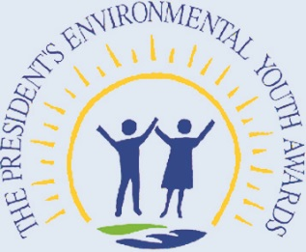 “These awards recognize the outstanding contributions of student leaders…on some of the most pressing issues facing our nation, including combating climate change and instituting sustainable practices.”

EPA Administrator Gina McCarthy, August 2014

# **Section 1: Program History**

The President’s Environmental Youth Awards (PEYA) recognizes outstanding environmental projects by K-12 youth. PEYA promotes awareness of our nation’s natural resources and encourage positive community involvement. Each year the PEYA program honors a wide variety of projects developed by young individuals, school classes (kindergarten through high school), summer camps, public interest groups, and youth organizations to promote environmental awareness.

Past projects have included building nature trails, starting recycling programs, restoring native habitats, installing renewable energy projects, and participating in many other creative, sustainable efforts. To read about past award-winning projects, visit: <http://www2.epa.gov/education/presidents-environmental-youth-award-peya-winners>

# **Section 2: How the Program Works**

The U.S. Environmental Protection Agency (EPA) has ten regional offices across the country. Each regional office will be responsible for selecting up to two winners per region, based on the evaluation criteria in Section 6. Applicants are welcome to include youth across multiple grade levels; however, the application will be categorized based on the applicant with the highest grade level. For example, if one applicant group consists of two 4th graders, one 3rd grader and one 6th grader, the application will be evaluated in the Grade 6-12 category.

Each award-winning project will receive a Presidential plaque. All qualified applicants will receive a certificate honoring them for their efforts to protect human health and the environment.

# **Section 3: Eligibility**

* Project is completed while the applicant(s) is in kindergarten through 12th grade.
* Applicant(s) is a citizen of the United States or its territories or has been lawfully admitted for permanent residency.
* Project is sponsored by at least one adult over the age of 21.
* Projects started on or after January 1, 2016 are eligible for consideration. As long as there was activity on the project after January 1, 2016, a project initiated prior to that date is eligible for consideration.

# **Section 4: Sponsors**

Each applicant or group of applicants applying for PEYA must be represented by a sponsor. The sponsor must be an adult at least 21 years of age and may be a parent, teacher, youth group adviser, summer camp counselor, community leader, or other interested individual. The adult sponsor plays an important role in helping a young person or group of young people carry out a project and apply for PEYA.

Typically, a sponsor offers suggestions and advice throughout the project to: develop a well thought-out project; implement the project; work with other groups and individuals in the community; complete the application form (for K-5 applicants); and assist in preparing accompanying materials. The sponsor must also sign and date the application. In signing, the sponsor confirms that he or she has parent or guardian consent for each applicant to participate in the PEYA program. Questions about the role of a sponsor should be directed to [PEYA@epa.gov](mailto:PEYA@epa.gov).

# **Section 5: How to Apply**

A blank application is provided on page A-1. A PDF version of this document can be viewed or downloaded at <http://www.epa.gov/education/presidents-environmental-youth-award-peya-applications-and-forms>.

## **Application Requirements**

* A project summary of up to 300 words must be provided on the application form. Please note that applicants that are applying in the 6-12 grade level category must complete the project summary section themselves. Applicants in the K-5 grade level may be advised by the sponsor and sponsors may assist in the writing of the project summary.
* A more detailed description of the project, no more than five pages, and addressing each of the evaluation criterion should be attached to the application.
* Applicants may submit up to five additional pages of photographs, newspaper articles, and other supporting materials to provide a more comprehensive view of the project. Accompanying videos must be web-based with functioning links (e.g., no CDs).
* Sponsors **must sign and date** page A-2 of the application. Sponsors will be notified of the application status in early May 2017.
* All application materials must be and received by March 1, 2017.

## **Submissions Instructions**

* Applications can be submitted electronically (email) or by hard copy (U.S. mail or commercial delivery service).
* All sponsors will receive a confirmation email upon receipt of the application package.
* Email completed application materials to [PEYA@epa.gov](mailto:PEYA@epa.gov) by **11:59 p.m. ET on March 1, 2017**. Applicants are encouraged to combine application materials into as few attachments as possible.
* Hard copies **must be delivered by 5:00 p.m. ET on March 1, 2017** to be eligible for consideration.
  + Mail completed application materials to:  
    U.S. Environmental Protection Agency

Office of Environmental Education

Attn: President’s Environmental Youth Award Program

William Jefferson Clinton North, Room 1426

1200 Pennsylvania Ave, NW, MC 1704-A

Washington, DC 20460

# **Section 6: How Applications Are Judged**

Each application is evaluated by a regional awards panel. The panel members review and evaluate each application based on the criteria. There are separate evaluation criteria for K-5 and 6-12 applications. A maximum of 100 points can be awarded to a given application.

## ***Evaluation Criteria K-5 (100 points)***

*Youth Initiative (20 points)*

How did the applicant(s) come up with the idea for the project? To what extent does the applicant(s) take charge of the project?

*Environmental Impact (30 points)*

How did the applicant(s) identify the environmental need for this project? How did the project positively affect the environment?

*Completion of Goals (15 points)*

What were the goals of the project? How were they accomplished?

*Community Involvement (10 points)*

To what extent did the project involve others in the school or community?

*Project creativity (15 points)*

What creative approach(es) did the applicant(s) use for the project?

*Project approach (10 points)*

To what extent does the application tell a complete story about the project? Did the applicant(s) have a thought-out approach to solving the problem?

## ***Evaluation Criteria 6-12 (100 points)***

*Youth Initiative (25 points)*

To what extent was the project designed, coordinated and implemented due to applicant (s) initiative? How was the project created and completed by the applicant(s)? The driving force for the project must be the applicant(s), not the sponsor.

*Environmental Need and Appropriateness (20 points)*

To what extent was there a clear environmental need for the project? How appropriate was the project for the community in which it was performed?

*Environmental Impact (15 points)*

To what extent was there a need for this project? How did the project positively affect the community? Were there any long-term environmental benefits or outcomes of the project?

*Completion of Goals (15 points)*

Were the goals accomplished?How were they accomplished?

*Community Involvement (10 points)*

To what extent did the project positively involve others in the community? What community resources, expertise, leadership, or publicity did the applicant(s) use?

*Project innovation (10 points)*

How did the applicant(s) use innovative approaches to achieve positive results?

*Soundness of approach, rationale, and scientific design (5 points)*

Was the approach to the problem clear? Did the applicant(s) have a sound justification for choosing that approach? If so, what is that justification?

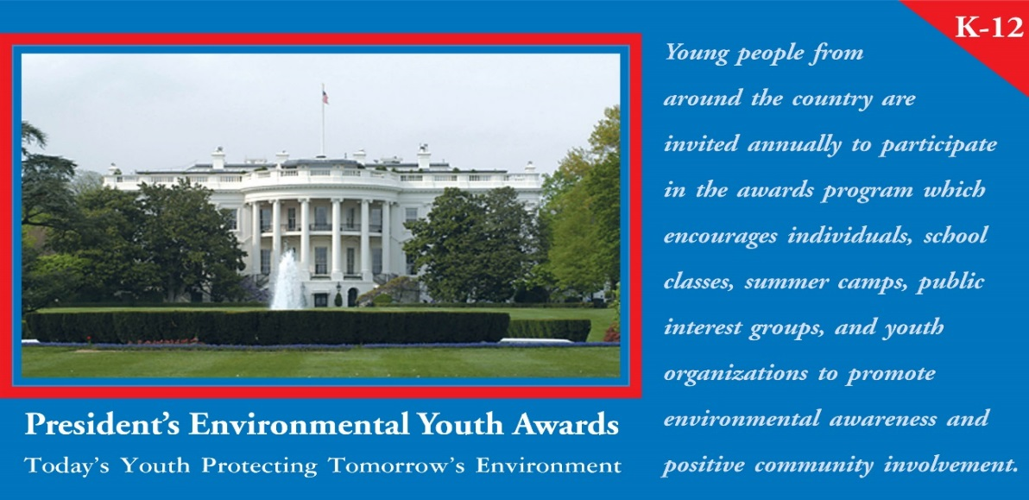

# **Individual/Group Information**

|  |  |
| --- | --- |
| Individual/Group Name: |  |
| Title of Project: |  |
| Number of Participants: |  |
| Date Project Began: |  |
| Date Project Ended: |  |

Please check the box for the grade level you are applying for below.

K-5  6-12

Did the project receive press coverage? If yes, please attach clippings.

Yes  No

# **Participants**

Fill in the table below with information for each of the youth participants. If necessary, continue on a separate sheet.

|  |  |  |  |  |  |
| --- | --- | --- | --- | --- | --- |
| **Name** | **Address** | **City** | **State** | **Age** | **Grade** |
|  |  |  |  |  |  |
|  |  |  |  |  |  |
|  |  |  |  |  |  |
|  |  |  |  |  |  |
|  |  |  |  |  |  |

# **Sponsor**

List the name and contact information for the adult sponsor. The sponsor must sign and date page A-2 of the application.

|  |  |
| --- | --- |
| Name: |  |
| Relationship to Applicants: |  |
| Address/City/State: |  |
| Phone Number: |  |
| Email: |  |

# **Description of the Project**

Please provide a short summary (no more than 300 words) of the project in the space provided below and identify the results achieved. The purpose and goals of the project should be included in the summary. A more detailed description of the project, addressing the evaluation criteria, should be included separately in 3-5 pages, double-spaced, Times New Roman, font size 12. You may also include up to 5 additional pages of photographs, press clippings, and other supporting materials.

*By signing below, the sponsor(s) certifies that the applicant(s) has performed this project. The sponsor also certifies that parent or guardian permission has been obtained for each applicant to participate in the PEYA program.*



Date: