***Draft***

Test Protocol for Evaluation of Idle Reduction Technologies

Table of Contents

1 General applicability 4

1.A Scope 4

2 Definitions 6

3 Abbreviations 8

4 Maintenance of records and application process 9

4.A Maintenance of Records 9

4.B Application Process 9

5 Measurements 10

5.A Fuel Consumption 10

5.B Emissions 11

5.C Noise 12

5.D Cabin Temperature 12

5.E Energy Performance 13

5.F Other Parameters 14

6 Test Procedures 15

6.A General Considerations 15

6.B IRT Fueling and Charging 15

6.C Test Conditions 15

6.D Test Setup 16

6.E Test Startup 17

6.F Test Sequence 17

6.G Starting a Test Run 17

6.H Test Duration 17

6.I Ending a Test Run 18

6.J Completing a Test 18

6.K Testing Procedure for Noise Measurement 18

7 Test Information 21

7.A Testing Organization 21

7.B Testing Facility 21

7.C Fuels and Engine Fluids Specifications 21

7.D Installation of IRT 21

7.E Test Truck Description 22

8 References 23

Appendix A – Forms 25

Form F1 – Application Form 25

Form F2 – Truck Form 26

Form F3 – Test Form 27

Form F4 – Evaluation Statement 28

# General applicability

The purpose of this document is to serve as a protocol for testing the emissions, fuel use, noise and operational performance of Idle Reduction Technologies (IRT). Idle Reduction Technologies are defined as devices that can be used in conjunction with a heavy duty truck, or other such vehicles, that will allow for the operator to shut down the truck engine and still have access to cabin features such as air conditioning and heating. This document outlines the procedures that allow an IRT manufacturer to have their device tested following a standardized protocol that ensures that all devices are tested in a similar manner.

This protocol focuses on the performance of the IRT with regard to five categories. These categories include exhaust emissions, fuel consumption, cabin temperature, energy consumption, and noise level of the IRT being tested. With the exception of noise level all other tests outlined in this procedure must be conducted in an environmentally controlled chamber. Testing in an environmental chamber ensures that all tests are conducted at representative, controlled, and repeatable ambient conditions. . Due to the effects of a chamber’s wall on the noise level measurements, this test alone must be conducted outside the test chamber.

Two specific ambient conditions were selected to represent summer and winter conditions expected in the U.S. These tests are described as the heating test and cooling test. The IRT being tested, depending on the type of device, will be subjected to either one or both of these test conditions. The cooling test measures the performance of the IRT maintaining the cabin temperature under hot and humid ambient conditions. The ambient conditions for the cooling test are 100±4 °F (38±2 °C), a relative humidity (RH) of 50±5%, and a 600±10 W/m2 vertical solar radiation measured at the roof’s surface of the vehicle. The heating test measures the performance of the IRT maintaining the cabin temperature under cold and windy ambient conditions. The ambient condition for the heating test are 0±4 °F (-18±2 °C), with a wind load blowing directly into the face of the truck at an average speed of 32±3.2 km/h (20±2 mph).

## Scope

The following describes the conditions under which this protocol is applicable and recommended.

### The recommended procedures of this document apply to idle reduction technologies (IRTs) for evaluating fuel use, emissions, noise, and energy performance in a controlled environment following standardized testing procedures.

### This document is applicable to all IRTs, including four major commercially available categories: internal combustion auxiliary power units (IC-APUs) including generator sets, battery air conditioning systems (BAC), fuel, fuel-operated heaters (FOH), and thermal storage cooling (TSC) systems.

### This evaluation process will address five elements of IRT operational characteristics: emissions of key pollutants (nitrogen oxides [NO*x* - NO and NO2], carbon monoxide [CO], carbon dioxide [CO2], total hydrocarbons [THC], and particulate matter [PM]), fuel consumption, noise, energy performance, and cabin temperature.

### The evaluation procedures of this document address only the performance of an IRT unit in de-greened state (stabilized operation). Durability evaluation or aged performance is not covered by these procedures.

# Definitions

Below is the definition of key terms used in this protocol:

### *Add-On IRT System:* An IRT system that can be used between trucks with few modifications.

### *Aging:* Subjecting the IRT unit to operating conditions that cause normal wear equivalent to at least 33% of the expected durability period declared by the manufacturer.

### *Applicant:* The person or organization requesting that their IRT be tested in accordance with the procedures outlined in the protocol.

### *Battery Air Conditioning System (BAC):* An IRT unit that is powered by a battery-powered electrical system to offer ventilation and air conditioning to the sleeping cabin.

### *De-Greening Period:* In the context of this protocol a brief period of use needed to achieve a stable operational condition that allows representative testing.

### *Fuel Cell IRT:* An IRT system powered by a fuel cell, which uses a chemical reaction to produce electricity from a fuel source such as hydrogen or other hydrocarbons.

### *Fuel-Operated Heaters (FOH):* An IRT system that provides heat to the cabin by combusting fuel which is drawn from truck’s main tank or other fuel sources.

### *Idle Reduction Technology (IRT):* A device that can be used in conjunction with a heavy duty truck, or other such vehicle, that will allow for the operator to shut down the vehicle engine and still have access to cabin features such as air conditioning and heating.

### *Integrated IRT System:* An IRT system integrated to a truck’s system such that moving it to another truck is not possible, or has significant adverse impacts on the performance of the system.

### *Internal Combustion Auxiliary Power Unit (IC-APU):* An IRT unit that is powered by an internal combustion engine and usually provides conditioned air as well as electricity to the cabin.

### *Point of No Service (PNS) –* The time at which a battery powered IRT no longer operates due to loss of battery capacity.

### *Portable Idle Reduction Technology (PIRT):* A device that is installed on a long-haul truck to offer drivers amenities such as air conditioning and electricity to the sleeping cabin while the engine is turned off.

### *Test Run:* A single test event for an evaluation element of a test sequence. Multiple test runs can be included in a single test sequence; e.g., multiple fuel consumption measurements.

### *Test Sequence (also Test):* A series of test runs conducted on an IRT unit to evaluate its performance. Multiple evaluation elements such as exhaust emissions, fuel use, and energy performance can be run during a single test. A single test sequence could include multiple test runs for different evaluation elements. The noise evaluation test must be run as a separate test.

### *Test Unit:* An IRT unit that is submitted to the testing organization to be tested.

### *Test Vehicle:* A long-haul truck with a sleeping cabin that is used by the testing organization for the purpose of testing the performance of an IRT system.

### *Testing Organization:* The organization that will perform the testing of the IRT device in accordance with the procedures outlined in the protocol.

### *Thermal Storage Cooling (TSC) System:* An IRT unit that provides cooling to the sleeping cabin through a thermal storage system. A thermal storage system stores energy in cold storage as the truck is driven and then provides air conditioning when the truck is turned off.

### *Warm-Up Period:* A brief period of operation needed to achieve a stable operational temperature that allows representative testing in non-cold start status.

# Abbreviations

### Battery Air Conditioning System (BAC)

### Carbon Dioxide (CO2)

### Carbon Monoxide (CO)

### Extended Duration Energy Performance (EDEP)

### Energy Performance (EP)

### Environmental Protection Agency (EPA)

### Evaluation Statement (ES)

### Federal Code of Regulations (CFR)

### Fuel Flow Meter (FFM)

### Fuel-Operated Heaters (FOH)

### Idle Reduction Technology (IRT)

### Internal Combustion Auxiliary Power Unit (IC-APU)

### International Organization for Standards (ISO)

### National Institute of Standards and Technology (NIST)

### Nitrogen Oxides (NOx)

### Overall Energy Performance (OEP)

### Particulate Matter (PM)

### Point of No Service (PNS)

### Portable Idle Reduction Technology (PIRT)

### Thermal Storage Cooling system (TSC)

### Total Hydrocarbons (THC)

# Maintenance of records and application process

## Maintenance of Records

The following forms should be filled out by applicants and testing organization during the different stages of the testing. Samples of the forms can be found in the Appendix A. These sample forms represent the minimal amount of information that must be submitted with the report detailing the findings of the test. The testing organization may provide other information as necessary for each report. All units must be specified on each form when it is filled out by the testing organization or applicant.

### *Application Form (F1):* The application form will be filled out by the applicant. The form will include all necessary information about the applicant and the IRT unit that is being submitted for testing.

### *Truck Form (F2):* The truck form is filled out by the testing organization. It contains all details about the truck that will be used for the test. Applicant can obtain a copy of this form prior to testing.

### *Test Form (F3):* The test form is filled out by the testing organization during testing. It contains facts about the test procedure, any notes that are made during the test by the testing organization, and other relevant information that is collected during the testing period.

### *Evaluation Statement (F4):* The ES is filled out by the testing organization after the test data has been collected and analyzed. The ES will include test results from all relevant tests for the IRT.

## Application Process

### The submitted units must be accompanied by a completed Application Form (F1).

### An applicant can include request for evaluation of more than one unit of a specific product, but a separate application form must be included for each unit.

### A single ES will be issued for each Application Form submitted. If an applicant wishes to have a unit retested they must submit a new Application Form.

### Applicants must specify all fueling, charging, and lubricating oil requirements along with recommended procedures. If any special equipment is required, the applicant should provide the equipment to the testing organization.

### Applicants must identify all normal maintenance requirements for their systems including cleaning or replacing components during the testing period. The testing period refers to the period that the IRT unit stays at the testing facility, including storage time.

### Applicants must provide recommended sleeper cabin blower settings. These settings will be used during the testing of the unit.

### Applicant should state if warm-up is necessary. If needed the applicant should describe what constitutes a fully warmed up state for the IRT.

# Measurements

This section describes the types of measurements required under the provisions of this protocol as well as the instrumentation and equipment needed to properly take the measurements.

## Fuel Consumption

Fuel use can be measured using a fuel flow meter (FFM), gravimetric method, or the carbon balance method.

### Fuel Flow Meter Method

#### The FFM must be capable of temperature density compensation.

#### The FFM must be calibrated to a minimum accuracy of ±1% at a flow rate consistent with the IRT unit being tested.

#### The FFM must record the flow rate at a minimum frequency of 1 Hz.

### Gravimetric Method

#### Gravimetric measurements require a good quality scale, accurately calibrated in increments of 0.1 lb (45 g) or 1 oz (28.4 g). Scales should be calibrated by an International Organization for Standards (ISO) 17025 certified lab. Scales should have a resolution of 0.1% of the expected fuel mass consumed (approximately $\frac{\text{1}}{\text{10}}$ oz for 1 gallon diesel fuel). When reading a scale with graduation marked at each ounce, it is a simple matter to interpolate to $\frac{\text{1}}{\text{4}}$ oz.

#### The gravimetric method uses a portable fuel tank to measure fuel consumption. The weight of the tank should be measured prior to starting the test. The test unit’s fuel line is connected to the portable tank the moment the test begins, and disconnected at the end of each test run, after which the portable tank is removed and reweighed. The fuel consumed during the test is calculated using the density of the fuel and the difference in the weight of the portable fuel tank before and after the test, to yield the volume (gallons) of fuel used.

#### The portable tank must have provisions for both supply and return lines of fuel. The fuel lines connected to the portable tank must be fitted with quick disconnect fittings to allow for removal without spillage.

#### All measurements must be weighed on the same portable scale. The outside of the portable tank should be wiped clean of dirt and fuel each time prior to being weighed. The scale should be placed inside a building to protect it from winds. Scales must be checked with a known deadweight before each series of readings. The deadweight shall be similar to that of a tank filled with fuel. The portable scale must not be moved between the initial and final weighting of a given test run.

#### The fuel temperature in the portable weighing tank must be kept below 160 °F (71 °C). Fuel coolers can be used to maintain the temperature below this value.

#### When gravimetric measurement method is used, the density of the test fuel must be determined following ASTM Test Method D-1298, Standard Test Method for Density, Relative Density (Specific Gravity), or API Gravity of Crude Petroleum and Liquid Petroleum Products by Hydrometer.

### Carbon Balance Method

#### If using the carbon balance method the testing must be conducted to comply with the Environmental Protection Agency (EPA) regulations as outlined in the federal Code of Regulations (CFR) 40 CFR Part 600, and 40 CFR part 86 subpart N. Carbon balance fuel efficiency must be calculated using the method outlined in SAE Standard J1094a.16. When using the carbon balance method it is acceptable to use either of the instruments listed in section 5.B.

It is recommended for quality control that a minimum of two types of fuel consumption measurements be used during a test, with one being the gravimetric method. This will allow the testing organization to validate the numbers measured by either the FFM or carbon balance method.

## Emissions

The following items describe the pollutants that need to be measured as well as the test equipment required.

### Emission measurements are required for an IRT that uses fuel (such as diesel) to deliver service. IRTs that use fuel include IC-APUs as well as FOHs.

### When measuring emissions the following items are required to be measured and reported:

#### Nitrogen Oxides - NO*x* (NO and NO2)

#### Carbon Monoxide - CO

#### Carbon Dioxide (CO2)

#### Total Hydrocarbons (THC)

#### Particulate Matter (PM)

### In addition to those listed above, the testing organization and applicant may agree to measure and report other emissions related criteria, such as air toxics.

### This test protocol adopts the requirements for laboratory exhaust gas sampling and analysis systems established in the federal emissions certification program described in 40 CFR Part 1065. For equipment and specifications not covered by that citation, 40 CFR Part 86, Subpart N will apply.

### Measurements can be also performed using a portable emissions measurement system (PEMS) which contain instruments using the same measurement technologies and meeting the same audit criteria as described in 40 CFR Part 1065 Subpart D.

### The devices used to measure the emissions must also measure the exhaust flow rate of the IRT so that the total amount of each pollutant can be calculated. This allows the final numbers to be reported in terms of mass, and not percentages.

## Noise

This section describes the procedures for determining truck’s sleeper-cab interior sound level due to the operation of IRT systems. This applies to all IRT systems.

### Sound level meter: A sound level meter must comply with the requirements of the Type I or S1A of American National Standard Institute (ANSI), specifications for Sound Level Meters, and S1.4-1983. Measurements can be made directly by using a microphone or a sound level meter with a data recorder and/or a graphic level recorder or other indicating instrument that meet the requirements of SAE J184.

### Sound level calibrator: A sound level calibrator must be capable of calibrating a sound level meter to within ±0.5 dB and must be National Institute of Standards and Technology (NIST) traceable.

### Microphones must be held in place in a manner that ensures that mechanical vibration will not affect the sound level measurement.

### All the measurements must be taken with the microphone oriented vertically upward.

### To minimize the impact of bystanders on the measurements, only 1 person should be present inside the cabin during measurements.

### When IRT has multiple blower fan settings (low, medium, high, etc.), noise measurements shall be performed for all settings.

## Cabin Temperature

Procedures for measuring cabin temperature are:

### The temperature inside the cabin should be measured using either thermocouples or resistance temperature detectors (RTD) or a combination of the two.

### It is required to collect and record cabin temperature at a minimum of once each minute, but can be recorded more frequently at the determination of the testing organization.

### There must be six thermal probes in the sleeper compartment’s area as shown in Figure 1.[1] The sleeper cabin temperature is presented as the average of the six probes.

### An optional single thermal probe may be installed at the front of IRT’s outlet vent to measure the temperature of the heated/cooled air exiting the IRT vent. This temperature may be included on the ES for the tested unit, but should not be included in the calculation of the sleeper cab temperature.

### The testing organization and test applicant may agree to use additional probes in the cab of the test vehicle for informational purposes. The locations of the additional probes should be noted in the test form (F3), but the measurements taken from these probes should not be included when calculating the sleeper cabin temperature for the ES.

### H:\HAQShare\Standard Operating Procedures\APU Protocol\Sleeper Cab Interior.jpg

Figure 1: Location of Cabin Temperature Probes

## Energy Performance

Energy consumption in this document refers to electric energy consumption.

### Any IRT that runs on its own battery power, or connects to the truck’s battery, is subject to the energy performance (EP) test.

### Two EP tests shall be performed on any IRT that runs on batteries: overall energy performance (OEP) and extended duration energy performance (EDEP) testing.

### OEP testing is required for all IRT systems that connect to the battery pack of the test truck. EDEP testing is required only for IRT systems which are charged while truck’s main engine is operating and have no other fuel source.

### OEP testing includes measurements representing the average EP of the IRT system while it maintains the target sleeper cabin temperatures. The purpose of this testing procedure is to determine if the IRT system can provide service to the sleeper cabin that meets the test criteria.

### EDEP testing demonstrates the ability of the IRT system to provide service to the sleeper cabin for an extended period of time, such as overnight service.

### For the EP measurements all instruments must record data at a minimum frequency of 1 Hz.

### The voltage and current of the truck batteries (or IRTs batteries if a separate battery pack is used) must be measured during the EP test.

### If a separate battery pack is used, but the unit also connects to the truck batteries, then the voltage of both battery packs must be measured and recorded.

### The final EP should be reported as follows:

#### electricity consumption in kilowatt-hours (kWh),

#### time the target cabin temperature was maintained (for EDEP testing) or the time to point of no service (EDEP testing),

#### whether the engine could be started at the end of the service period (EDEP testing).

## Other Parameters

Other parameters to be measured are wind speed and engine speed.

### *Anemometer:* An anemometer must be accurate within ±10% at 20 km/h (12 mph). The average wind speed measurements are made at the points indicated by an “X” in **Error! Reference source not found.**.

### *RPM Sensor:* An RPM sensor should be used for all IRTs that utilize an internal combustion engine. The RPM sensor is used to measure a unit’s engine rotational speed. At minimum, the RPM sensor must have a measurement range of 100-10,000 rpm, an accuracy of 10 rpm, and reports/records readings at a minimum frequency of 1 Hz.

# Test Procedures

## General Considerations

### The submitted unit must be in de-greened condition, according to the manufacturer’s recommendation, prior to testing, i.e., stable operational condition that allows representative testing. It is applicant’s responsibility to perform and document de-greening efforts and report those to the testing organization.

### This section describes the procedures that should be followed when running a test sequence on an IRT. Unless otherwise noted, these procedures should be followed for all measurements, with the exception of the noise measurement. The procedures for taking the noise level measurements are described later in this section.

### All measurements, other than the noise measurement, should be conducted concurrently during a test wherever possible. If separate tests are used to take the emissions, energy, fuel, or cabin temperature measurements, the testing organization should justify the use of separate tests on the Test Form (F3).

## IRT Fueling and Charging

### Fueling

#### If the IRT requires fuel, the fuel tank must have enough fuel for the duration of the test run. Fuel requirements are described in section 7.C.

### Charging

#### If the IRT is operated by battery it’s battery must be fully charged prior to beginning a test sequence. Charging is not required for each test run (with the exception of the extended duration energy performance (EDEP) test). Charging shall be accomplished using the procedure(s) recommended by the applicants for each IRT.

## Test Conditions

### Two ambient conditions (test chamber settings) are considered for fuel consumption, emissions, energy performance, and cabin temperature measurements.

#### Cooling Test: Measurements must be made at an ambient temperature of 100±4 °F (38±2 °C), a relative humidity (RH) of 50±5%, and a 600±10 W/m2 vertical solar radiation measured at the roof’s surface of the vehicle.

#### Heating Test: Measurements must be made at an ambient temperature of 0±4 °F (-18±2 °C), and a wind load blowing directly into the face of the truck at an average speed of 32±3.2 km/h (20±2 mph). The average wind speed measurements are made at the points indicated by an “X” in **Error! Reference source not found.**.

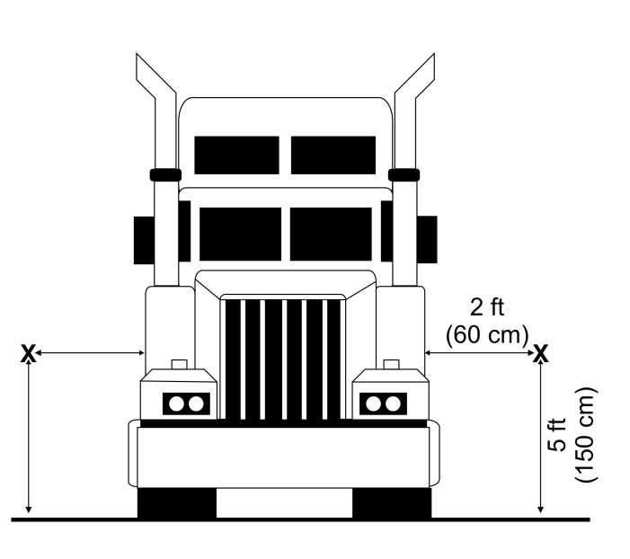

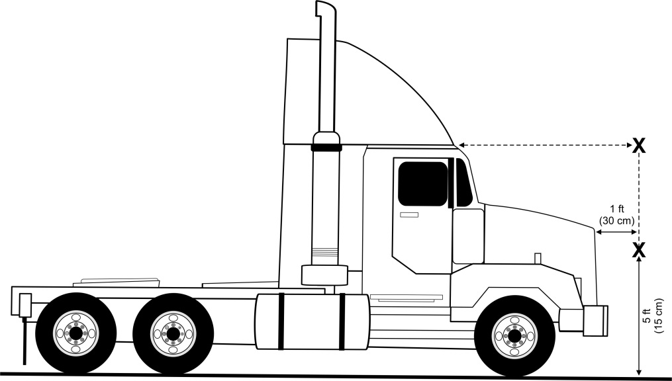

Figure 2: Locations for Wind Speed Measurement

## Test Setup

### Service Loading: If the unit provides electricity to the cabin, a constant standard power of 120 Watts must be applied to the unit for all measurements. This load is approximately equivalent to a typical laptop computer and a small television. For an EDEP test the service load shall only be applied for the first 2 hours.

### The sleeper curtain should remain closed during all tests covered in this document, unless the blower of the test unit is located in front of the curtains. In this case the curtains may remain open, but the configuration must be noted in the Test Form (F3) and ES.

### The test truck’s windows and vents must be in closed position for the entire duration of a test.

### At no time during testing should there be more that 1 person present in the cabin.

### For all measurements, the IRT’s thermostat must be set so the steady-state temperature in the cabin can reach the target value of 73±2 °F (23±1 °C). The reading on the thermostat that is required to meet the temperature must be reported in the ES. If the IRT does not have a thermostat, the blower controls should be adjusted so that the steady-state temperature in the cabin reaches 73±2 °F (23±1 °C). It is recommended that the testing organization conduct preliminary tests, prior to starting an official test run to determine the appropriate blower settings to meet the desired temperature range. Once the thermostat is set the settings must remain unchanged throughout the duration of the entire test sequence. If the setting is changed, the test sequence must start over.

### If the IRT is unable to meet the required steady-state temperatures inside the cabin then the ES shall include the temperatures IRT was capable of reaching at maximum setting.

## Test Startup

### Testing should not start until the test chamber has reached steady-state ambient conditions. This requires that the key ambient parameters (temperature, relative humidity, simulated solar radiation, and/or wind speed) remain within their desired range for at least a 5-minute period.

### All measurement devices should be switched on and recording prior to starting a test run.

## Test Sequence

### For an IC-APU a test sequence consists of a minimum of four valid test runs. The first test run should be a cold start test run, and the three subsequent test runs should be conducted when the test device is in a warmed up state. A device is in a warmed up state if it has been running continuously for 15 minutes prior to beginning the test. If the device is shut off for more than 5 minutes it must be warmed up again prior to starting another rest run. For all other types of IRT devices only three valid test runs are required as the cold start test run is not required.

## Starting a Test Run

### Once all test startup requirements are met the first test run may start.

### The first test run begins when the IRT device is turned on. The remaining test runs do not require the IRT to be turned off between test runs, as long as the measurements are taken for the correct duration of a test run.

### The start time for the test should be recorded on the Test Form (F3).

## Test Duration

### Each test run (except for EDEP tests) consists of measurements for a continuous operation of the unit for a minimum duration of 60 minutes. A longer period may be used, but should be noted on the Test Form (F3). The duration of each test run must be repeated within ±0.25% (±9 seconds for 60 minutes testing) for each run within a test sequence.

### The fuel consumption for each test run must be within ±2% of each other in order to be valid, except the cold start test. If the fuel consumed for any of the runs is out of these limits the run is said to be invalid and should not be counted in the results.

### The test duration for an EDEP test will depend on the performance of the IRT. The EDEP test run consists of a single measurement for a continuous operation of the unit for 10 hours, or until it reaches the point of no service (PNS). The PNS is reached when the temperature in the sleeper cabin has been out of the 73±5 °F (23±3 °C) range for 10 minutes or the unit turns off. If the unit cannot meet the requirements of 73±5 °F (23±3 °C), the temperature must remain within ±5 °F (±3 °C) of the IRT’s optimal temperature for the duration of the test. If the unit is still running after 10 hours the applicant and testing organization may agree to keep the test running until the unit turns off. The total duration time that the unit runs is then reported on the ES.

## Ending a Test Run

### At the end of a test run the IRT may either be turned off or allowed to continue to run. If the IRT is allowed to continue to run it is important that the measurements be stopped at the end of the run, including swapping the fuel tank for the IRT if the gravimetric method is being used to measure fuel consumption.

### The end time of the test should be recorded on the Test Form (F3).

### At the end of each test run, all data are recorded and measurement instruments calibrated. If the IRT is turned off between runs, it must be started again within 15 minutes for each test run after the initial cold start test.

### After all instruments are calibrated a new test run can begin.

### At the end of an EDEP test run the testing organization must attempt to start the truck’s main engine. The result is reported as either “failed” (the engine could not be started) or “passed” (the engine could be started). If the truck did not start due to circumstances other than the voltage of the truck battery, it must be noted on the ES.

### A valid test run is one that meets the time and fuel requirements of a test run and has no equipment malfunctions during the test.

## Completing a Test

### A valid test, or test sequence, consists of a minimum of four valid test runs, with the exception of an EDEP test. An EDEP test only requires one valid test run.

### The final results of each measurement (except cabin temperature and noise) are reported as two numbers, a cold start number and a normal operation number. The cold start number will be the data from the cold start test, and the normal operation number will be the average of the remaining three valid tests. Data from test runs that fail, or are invalid for any reason, should not be included in the average.

### The cabin temperature result should be the average final temperature measured at the end of each test run.

## Testing Procedure for Noise Measurement

### Measurements must be made at the expected locations of the operator’s head while using the sleeper cabin. At minimum, measurements must be made at two points representing operator’s head at sleeping and sitting positions. Use good engineering judgment to interpret the terms “sleeping” and “sitting” in this part to select the measurement points.

### Vehicle windows and vents must be in closed position.

### The truck engine and all the accessories must be turned off.

### The IRT must be running within the manufacturer’s recommended operating conditions.

### Measurements must be made for both heating and cooling modes. The field calibration must be made immediately before and after each test run.

### No large sound-reflecting surfaces should be within 15 m (50 ft.) of the test vehicle. **Error! Reference source not found.** illustrates this requirement.

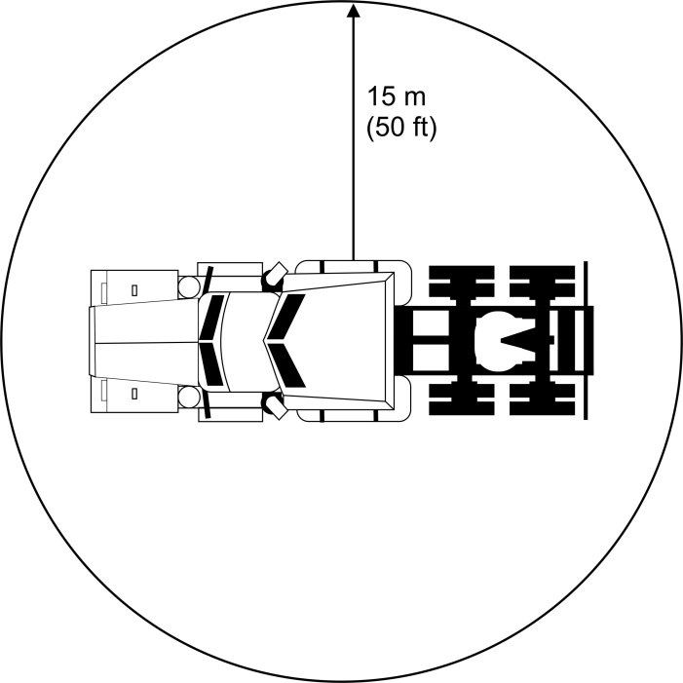

Figure 3: Location Requirement for Noise Measurement

### Measurements must be taken on a smooth, dry concrete or asphalt surface.

### Wind speed should not exceed 20 km/h (12 mph).

### A minimum of 3 test runs must be performed. Each test run shall be made within 5 minutes of the previous test and consist of a minimum of 4 measurement readings that are 30 to 60 seconds apart. The test runs must be repeated until 4 consecutive readings of that run are within a 2 dB range. The average of these 4 readings will be recorded as a representative value for that run.

### All readings must be the A-weighted sound level measurements.

### The reported sound level will be the highest average test run sound level value.

### If a data recording system is used, a recording will be documented during each test run. Record a calibration signal of known acoustic level immediately prior to and following each test run. For analysis of the test run recordings, use the calibration signal to establish a playback gain and thus calibrate the analysis system. Set the level indicating instruments for “fast-exponential-averaging” or equivalent for analysis of the recorded data.

### Table 1 is an example that may be used to record the noise measurements.

Table 1: Sample Calculation Table for Noise Measurements

|  |  |  |  |  |  |  |  |  |  |  |  |
| --- | --- | --- | --- | --- | --- | --- | --- | --- | --- | --- | --- |
|  | | | **A-weighted Sound Level (dB)** | | | | | | | | **Average of 4 consecutive measurements within 2 dB** |
|  | **Temperature**  **⁰C (⁰F)** | **Relative Humidity %** | **Measurement 1** | **Measurement 2** | **Measurement 3** | **Measurement 4** | **Measurement 5** | **Measurement 6** | **Measurement 7** | **Measurement 8** |
| **Run 1** |  |  |  |  |  |  |  |  |  |  |  |
| **Run 2** |  |  |  |  |  |  |  |  |  |  |  |
| **Run 3** |  |  |  |  |  |  |  |  |  |  |  |
| **Run 4** |  |  |  |  |  |  |  |  |  |  |  |
| **Run 5** |  |  |  |  |  |  |  |  |  |  |  |
| **Run 6** |  |  |  |  |  |  |  |  |  |  |  |
| **Final Sound Level (dB)** | | | | | | | | | | |  |

# Test Information

## Testing Organization

### The testing organization must have all facilities and instruments required to perform all testing procedures. All instrumentation required for this test is listed in Section 5. The instrumentation used must meet all applicable specifications that are listed in this section for fuel consumption, emissions, noise, cabin temperature, as well as electric energy consumption.

## Testing Facility

### Fuel consumption, emissions, energy performance, and cabin temperature measurements must be performed inside an environmental chamber that can provide consistent ambient conditions (temperature and relative humidity (RH)) for the duration of testing. The environmentally controlled test chamber must be capable of achieving the proper ambient conditions for both the heating and cooling tests. The conditions necessary for testing, are shown in section 6.C.i. The chamber must also be able to provide the necessary solar load and wind speed described in section 6.C.i.

### Noise measurements must be performed in a location that meets the criteria described in section 6.K.

## Fuels and Engine Fluids Specifications

### Fuels

#### Standard highway diesel meeting 40 CFR part 1065 subpart H should be used for all tests requiring diesel fuel. Fuel analysis must be attached to the ES form (F4).

#### A winterized diesel (85% standard highway diesel and 15% kerosene with maximum 15 ppm sulfur content) shall be used for heating tests.

#### Applicant should specify the fuel requirements for the device if the required fuel is different from the standard test fuel.

#### The unit must be fueled from the same fuel source during the entire test to ensure consistent fuel quality.

### Lubricants

#### Applicants must specify and provide all necessary lubricants that are required to operate the submitted IRT.

### Coolants

#### Applicants must specify and provide all necessary coolants that are required to operate the submitted IRT.

## Installation of IRT

### Applicants are responsible for proper installation of their unit on the test truck.

### The applicant and the testing organization may agree to a modified installation of the unit. Modifications can be made only to protect the test vehicle from damage due to installing and uninstalling the unit and must be reported on the ES. Any modifications made to the installation should not affect the performance of the IRT.

## Test Truck Description

### The testing organization must supply the applicants with the following information about the test vehicle. These features should also be included in the Truck Form (F2).

#### Cabin Description/Dimensions (Sleeper/Day Cab)

#### Make and Model

#### Model Year

#### Exterior Color

### Standard cabin insulation features such as door seals and sleeper curtain must be in good conditions and free of any obvious leak or damage.

### If the test vehicle has any non-factory insulation installed, it must be approved by the applicant and testing organization and noted in the truck form.

# References

1. California Air Resources Board, *Code of Regulations*, Title 13 Division 3 Chapter 14 p.1.
2. California Air Resources Board, *Code of Regulations*, Title 13 Division 3 Chapter 14 p.39.
3. Department of Defense (1989) Military Standard: Generator Sets, Engine Driven

Methods of Tests and Instructions, MIL-STD-705C.

1. RTI International, *Generic Verification Protocol for Bioreaction System Control Technologies for Volatile Organic Compound Emissions,* EPA Cooperative Agreement No. CR826152-01-3.
2. RTI International, *Generic Verification Protocol for Bioreaction System Control Technologies for Volatile Organic Compound Emissions*, EPA Cooperative Agreement No. CR826152-01-3, Page 20.
3. RTI International, *Generic Verification Protocol for Bioreaction System Control Technologies for Volatile Organic Compound Emissions*, EPA Cooperative Agreement No. CR826152-01-3, Page 28.
4. Society of Automotive Engineers (SAE), *J1094 Constant Volume Sampler System for Exhaust Emissions Measurement*, Part a.16.
5. Society of Automotive Engineers (SAE), *J1321 Fuel Consumption Test Procedure Type 2*.

(9) Society of Automotive Engineers (SAE) 1998, *J184 Qualifying a Sound Data*

*Acquisition System*, SAE Recommended Practice.

(10) Society of Automotive Engineers (SAE) 2000, *J1096 Measurement of Exterior Sound*

*Levels for Heavy Trucks under Stationary Conditions*, SAE Recommended Practice.

(11) Society of Automotive Engineers (SAE) 2001, *J336 Sound Level for Truck Cab*

*Interior*, SAE Recommended Practice.

(12) U.S. EPA, Title 40: Protection of Environment Part 1065-Engine-Testing Procedures,

Section 25, 1001.

(13) U.S. EPA, Title 40: Protection of Environment Part 1065-Engine-Testing Procedures,

Subparts B, D.

(14) U.S. EPA, Title 40: Protection of Environment Part 1065-Engine-Testing Procedures,

Subpart H.

(15) U.S. EPA, Title 40: Protection of Environment Part 600-Fuel Economy and Greenhouse

Gas Exhaust Emissions of Motor Vehicles.

(16) U.S. EPA, SmartWay Fuel Efficiency Test Protocol for Medium and Heavy Duty

Vehicles.

(17) U.S. EPA, Title 40: Protection of Environment Part 86-Control of Emissions from New

and In-Use Highway Vehicles and Engines, Subpart N.

(18) Technology and Maintenance Council (TMC) RP 432: *Engine Off HVAC*

*Performance Requirements for Truck Cabs with Sleepers*.

# Appendix A – Forms

## Form F1 – Application Form



## Form F2 – Truck Form



## Form F3 – Test Form



## Form F4 – Evaluation Statement



1. Adapted from ATA Technology and Maintenance (TMC) 432.