NPDES Security Enhancement: Details for MSGP Certifiers
January 27, 2016

Information for Certifiers:
- For New NOIs: You will automatically receive access to the NPDES IDs of any New NOIs you submit. In most cases you should also have access to the NPDES IDs of NOIs you submitted through NeT before we made this change.
- For Change NOIs, NOTs, and Annual Reports:
  - You will need access to the NPDES ID before you can prepare or sign any of these forms from now on. If you do not already have access from signing and submitting a New NOI, please see “Requesting Access to a NPDES ID” below.
  - If you would like someone else to prepare a form for you to sign, both they and you will need access to the NPDES ID. Instructions for a Preparer to access a NPDES ID are included below in the Information for Preparers.
- If you choose, you can grant someone within your organization “Permit Administrator” authority for a NPDES ID you have access to. This means that they will be able to manage access to that NPDES ID for you and can grant or revoke access to that NPDES ID for other NeT users inside and outside of your organization. You should only give this authority to someone you trust.
Permit Administrators cannot sign and submit permits like Certifiers, but placing someone in this role may be useful for controlling which Preparers can prepare forms for that NPDES ID.

Requesting Access to a NPDES ID:
- Log into CDX at https://cdx.epa.gov and go open NeT
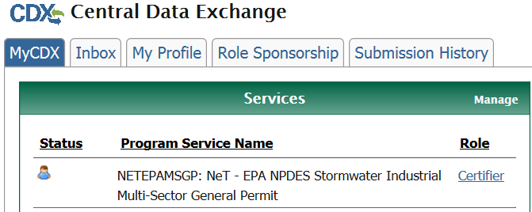
- If no one has access to the NPDES ID you need:
  - Go to “Forms”:
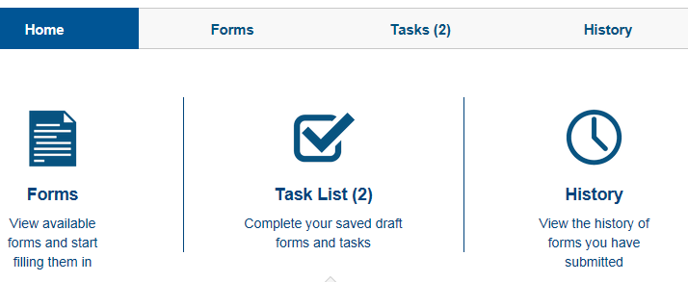
  - Choose the “Request NPDES ID Access” form:
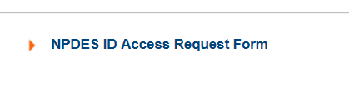
  - Under “What action would you like to take?” choose “Initial Permit Administrator Request to Regulatory Authority”
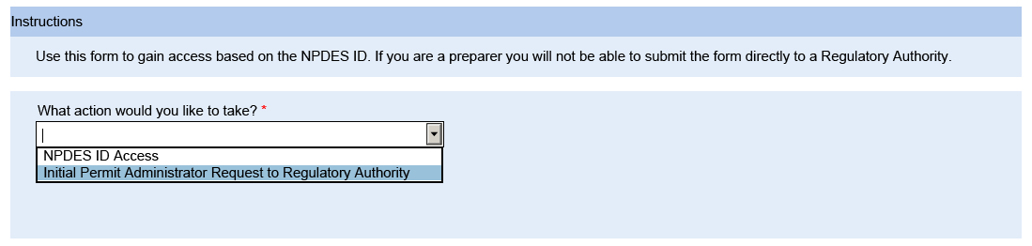
  - Enter the NPDES ID and click Lookup
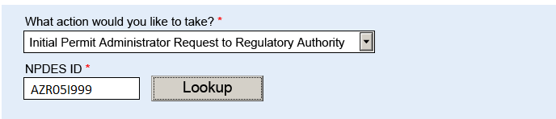
  - Check the box below to confirm you have the right NPDES ID
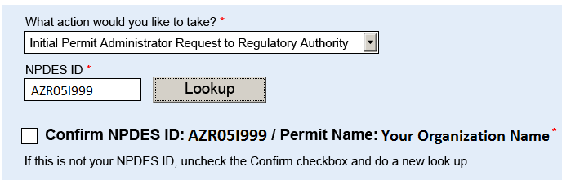
  - Click Submit Now
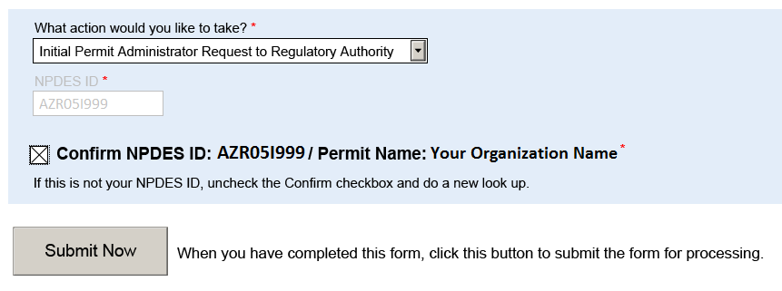
  - This form will be approved or rejected by the Regulatory Authority within NeT, similar to the process of approval or rejection of NOIs
  - Once this is approved, you will be able to grant someone else within your organization “Permit Administrator” authority and they will be able to control who has access in the future. This authority should only be given to someone trusted to act in the best interests of your organization.
- If a Certifier or Permit Administrator within your organization already has access to the NPDES ID, but now you need access:
  - Within NeT, the user who needs access should fill out and submit the “Request NPDES ID Access” form
  - Under “What action would you like to take?” choose “NPDES ID Access”
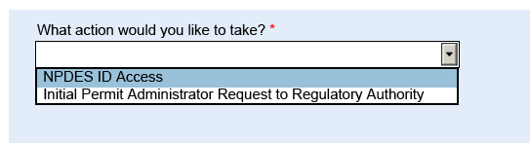
  - Enter the NPDES ID and click Lookup
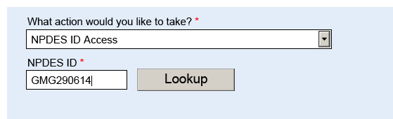
  - Check the box below to confirm you have the right NPDES ID
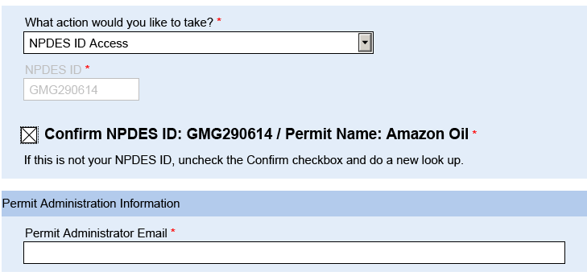
  - Enter the email of the Certifier or Permit Administrator who already has access
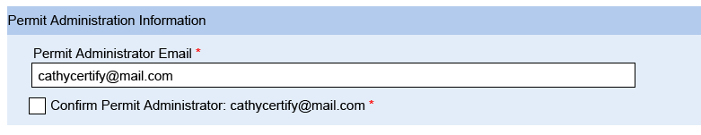
  - Click the Confirm box and Submit Now
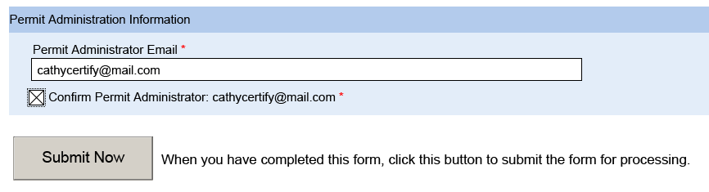
  - The Certifier/Permit Administrator will need to log into NeT and approve or reject your request, as they would with a form you had prepared

