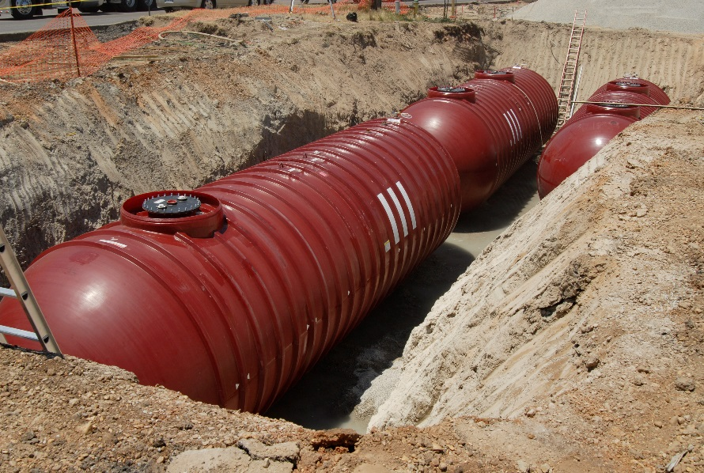
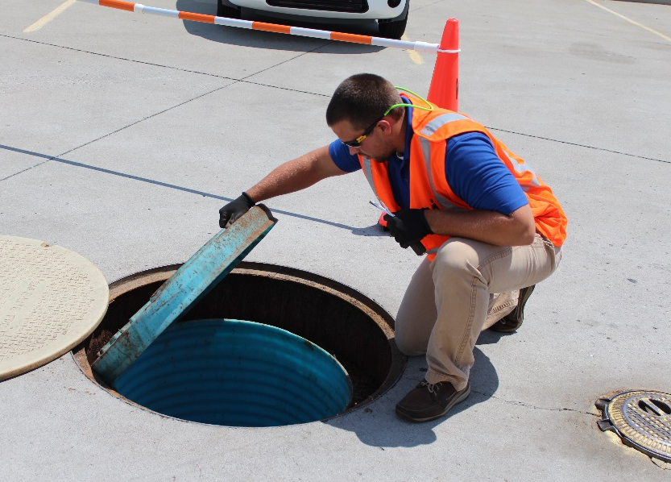
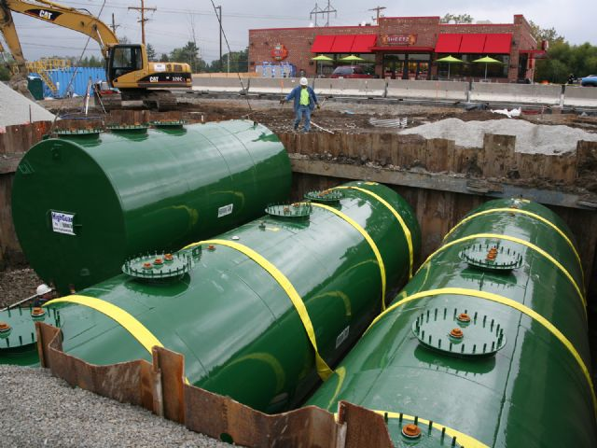
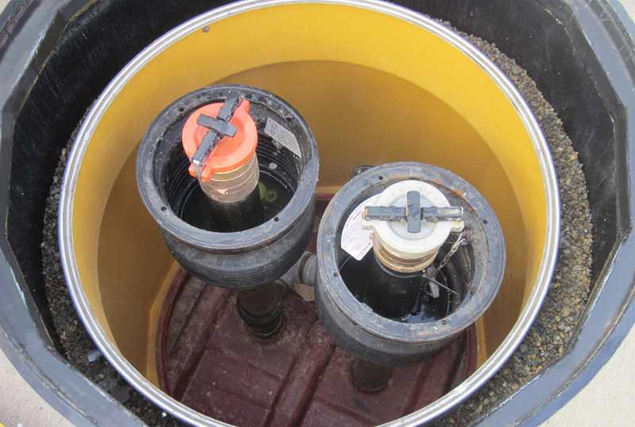
EPA 510-K-15-002
November 2015

UST System Compatibility With Biofuels

Printed on Recycled Paper

EPA wrote this booklet for owners and operators of underground storage tanks (USTs).
This booklet describes the 2015 revised federal UST regulation. Many states and territories (referred to as states in this booklet) have state program approval from EPA. To find a list of states with state program approval, see www.epa.gov/ust/state-underground-storage-tank-ust-programs.
If your UST systems are located in a state with state program approval, your requirements may be different from those identified in this booklet. To find information about your state’s UST regulation, contact your implementing agency or visit its website. You can find links to state UST websites at www.epa.gov/ust/underground-storage-tank-ust-contacts#states.
If your UST systems are located in a state without state program approval, both the requirements in this booklet and the state requirements apply to you.
If your UST systems are located in Indian country, the requirements in this booklet apply to you.

Image credits:

MVI Field Services (inspector on cover)
Highland Tank & Manufacturing Company (steel tanks on cover and in headers)
OPW (fill sump on cover)

Free Publications About UST Requirements
Download or read UST System Compatibility With Biofuels on EPA’s underground storage tank (UST) website at www.epa.gov/ust. Order printed copies of many, but not all, of our documents from the National Service Center for Environmental Publications (NSCEP), EPA’s publication distributor: write to NSCEP, PO Box 42419, Cincinnati, OH 45242; call NSCEP’s toll-free number 800-490-9198; or fax your order to NSCEP 301-604-3408.

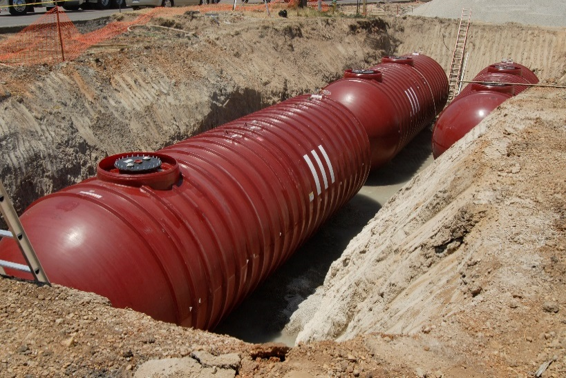

Contents
Contents

What Is This Booklet About? 1
How Do You Meet The Updated Compatibility Requirements? 7
Upgrading Equipment To Meet Compatibility Requirements For Storing Biofuels 11
Resources For More Information About Biofuel Compatibility Determinations 12
Publications About USTs 13
Appendices A-1
Disclaimer

This document provides information about underground storage tank (UST) system compatibility. The document is not a substitute for U.S. Environmental Protection Agency regulations nor is it a regulation itself — it does not impose legally binding requirements.

For regulatory requirements regarding UST systems, refer to the federal regulation governing UST systems (40 CFR part 280).

What Is This Booklet About?

Releases from USTs can threaten human health and the environment, contaminating both soil and groundwater. As of 2015, more than 525,000 UST releases have been confirmed.

Ensuring UST systems are compatible with the substances they store is essential to preventing releases of regulated substances to the environment.

As of 2015, the U.S. Environmental Protection Agency (EPA) regulates over one-half million underground storage tank (UST) systems that contain petroleum or hazardous substances. EPA’s Office of Underground Storage Tanks was formed in response to the discovery in the early 1980s that thousands of USTs had leaked and contaminated groundwater supplies in the United States. While the number of annual releases since that time has gone down significantly, releases of petroleum from USTs into the environment are still a significant concern today. Underground storage tanks form a crucial part of our country’s fueling infrastructure. It is important for USTs to be constructed, maintained, and operated in a manner such that petroleum and other regulated substances are stored safely. EPA developed the UST regulation to help owners and operators meet those goals.

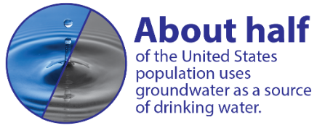
Two biofuels, primarily ethanol and biodiesel, have significantly increased their volume share of the total national vehicle fuel market over the last decade. Other biobased fuels are projected to enter the market soon. Ensuring compatibility of UST systems with these fuels – knowing the materials that make up the UST system will maintain their respective chemical and physical properties when in contact with the substance they are storing – is essential. Storing a fuel in an UST system with which it is not compatible may jeopardize the integrity of the UST system and cause a release to the environment.

This booklet will help you understand what you need to do in order to meet the 2015 UST compatibility requirements when storing biofuels and petroleum-biofuel blends and minimize the risk of a release from your UST system due to incompatibility.
Remember, compatibility with the substance stored is required for all UST systems. Equipment incompatible with the fuel stored could harden, soften, swell, or shrink and could lead to release of fuel to the environment.

Why Is Compatibility Important?

In an UST system, the regulated substances stored must not interact with the materials comprising the system in any way that would cause the material to change its performance. USTs contain many components made of different materials. If any of these materials are incompatible with the regulated substance stored and even temporarily lose their manufactured properties such as shape or flexibility, the UST system may fail to contain the substance. This could lead to a release to the environment and possibly a failure to detect the release. Examples of observed incompatibility between fuels stored and UST materials include equipment or components such as tanks, piping, or gaskets and seals that have become brittle, elongated, thinner, or swollen when compared with their as-installed conditions.
The 2015 UST regulation clarifies methods for demonstrating compatibility for fuels containing greater than 10 percent ethanol or greater than 20 percent biodiesel. However, implementing agencies may have different compatibility requirements for storing biofuels, so it is important to contact them before storing higher blends of biofuels.

Compatibility In The 1988 UST Regulation
EPA has required UST systems to be compatible with the substance stored in them since the 1988 UST regulation. Compatibility is required for as long as the UST system is used to store regulated substances. From the 1988 UST regulation:

- You must use an UST system made of or lined with materials compatible with the regulated substance stored in the UST system.
Most currently installed UST systems have at least some components that may not be compatible with fuel blends containing more than 10 percent ethanol or more than 20 percent biodiesel. However, components compatible with higher blends are now available. If you choose to upgrade your UST system, remember to require that your installer use compatible equipment.

However, the United States’ fuel supply has changed significantly since 1988 and there has been an exponential growth of the use of alternative fuels. Biodiesel is commonly blended into diesel and ethanol into gasoline. The resulting blended fuels stored in USTs usually contain 20 percent biodiesel (B20) or less or 10 percent ethanol (E10) or less of the petroleum based fuel volume. However, in certain percentages petroleum-biofuel blends are more aggressive toward certain materials used in UST system construction than the petroleum based fuel without biofuels. In addition to the compatibility requirement above, the 2015 UST regulation includes requirements for owners and operators of certain UST systems to help ensure UST systems are compatible with biofuels prior to storing them.

Why EPA Updated The Compatibility Requirements In The 2015 UST Regulation
Adding any amount of ethanol to petroleum based fuels changes how the fuel interacts with materials. Blends greater than 10 percent ethanol by volume show the most ability to affect the performance of some materials in older UST systems. New materials that are compatible with these fuels are readily available.

The fuel supply in the United States is constantly evolving. Ensuring compatibility prior to storing any regulated substance in an existing or new UST system is important, because your UST system may have been built with components that were not intended for use with the biofuel you wish to store today.

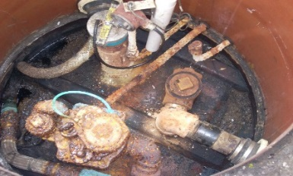
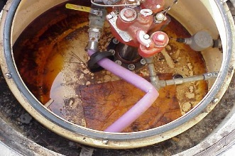
One example that demonstrates the importance of knowing the compatibility of your UST system involves ethanol, an oxygenate commonly blended into fuel to improve engine efficiency and emissions. Ethanol became widely used in the United States in blends up to 10 percent by volume in the mid-2000s when methyl tertiary butyl ether (MTBE), an oxygenate introduced to enhance octane as lead was phased out of gasoline, was itself phased out due to environmental concerns.

These photos of UST system material incompatibility were not caused by biofuels, but provide good examples of incompatibility. Top to bottom are pipe elongation, cracking of the internal tank lining, and delamination of product piping (in top left of the picture.)

Research has shown that some materials, such as some polymers and elastomers commonly used in UST system construction prior to ethanol becoming widely used, may swell and lose their shape when in contact with ethanol. In an UST system, these materials may be intended to create a seal between components, but if damaged, may not perform correctly and could lead to a release of a regulated substance to the environment. These materials may show the most swelling in gasoline blended with ethanol greater than 10 percent by volume. Other regulated substances, such as higher concentrations of biodiesel, may also present compatibility considerations for these or other UST components.

UST systems are designed for long lifespans and are normally not frequently replaced. As the fuel supply changed to incorporate more ethanol, UST and fuels stakeholders found that some installed UST systems were incompatible with lower level ethanol blends. The UST system equipment industry responded to the increasing use of biofuels and the risks identified by creating equipment compatible with lower blends of these fuels. Over time, the industry also began producing equipment compatible with higher blends of ethanol and biodiesel – those that are generally more aggressive towards more commonly used UST system materials. EPA thinks that all new tanks and piping produced today are compatible with blends of up to 100 percent ethanol and biodiesel.

However, many of the ancillary components may still be available in versions not compatible with up to 100 percent biodiesel or 100 percent ethanol. The whole UST system – including the tank, piping, containment sumps, pumping equipment, release detection equipment, spill prevention equipment, and overfill prevention equipment – needs to be compatible with the fuel stored to prevent releases to the environment. Biofuel blends with ethanol up to 98 percent (E98) and biodiesel up to 99 percent (B99) have been stored compatibly in some UST systems around the country.

EPA thinks most UST systems are not fully compatible with higher blends of biofuels because many were installed before some compatible UST system equipment was available. EPA updated the compatibility requirements in the 2015 UST regulation to ensure higher blends of biofuels will be stored only in compatible UST systems.

The 2015 UST regulation describes the steps UST owners and operators must take to help protect our health and environment from potential UST releases due to incompatibility. These steps will also help you avoid the high cost of cleaning up releases and possible legal actions that can result if your UST system releases product to the environment.

Check With Your Implementing Agency
This booklet describes EPA’s requirements for compatibility, but your implementing agency may have requirements that are somewhat different or more stringent than the federal requirements. Contact your implementing agency for its specific compatibility requirements. Many agencies may require owners who store biofuels follow different requirements, which could include submitting documents that differ from the examples provided in this booklet.

Many states and territories (referred to as states in this booklet) have state program approval from EPA. To find a list of states with state program approval, see www.epa.gov/ust/state-underground-storage-tank-ust-programs.

If your UST systems are located in a state with state program approval, your requirements may be different from those identified in this booklet. Check with the state UST program in the state where your USTs are located.

If your UST systems are located in a state without state program approval, both the requirements in this booklet and the state requirements apply to you.

If your UST systems are located in Indian country, the requirements in this booklet apply to you.

Compatibility Requirements In The 2015 UST Regulation
A list of contacts
is available at
www.epa.gov/ust/
underground-storage-tank-
ust-contacts#states.
The 2015 UST regulation maintains the requirement that all UST systems must be made of or lined with materials compatible with the substance stored in the UST system.

The 2015 UST regulation provides clarity to the 1988 compatibility requirement by specifying additional compatibility requirements for owners and operators wishing to store certain regulated substances, including gasoline containing more than 10 percent ethanol and diesel containing greater than 20 percent biodiesel. Research has identified these substances as having a higher likelihood of incompatibility with many existing UST systems. By targeting the additional compatibility requirements toward the specific subset of the UST operating universe with the highest risk of failure due to incompatibility, the overall risk of releases will be minimized.

The 2015 UST compatibility requirements incorporate some elements similar to EPA’s 2011 Guidance On Compatibility Of UST Systems With Ethanol Blends Greater Than 10 Percent And Biodiesel Blends Greater Than 20 Percent (www.epa.gov/ust/guidance-compatibility-ust-systems-ethanol-blends-greater-10-percent-and-biodiesel-blends), including demonstrating that the UST system is compatible with the substance stored and keeping certain records. Beginning on October 13, 2015, in addition to the 1988 requirement of ensuring that the UST system is compatible, UST owners and operators intending to store regulated substances must also meet these additional compatibility requirements:

Notification

- You must notify your implementing agency at least 30 days before switching to any of the following products:
  - Regulated substances containing greater than 10 percent ethanol
  - Regulated substances containing greater than 20 percent biodiesel
  - Any other regulated substance identified by your implementing agency

Please see Appendix 1 for a sample letter for notifying your implementing agency that you plan to switch to store a biofuel.

Additionally, owners and operators storing one or more of these regulated substances must meet the compatibility requirement by demonstrating compatibility of the system with the fuel or by using an alternative method approved by the implementing agency:

Demonstration of compatibility

- If you store any of these substances, you must either:
  - Demonstrate that the following UST system components are compatible with the regulated substance: tank, piping, containment sumps, pumping equipment, release detection equipment, spill prevention equipment, and overfill prevention equipment
Note: In this list, pumping equipment refers to the equipment used to move the fuel from the underground storage tank to the fuel dispenser. The regulation does not address the fuel dispenser itself because the UST regulation only covers equipment at or under the surface of the ground. Although not covered in the UST regulation or this document, you should make sure your dispenser is also compatible with the substance stored. Check with your local implementing agency to find out which department or agency regulates fuel dispensers in your area, so that you can ensure you meet all requirements for fuel dispenser compatibility.
  - Use another option determined by the implementing agency to be no less protective of human health and the environment than the demonstration method

Recordkeeping

- Beginning on October 13, 2015, if you store regulated substances containing greater than 10 percent ethanol, greater than 20 percent biodiesel, or other substances identified by your implementing agency, you must keep records showing that your UST system is compatible with those substances. If you choose to follow an alternative method determined to be no less protective of human health and the environment established by your implementing agency, then you must keep documentation of adherence to this requirement as required by the implementing agency’s rules. You must keep these records for as long as you store these regulated substances

Owners and operators may wish to consult American Petroleum Institute’s Recommended Practice 1626, Storing and Handling Ethanol and Gasoline-Ethanol Blends at Distribution Terminals and Filling Stations. It may be useful in complying with the compatibility requirement.

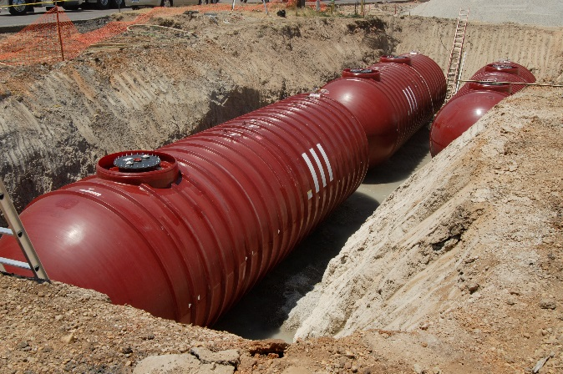

How Do You Meet The 2015 Compatibility Requirements?

This section explains how to meet the requirements for compatibility when storing biofuels. Below is a chart of the requirements for the vehicle fuels most commonly stored in UST systems. The chart is not a complete list of regulated substances which must meet the additional compatibility requirements in the 2015 UST regulation. The chart is a quick guide to help owners and operators storing regulated vehicle fuels understand which compatibility requirements they must meet.

Type of regulated substance | Must be compatible with UST system | Must notify implementing agency before switching to store this fuel | Must demonstrate compatibility of UST system with the substance being stored | Must keep these records for as long as the substance is stored | *Must keep records of leak detection performance claims
Regulated substances containing up to 10 percent ethanol. This includes the fuel commonly referred to as E10.
Regulated substances containing up to 20 percent biodiesel, called B20. This includes fuels such as B5, B10, and B20.
Regulated substances containing greater than 10 percent ethanol. This includes fuels such as E15 or E85.
Regulated substances containing greater than 20 percent diesel, including fuels such as B50 or B99.
Other regulated substances identified by implementing agency.

*Leak detection performance claims are associated with equipment functionality in biofuels. See page 9 for more information.

How Can You Demonstrate That Your UST System Is Compatible With Biofuels?

Two options are available to demonstrate that your UST system is compatible with fuels containing greater than 10 percent ethanol or greater than 20 percent biodiesel.
Remember to keep all compatibility demonstration documents for all UST system equipment and components that come into contact with the substance stored. You must also keep records of any repairs to these components or equipment because the records may be required to demonstrate compatibility. See Appendix 2 for a sample checklist which can help owners and operators ensure they can meet the compatibility requirements.

- Certification or listing of UST system equipment or components by a nationally recognized, independent testing laboratory for use with the regulated substance stored; or

- Equipment or component manufacturer approval. This manufacturer’s approval must:
  - be in writing,
  - indicate an affirmative statement of compatibility,
  - specify the range of biofuel blends the component is compatible with, and
  - be from the equipment or component manufacturer

See Appendix 2 for a sample checklist for owners and operators wanting to determine compatibility of UST systems. Equipment manufacturers should be able to provide information on the substances for which their equipment is compatible. Determining the compatibility status of some older UST equipment or components for which paperwork has been lost could be challenging, so remember to keep your documentation.

In addition to your UST implementing agency, the resources on page 12 may help identify the compatibility status of your installed UST system components. EPA anticipates that most older UST systems will require retrofitting of some equipment with compatible equipment, if the owners or operators choose to store higher level biofuel blends in these systems.

Meeting The Compatibility Requirement Through Use Of An Alternative Method Developed By The Implementing Agency
The 2015 UST regulation allows implementing agencies to determine alternative methods of meeting the compatibility requirement for regulated substances containing greater than 10 percent ethanol, greater than 20 percent biodiesel, or other substances identified by the agency. These alternative methods must be no less protective of human health and the environment than the manufacturer’s approval or certification or listing by a nationally recognized, independent testing laboratory. Contact your implementing agency for the compatibility requirements that apply to your USTs.

What records must you keep?

The 2015 UST regulation requires you keep documentation showing that your system is compatible when storing certain biofuels:
Generally follow this useful rule of thumb for recordkeeping: When in doubt, keep it.

Beginning on October 13, 2015, if you store regulated substances containing greater than 10 percent ethanol, greater than 20 percent biodiesel, or any other substances identified by your implementing agency, you must keep records showing that your UST system is compatible with those substances. You must keep these records for as long as you store these regulated substances.

If you choose to follow an alternative method determined to be no less protective of human health and the environment established by the implementing agency, then you must keep documentation demonstrating compliance with this requirement as required by the implementing agency’s rules. You must keep these records for as long as you store these regulated substances.

You should also contact your implementing agency about the particular recordkeeping requirements that apply to your USTs.

Compatibility Versus Functionality For Release Detection Equipment
Remember, compatibility is different from functionality. You can use testing protocols to evaluate the functionality of various release detection technologies in different regulated substances.
Compatibility of equipment, or the ability of two or more substances to maintain their respective chemical and physical properties when in contact with one another, is different from functionality of equipment. Functionality is the ability of equipment to perform the job it was designed to do.

Some higher blends of biofuels could potentially affect both the compatibility and functionality of UST equipment. Biofuels containing ethanol can affect the amount of water absorbed or retained in fuel. Some types of release detection equipment rely on sophisticated technologies to evaluate product levels in underground storage tanks. These methods for leak detection could be adversely affected by ethanol’s ability to dissolve and mix with water, which could prevent them from functioning as designed as a release detection device in fuels blended with ethanol. Owners and operators should ensure that their release detection equipment is both compatible with the biofuel stored and meets EPA’s release detection performance standards for use with the biofuel.

EPA is updating our 1990 protocols Standard Test Procedures for Evaluating Various Leak Detection Methods; these help manufacturers certify that their leak detection equipment meets federal performance standards for functionality. The updated protocols will account for new fuels and technologies. You can access the current protocols at www.epa.gov/ust/standard-test-procedures-evaluating-various-leak-detection-methods.

Upgrading Equipment To Meet Compatibility Requirements For Storing Biofuels

Remember, keeping records of equipment or components installed or repaired now may help to determine compatibility of that equipment at a later date, even if you aren’t currently storing biofuels. If you are already storing biofuels, you may already be required to keep such documentation to demonstrate compatibility of the UST system.

Owners and operators having a new UST system installed may wish to choose equipment that will be compatible with gasoline containing greater than 10 percent ethanol or diesel containing greater than 20 percent biodiesel. This provides owners with the option of storing biofuels later, even if they do not store them now.

Remember that you must specifically request equipment that is compatible with higher biofuel blends from the installer prior to the installation or the installer may install less expensive equipment that may not be compatible with biofuels.

It is possible that many owners and operators of existing UST systems wishing to store higher blends of biofuels will find, after evaluating their systems and documentation, they are not able to demonstrate compatibility for their entire UST system. These owners have three options.

One option is to use targeted retrofits of specific equipment to upgrade their existing UST systems. Many owners may already be able to demonstrate compatibility for the tanks and piping in their UST systems. These components are often the largest expenses associated with an UST system installation and owners may have documentation available for this equipment. In this situation, an owner may be able to upgrade other components of his UST system with less operational downtime and less cost because he will not need to break the concrete pad over the UST system to replace tanks or piping.

Another option is to install a new UST system that can be demonstrated compatible with the substance to be stored. When installing a new system for this purpose, an owner should specifically request equipment that is compatible with regulated substances containing greater than 10 percent ethanol and greater than 20 percent biodiesel. The marginal upgrade cost for equipment that is compatible with ethanol or biodiesel blends up to 100 percent is a small percentage increase compared with the overall cost of a new system. However, owners must ensure they request such equipment prior to equipment installation.

The other option is to not store the substance. This will ensure no releases occur due to incompatibility of the substance and the UST system. This could prevent an owner from being out of compliance with the compatibility requirements or becoming responsible for cleaning up a release to the environment from an incompatible system.

Owners and operators can explore options for upgrading their UST systems to meet compatibility requirements by consulting with their implementing agency, UST servicing contractor, or the resources listed on page 12.

Resources For More Information About Biofuel Compatibility Determinations

Government

- EPA’s alternative fuels and USTs: www.epa.gov/ust/alternative-fuels-and-underground-storage-tanks-usts
- EPA’s industry codes and standards for USTs: www.epa.gov/ust/underground-storage-tanks-usts-laws-regulations#code
- Association of State and Territorial Solid Waste Management Officials: www.astswmo.org
- New England Interstate Water Pollution Control Commission: www.neiwpcc.org

Industry Organizations

- Petroleum Equipment Institute’s UST Component Compatibility Library: www.pei.org/ust-component-compatibility-library
- American Petroleum Institute: www.api.org
- Fiberglass Tank & Pipe Institute: www.fiberglasstankandpipe.com
- Steel Tank Institute: www.steeltank.com
- Petroleum Marketers Association of America: www.pmaa.org
- NACS: The Association for Convenience & Fuel Retailing: www.nacsonline.com
- Underwriters Laboratories Inc. (UL): http://ul.com/

Publications About USTs

You can access EPA’s publications about USTs by downloading or reading documents on EPA’s website at www.epa.gov/ust.

Printed copies of many, but not all, of our documents are available from the National Service Center for Environmental Publications (NSCEP), EPA’s publication distributor.

- Write to NSCEP, PO Box 42419, Cincinnati, OH 45242.
- Call NSCEP’s toll-free number 800-490-9198.
- Fax your order to NSCEP 301-604-3408.

Appendices

Remember, you must notify the implementing agency 30 days before you switch to store a regulated substance containing greater than 10 percent ethanol or greater than 20 percent biodiesel.

Appendix 1: Sample Notification Letter

Below is a sample letter that you can use as a template for notifying your implementing agency at least 30 days before you switch to regulated substances containing greater than 10 percent ethanol, greater than 20 percent biodiesel, or any other substance identified by your implementing agency. You may also call or email the implementing agency, but you should include the same information described in this sample letter. [Date]

[Name of UST Implementing Agency
Street Address
City, State, Zip Code]

Dear Sir or Madam:

This letter is notifying you that pursuant to the federal underground storage tank (UST) regulation at 40 CFR 280.32, I intend to store [type of regulated substance] beginning on [date] in my underground storage tank system, which is uniquely identified as [UST system identification number]. My underground storage tank facility is located at [facility address]. I understand my UST system must be fully compatible with [type of regulated substance]. If you have questions, please contact me at [phone number].

Sincerely,
[signature]
[owner or operator name]

Appendix 2: Sample Checklist For Determining UST System Compatibility
This sample checklist can help owners and operators determine and document the compatibility of their UST systems. Be sure to check with your implementing agency for their specific compatibility requirements. They may require you submit a compatibility documentation checklist that differs from the sample checklist provided below.

Checklist For Determining And Documenting UST System Compatibility
Instructions: Complete all sections. This will help ensure you have the required information to demonstrate compatibility of an UST system with biofuels containing more than 10 percent ethanol or more than 20 percent biodiesel.
Facility Owner:  Facility Name:  Facility Number: |  |  |  | Facility’s Street Address, City, State, Zip Code:
UST System Identifier: | Type And Blend Of Regulated Substance: |  |  |  |  | UST Capacity In Gallons:
Complete the checklist below, listing compatibility determination, method*, and description. All answers must be Yes and supported with a sufficient description or documentation for your system to be demonstrated compatible with the biofuel.
UST System Components | Documentation Demonstrating Compatibility With The Substance Listed Above? |  | Method* A, B, Or C |  | Description Of Component Type, Model Number, And National Laboratory Certification, Listing Or Manufacturer Approval
Tank | No | Yes
Piping | No | Yes
Containment Sumps | No | Yes
Pumping Equipment | No | Yes
Release Detection Equipment | No | Yes
Spill Equipment | No | Yes
Overfill Prevention Equipment | No | Yes
*Methods:

A: Certification or listing of UST system equipment or components by a nationally recognized, independent testing laboratory for use with the regulated substance stored

B: Equipment or manufacturer approval. The manufacturer’s approval must be in writing, indicate an affirmative statement of compatibility, specify the range of biofuel blends the component is compatible with, and be from the equipment or component manufacturer

C: Use another option determined by your implementing agency to be no less protective of human health and the environment than methods A or B. If using C, list your implementing agency and immediately below describe the approved alternative method for meeting the compatibility requirement

Method C Description: ________________________________________________________________________________________________________________________________________________________________________________________________________________________________________________________________________________________________________________________________________

Note: Owners and operators may find American Petroleum Institute’s Recommended Practice 1626, Storing and Handling Ethanol and Gasoline-Ethanol Blends at Distribution Terminals and Filling Stations, useful in complying with the compatibility requirements.

In order to be in compliance with the 2015 UST regulation compatibility requirements for storing biofuels, you must keep documentation of compatibility of the UST system components listed on this page as long as you store the fuel.

For your records, you should update this checklist each time you repair or replace components of your UST system to ensure you have all the required compatibility documentation while storing biofuels.

United States Environmental Protection Agency
5401P
Washington, DC 20460

EPA 510-K-15-002
November 2015

Throughout this document, the term biofuel refers to all substances listed in the 2015 UST regulation that require additional actions of owners and operators pertaining to compatibility: gasoline blends containing greater than 10 percent ethanol; diesel blends containing greater than 20 percent biodiesel; or any other substance identified by the implementing agency now or in the future. However, the primary focus of this booklet is on the ethanol and biodiesel fuel blends in this footnote.
All UST systems must be compatible with the regulated substances they store. The 2015 UST regulation requires additional notification, demonstration, and record keeping actions of owners wishing to store biofuels.

