Updates to Protect Your Family (Version: June 2003)

The following changes are required as a result of EPA’s 2008 Renovation, Repair and Painting Rule:

- Inside front cover. The statement, “Renovators disturbing more than 2 square feet of painted surfaces have to live you this pamphlet (not Renovate Right) before starting work,” should be replaced with, “If undertaking renovations, repairs, or painting (RRP) projects in your pre-1978 home or apartment: Read EPA’s pamphlet, The Lead-Safe Certified Guide to Renovate Right, to learn about the lead-safe work practices that contractors are required to follow when working in your home”.
- Page 6. “Home test kits for lead are available, but may not always be accurate. Consumers should not rely on these kits before doing renovations or to assure safety,” should be replaced with, “In preparing for renovation, repair, or painting work in a pre-1978 home, Lead-Safe Certified renovators may:
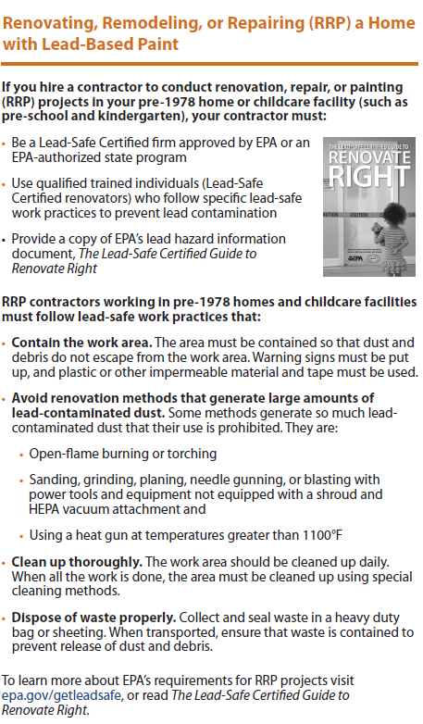
- Take paint chip samples to determine if lead-based paint is present in the area planned for renovation and send them to an EPA-recognized lead lab for analysis. In housing receiving federal assistance, the person collecting these samples must be a certified lead-based paint inspector or risk assessor
- Use EPA-recognized tests kits to determine if lead-based paint is absent (but not in housing receiving federal assistance)
- Presume that lead-based paint is present and use lead-safe work practices”

- Page 9. The information provided in the box to the right, replaces the entire content of this page.

- Back page. The statement, “Don’t use a belt-sander, propane torch, high temperature heat gun, scraper, or sandpaper on painted surfaces that may contain lead,” should be replaced with, “When renovating, repairing, painting, hire only EPA- or state- approved Lead-Safe Certified renovation firms.”

- Contact information throughout the document may be out of date. Please visit epa.gov/lead for the most current information.

