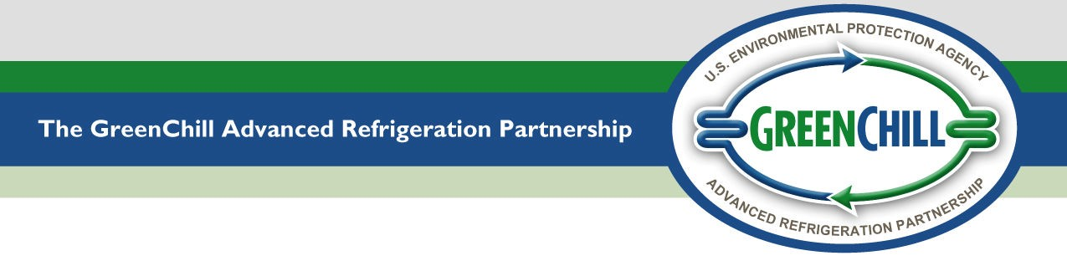

Installation Leak Tightness Testing: Verification Form
The following form must be completed by an authorized installation company representative to verify that your store’s remote commercial refrigeration system was tested for leaks at the time of installation in accordance with GreenChill’s Best Practices Guideline for Leak Tightness at Installation. Please refer to the Guideline for more details.
Store Contact Information
Store Name: |  |  |  |  |  |  | Location:
Installation Company Name:
Representative’s Name: |  |  |  |  |  |  |  | Title:
Telephone: |  |  |  |  | Email:
Leak Testing Information
- Pressure Testing for Leaks:
Tracer gas used:
The system pressure was brought up to psig and was successfully held for hours.
- Stairstep Evacuation Procedure:
First vacuum was pulled down to microns and was successfully held for hours.
Second vacuum was pulled down to microns and was successfully held for hours.
Third vacuum was pulled down to microns and was successfully held for hours.
Signature/Certification by Authorized Company Representative
By signing this form I attest that all information contained is true and correct.
Signature: |  | Date:

